# Question #1

Evaluate the following SQL statement:  
SQL> select cust_id, cust_last_name "Last name"  
  
FROM customers -  
  
WHERE country_id = 10 -  
  
UNION -  
SELECT cust_id CUST_NO, cust_last_name  
  
FROM customers -  
  
WHERE country_id = 30 -  
Identify three ORDER BY clauses either one of which can complete the query.

* A. ORDER BY "Last name"
* B. ORDER BY 2, cust_id
* C. ORDER BY CUST_NO
* D. ORDER BY 2, 1

**Correct Answer:** *ABD*   
Using the ORDER BY Clause in Set Operations  
-The ORDER BY clause can appear only once at the end of the compound query.  
-Component queries cannot have individual ORDER BY clauses.  
-The ORDER BY clause recognizes only the columns of the first SELECT query.  
-By default, the first column of the first SELECT query is used to sort the output in an ascending order.

# Question #2

Which three statements are true regarding the WHERE and HAVING clauses in a SQL statement? (Choose three.)

* A. WHERE and HAVING clauses cannot be used together in a SQL statement.
* B. The HAVING clause conditions can have aggregate functions.
* C. The HAVING clause conditions can use aliases for the columns.
* D. The WHERE clause is used to exclude rows before the grouping of data.
* E. The HAVING clause is used to exclude one or more aggregated results after grouping data.

**Correct Answer:** *BDE* 

# Question #3

Which statement is true regarding external tables?

* A. The CREATE TABLE AS SELECT statement can be used to upload data into a normal table in the database from an external table.
* B. The data and metadata for an external table are stored outside the database.
* C. The default REJECT LIMIT for external tables is UNLIMITED.
* D. ORACLE_LOADER and ORACLE_DATAPUMP have exactly the same functionality when used with an external table.

**Correct Answer:** *A*   
References:  
https://docs.oracle.com/cd/B28359_01/server.111/b28310/tables013.htm

https://hiteshgondalia.wordpress.com/managing-external-tables/

# Question #4

Which two statements are true about Data Manipulation Language (DML) statements?

* A. An INSERT INTO...VALUES.. statement can add multiple rows per execution to a table.
* B. An UPDATE... SET... statement can modify multiple rows based on multiple conditions on a table.
* C. A DELETE FROM..... statement can remove rows based on only a single condition on a table.
* D. An INSERT INTO... VALUES..... statement can add a single row based on multiple conditions on a table.
* E. A DELETE FROM..... statement can remove multiple rows based on multiple conditions on a table.
* F. An UPDATE....SET.... statement can modify multiple rows based on only a single condition on a table.

**Correct Answer:** *BE*   
References:  
http://www.techonthenet.com/sql/and_or.php

# Question #5

Which two statements are true regarding roles? (Choose two.)

* A. A role can be granted to itself.
* B. A role can be granted to PUBLIC.
* C. A user can be granted only one role at any point of time.
* D. The REVOKE command can be used to remove privileges but not roles from other users.
* E. Roles are named groups of related privileges that can be granted to users or other roles.

**Correct Answer:** *BE*   
References:  
http://docs.oracle.com/cd/E25054_01/network.1111/e16543/authorization.htm#autoId28

# Question #6

Which two statements are true regarding constraints? (Choose two)

* A. A constraint is enforced only for an INSERT operation on a table.
* B. A foreign key cannot contain NULL values.
* C. A column with the UNIQUE constraint can store NULLS.
* D. You can have more than one column in a table as part of a primary key.

**Correct Answer:** *CD* 

# Question #7

Evaluate the following statement.  
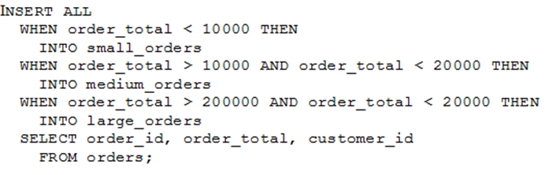  
Which statement is true regarding the evaluation of rows returned by the subquery in the INSERT statement?

* A. They are evaluated by all the three WHEN clauses regardless of the results of the evaluation of any other WHEN clause.
* B. They are evaluated by the first WHEN clause. If the condition is true, then the row would be evaluated by the subsequent WHEN clauses.
* C. They are evaluated by the first WHEN clause. If the condition is false, then the row would be evaluated by the subsequent WHEN clauses.
* D. The insert statement would give an error because the ELSE clause is not present for support in case none of WHEN clauses are true.

**Correct Answer:** *A*   
References:  
http://psoug.org/definition/WHEN.htm

# Question #8

Examine the structure of the MEMBERS table:  
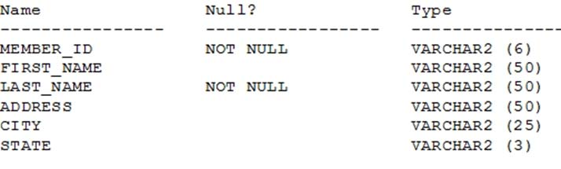  
You want to display details of all members who reside in states starting with the letter A followed by exactly one character.  
Which SQL statement must you execute?

* A. SELECT * FROM MEMBERS WHERE state LIKE '%A_';
* B. SELECT * FROM MEMBERS WHERE state LIKE 'A_';
* C. SELECT * FROM MEMBERS WHERE state LIKE 'A_%';
* D. SELECT * FROM MEMBERS WHERE state LIKE 'A%';

**Correct Answer:** *B* 

# Question #9

You want to display 5 percent of the rows from the SALES table for products with the lowest AMOUNT_SOLD and also want to include the rows that have the same even if this causes the output to exceed 5 percent of the rows.  
  
AMOUNT_SOLD -  
Which query will provide the required result?

* A. SELECT prod_id, cust_id, amount_sold FROM sales ORDER BY amount_sold FETCH FIRST 5 PERCENT ROWS WITH TIES;
* B. SELECT prod_id, cust_id, amount_sold FROM sales ORDER BY amount_sold FETCH FIRST 5 PERCENT ROWS ONLY WITH TIES;
* C. SELECT prod_id, cust_id, amount_sold FROM sales ORDER BY amount_sold FETCH FIRST 5 PERCENT ROWS WITH TIES ONLY;
* D. SELECT prod_id, cust_id, amount_sold FROM sales ORDER BY amount_sold FETCH FIRST 5 PERCENT ROWS ONLY;

**Correct Answer:** *A* 

# Question #10

Examine the structure of the MEMBERS table:  
Name Null? Type  
------------------ --------------- ------------------------------  
MEMBER_ID NOT NULL VARCHAR2 (6)  
FIRST_NAME VARCHAR2 (50)  
LAST_NAME NOT NULL VARCHAR2 (50)  
ADDRESS VARCHAR2 (50)  
You execute the SQL statement:  
SQL > SELECT member_id, ' ' , first_name, ' ' , last_name "ID FIRSTNAME LASTNAME " FROM members;  
What is the outcome?

* A. It fails because the alias name specified after the column names is invalid.
* B. It fails because the space specified in single quotation marks after the first two column names is invalid.
* C. It executes successfully and displays the column details in a single column with only the alias column heading.
* D. It executes successfully and displays the column details in three separate columns and replaces only the last column heading with the alias.

Correct Answer: *D*

# Question #11

You issue the following command to drop the PRODUCTS table:  
SQL > DROP TABLE products;  
Which three statements are true about the implication of this command? (Choose three.)

* A. All data along with the table structure is deleted.
* B. A pending transaction in the session is committed.
* C. All indexes on the table remain but they are invalidated.
* D. All views and synonyms on the table remain but they are invalidated.
* E. All data in the table is deleted but the table structure remains.

**Correct Answer:** *ABD*   
<https://docs.oracle.com/database/121/CNCPT/transact.htm#CNCPT016>

# Question #12

You execute the following commands:  
SQL > DEFINE hiredate = '01-APR-2011'  
SQL >SELECT employee_id, first_name, salary  
  
FROM employees -  
WHERE hire_date > '&hiredate'  
AND manager_id > &mgr_id;  
For which substitution variables are you prompted for the input?

* A. none, because no input required
* B. both the substitution variables ''hiredate' and 'mgr_id'.
* C. only hiredate'
* D. only 'mgr_id'

**Correct Answer:** *D*   
<http://its-all-about-oracle.blogspot.com/2013/07/vs-in-oracle.html>

# Question #13

View the Exhibit and examine the structure of ORDERS and ORDER_ITEMS tables. is the primary key in the ORDERS table. It is also the foreign key in the ORDER_ITEMS table wherein it is created with the ON DELETE CASCADE option.  
  
ORDER_ID -  
Which DELETE statement would execute successfully?  
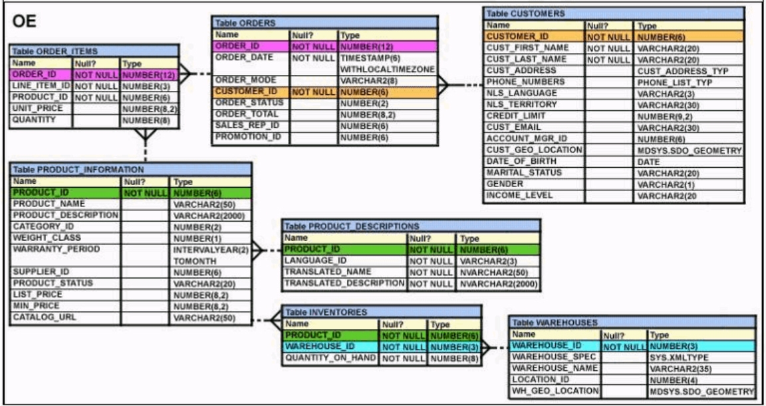

* A. DELETE orders o, order_items i WHERE o.order_id = i.order_id;
* B. DELETE FROM orders WHERE (SELECT order_id FROM order_items);
* C. DELETE orders WHERE order_total < 1000;
* D. DELETE order_id FROM orders WHERE order_total < 1000;

**Correct Answer:** *C* 

# Question #14

View the Exhibit and examine the structure of CUSTOMERS table.  
Using the CUSTOMERS table, you need to generate a report that shows an increase in the credit limit by 15% for all customers. Customers whose credit limit has not been entered should have the message "Not Available" displayed.  
Which SQL statement would produce the required result?  
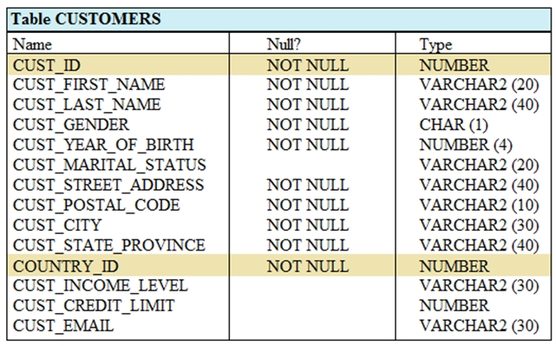

* A. SELECT NVL (TO CHAR(cust_credit_limit * .15), 'Not Available') "NEW CREDIT" FROM customers;
* B. SELECT TO_CHAR (NVL(cust_credit_limit * .15), 'Not Available') "NEW CREDIT" FROM customers;
* C. SELECT NVL(cust_credit_limit * .15), 'Not Available') "NEW CREDIT" FROM customers;
* D. SELECT NVL(cust_credit_limit), 'Not Available') "NEW CREDIT" FROM customers;

**Correct Answer:** *A*   
<https://www.oracletutorial.com/oracle-comparison-functions/oracle-nvl/>

<https://www.oracletutorial.com/oracle-comparison-functions/oracle-nvl2/>

<https://www.oracletutorial.com/oracle-comparison-functions/oracle-coalesce/>

<https://www.oracletutorial.com/oracle-comparison-functions/oracle-nullif/>

# Question #15

View the exhibit and examine the structures of the EMPLOYEES and DEPARTMENTS tables.  
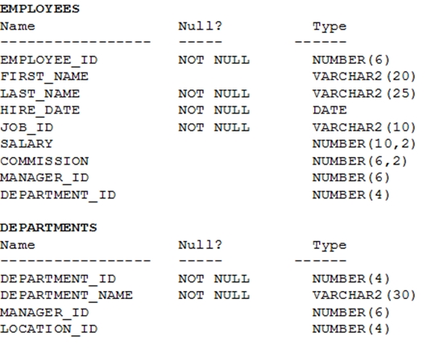  
You want to update EMPLOYEES table as follows:  
✑ Update only those employees who work in Boston or Seattle (locations 2900 and 2700).  
✑ Set department_id for these employees to the department_id corresponding to London (location_id 2100).  
✑ Set the employees' salary in location_id 2100 to 1.1 times the average salary of their department.  
✑ Set the employees' commission in location_id 2100 to 1.5 times the average commission of their department.  
You issue the following command:  
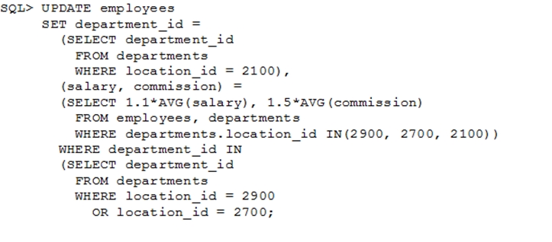  
What is outcome?

* A. It generates an error because multiple columns (SALARY, COMMISSION) cannot be specified together in an UPDATE statement.
* B. It generates an error because a subquery cannot have a join condition in a UPDATE statement.
* C. It executes successfully and gives the desired update
* D. It executes successfully but does not give the desired update

**Correct Answer:** *D* 

# Question #16

Evaluate the following two queries:  
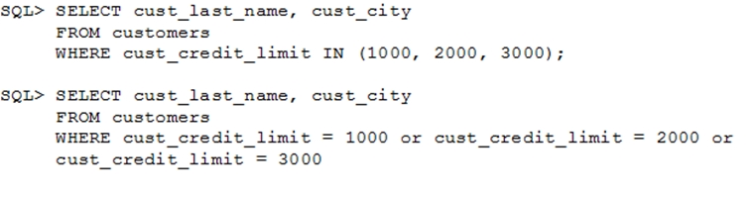  
Which statement is true regarding the above two queries?

* A. Performance would improve in query 2 only if there are null values in the CUST_CREDIT_LIMIT column.
* B. There would be no change in performance.
* C. Performance would degrade in query 2.
* D. Performance would improve in query 2.

**Correct Answer:** *B* 

# Question #17

Examine the business rule:  
Each student can work on multiple projects and each project can have multiple students.  
You need to design an Entity Relationship Model (ERD) for optimal data storage and allow for generating reports in this format:  
STUDENT_ID FIRST_NAME LAST_NAME PROJECT_ID PROJECT_NAME PROJECT_TASK  
Which two statements are true in this scenario? (Choose two.)

* A. The ERD must have a 1:M relationship between the STUDENTS and PROJECTS entities.
* B. The ERD must have a M:M relationship between the STUDENTS and PROJECTS entities that must be resolved into 1:M relationships.
* C. STUDENT_ID must be the primary key in the STUDENTS entity and foreign key in the PROJECTS entity.
* D. PROJECT_ID must be the primary key in the PROJECTS entity and foreign key in the STUDENTS entity.
* E. An associative table must be created with a composite key of STUDENT_ID and PROJECT_ID, which is the foreign key linked to the STUDENTS and entities. PROJECTS

**Correct Answer:** *BE*   
References:  
<http://www.oracle.com/technetwork/issue-archive/2011/11-nov/o61sql-512018.html>

# Question #18

View the Exhibit and examine the details of PRODUCT_INFORMATION table.  
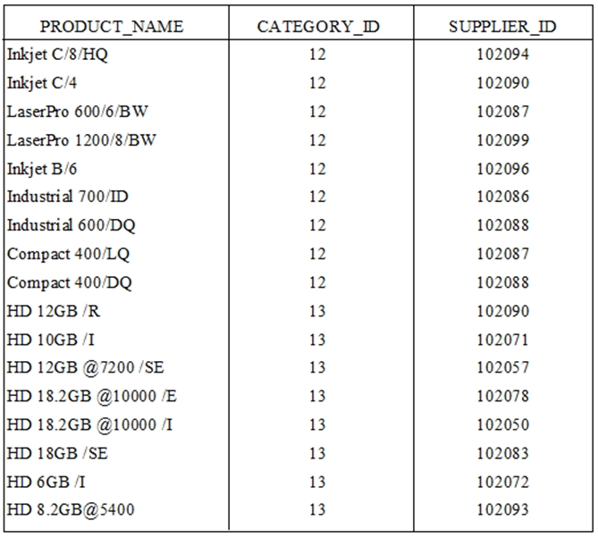  
You have the requirement to display PRODUCT_NAME from the table where the CATEGORY_ID column has values 12 or 13, and the SUPPLIER_ID column has the value 102088. You executed the following SQL statement:  
  
SELECT product_name -  
  
FROM product_information -  
WHERE (category_id = 12 AND category_id = 13) AND supplier_id = 102088;  
Which statement is true regarding the execution of the query?

* A. It would not execute because the same column has been used in both sides of the AND logical operator to form the condition.
* B. It would not execute because the entire WHERE clause condition is not enclosed within the parentheses.
* C. It would execute and the output would display the desired result.
* D. It would execute but the output would return no rows.

**Correct Answer:** *D* 

# Question #19

Which two statements are true regarding the EXISTS operator used in the correlated subqueries? (Choose two.)

* A. The outer query stops evaluating the result set of the inner query when the first value is found.
* B. It is used to test whether the values retrieved by the inner query exist in the result of the outer query.
* C. It is used to test whether the values retrieved by the outer query exist in the result set of the inner query.
* D. The outer query continues evaluating the result set of the inner query until all the values in the result set are processed.

**Correct Answer:** *AC*   
References:  
http://www.techonthenet.com/oracle/exists.php

# Question #20

View the exhibit and examine the structure of the STORES table.  
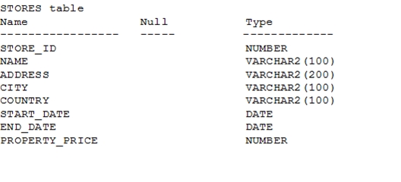  
You must display the NAME of stores along with the ADDRESS, START_DATE, PROPERTY_PRICE, and the projected property price, which is 115% of property price.  
The stores displayed must have START_DATE in the range of 36 months starting from 01-Jan-2000 and above.  
Which SQL statement would get the desired output?

* A. SELECT name, concat (address| | ','| |city| |', ', country) AS full_address, start_date, property_price, property_price*115/100 FROM stores WHERE MONTHS_BETWEEN (start_date, '01-JAN-2000') <=36;
* B. SELECT name, concat (address| | ','| |city| |', ', country) AS full_address, start_date, property_price, property_price*115/100 FROM stores WHERE TO_NUMBER(start_date-TO_DATE('01-JAN-2000','DD-MON-RRRR')) <=36;
* C. SELECT name, address||', '||city||', '||country AS full_address, start_date, property_price, property_price*115/100 FROM stores WHERE MONTHS_BETWEEN(start_date,TO_DATE('01-JAN-2000','DD-MON-RRRR')) <=36;
* D. SELECT name, concat (address||','| |city| |', ', country) AS full_address, start_date, property_price, property_price*115/100 FROM stores WHERE MONTHS_BETWEEN (start_date, TO_DATE('01-JAN-2000','DD-MON-RRRR')) <=36;

Correct Answer: *D*

# Question #21

The BOOKS_TRANSACTIONS table exists in your database.  
SQL>SELECT * FROM books_transactions ORDER BY 3;  
What is the outcome on execution?

* A. The execution fails unless the numeral 3 in the ORDER BY clause is replaced by a column name.
* B. Rows are displayed in the order that they are stored in the table only for the three rows with the lowest values in the key column.
* C. Rows are displayed in the order that they are stored in the table only for the first three rows.
* D. Rows are displayed sorted in ascending order of the values in the third column in the table.

**Correct Answer:** *D* 

# Question #22

Examine the command:  
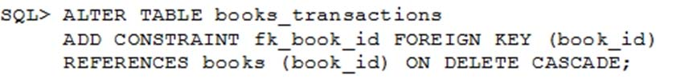  
What does ON DELETE CASCADE imply?

* A. When the BOOKS table is dropped, the BOOK_TRANSACTIONS table is dropped.
* B. When the BOOKS table is dropped, all the rows in the BOOK_TRANSACTIONS table are deleted but the table structure is retained.
* C. When a row in the BOOKS table is deleted, the rows in the BOOK_TRANSACTIONS table whose BOOK_ID matches that of the deleted row in the BOOKS table are also deleted.
* D. When a value in the BOOKS.BOOK_ID column is deleted, the corresponding value is updated in the BOOKS_TRANSACTIONS.BOOK_ID column.

**Correct Answer:** *C* 

# Question #23

View the exhibit and examine the structure of the EMPLOYEES table.  
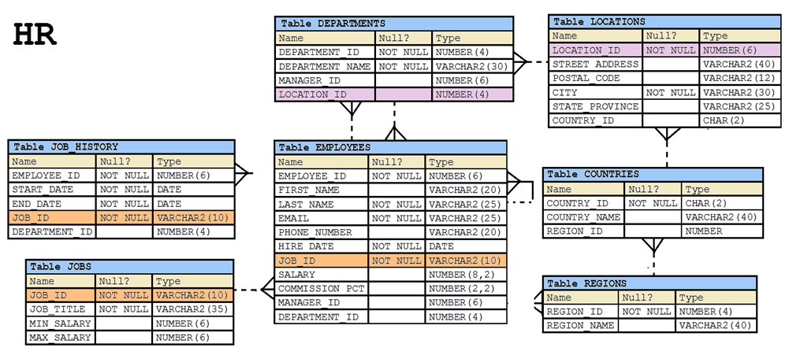  
You want to display all employees and their managers having 100 as the MANAGER_ID. You want the output in two columns: the first column would have the of the managers and the second column would have LAST_NAME of the employees.  
  
LAST_NAME -  
Which SQL statement would you execute?

* A. SELECT m.last_name "Manager", e.last_name "Employee" FROM employees m JOIN employees e ON m.employee_id = e.manager_id WHERE m.manager_id = 100;
* B. SELECT m.last_name "Manager", e.last_name "Employee" FROM employees m JOIN employees e ON m.employee_id = e.manager_id WHERE e.manager_id = 100;
* C. SELECT m.last_name "Manager", e.last_name "Employee" FROM employees m JOIN employees e ON e.employee_id = m.manager_id WHERE m.manager_id = 100;
* D. SELECT m.last_name "Manager", e.last_name "Employee" FROM employees m JOIN employees e WHERE m.employee_id = e.manager_id AND e.manager_id = 100

**Correct Answer:** *B* 

# Question #24

Which three statements are true about multiple-row subqueries?

* A. They can contain a subquery within a subquery.
* B. They can return multiple columns as well as rows.
* C. They cannot contain a subquery within a subquery.
* D. They can return only one column but multiple rows.
* E. They can contain group functions and GROUP BY and HAVING clauses.
* F. They can contain group functions and the GROUP BY clause, but not the HAVING clause.

**Correct Answer:** *ABE* 

# Question #25

Examine the structure of the EMPLOYEES table.  
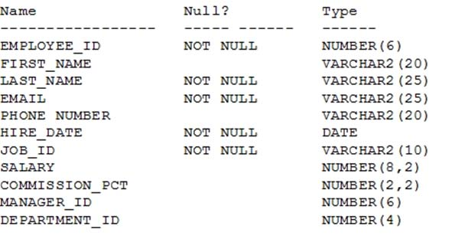  
There is a parent/child relationship between EMPLOYEE_ID and MANAGER_ID.  
You want to display the last names and manager IDs of employees who work for the same manager as the employee whose EMPLOYEE_ID is 123.  
Which query provides the correct output?

* A. SELECT e.last_name, m.manager_id FROM employees e RIGHT OUTER JOIN employees m on (e.manager_id = m.employee_id) AND e.employee_id = 123;
* B. SELECT e.last_name, m.manager_id FROM employees e LEFT OUTER JOIN employees m on (e.employee_id = m.manager_id) WHERE e.employee_id = 123;
* C. SELECT e.last_name, e.manager_id FROM employees e RIGHT OUTER JOIN employees m on (e.employee_id = m.employee_id) WHERE e.employee_id = 123;
* D. SELECT m.last_name, e.manager_id FROM employees e LEFT OUTER JOIN employees m on (e.manager_id = m.manager_id) WHERE e.employee_id = 123;

**Correct Answer:** *D* 

# Question #26

Which normal form is a table in if it has no multi-valued attributes and no partial dependencies?

* A. second normal form
* B. first normal form
* C. third normal form
* D. fourth normal form

**Correct Answer:** *A*   
References:  
<https://blog.udemy.com/database-normal-forms/>

# Question #27

Sales data of a company is stored in two tables, SALES1 and SALES2, with some data being duplicated across the tables. You want to display the results from the table, which are not present in the SALES2 table.  
  
SALES1 -  
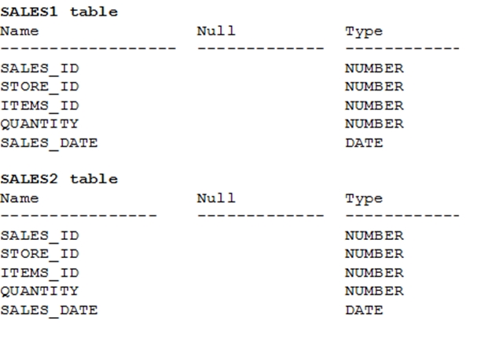  
Which set operator generates the required output?

* A. INTERSECT
* B. UNION
* C. PLUS
* D. MINUS
* E. SUBTRACT

**Correct Answer:** *D*   
References:  
<https://docs.oracle.com/cd/B19306_01/server.102/b14200/queries004.htm>

# Question #28

Evaluate the following ALTER TABLE statement:  
  
ALTER TABLE orders -  
SET UNUSED (order_date);  
Which statement is true?

* A. After executing the ALTER TABLE command, you can add a new column called ORDER_DATE to the ORDERS table.
* B. The ORDER_DATE column must be empty for the ALTER TABLE command to execute successfully.
* C. ROLLBACK can be used to get back the ORDER_DATE column in the ORDERS table.
* D. The DESCRIBE command would still display the ORDER_DATE column.

**Correct Answer:** *A*   
<https://oracle-base.com/articles/8i/dropping-columns>

# Question #29

Evaluate the following SQL statements that are issued in the given order:  
  
CREATE TABLE emp -  
(emp_no NUMBER(2) CONSTRAINT emp_emp_no_pk PRIMARY KEY,  
ename VARCHAR2(15),  
salary NUMBER (8,2),  
mgr_no NUMBER(2) CONSTRAINT emp_mgr_fk REFERENCES emp(emp_no));  
  
ALTER TABLE emp -  
DISABLE CONSTRAINT emp_emp_no_pk CASCADE;  
  
ALTER TABLE emp -  
ENABLE CONSTRAINT emp_emp_no_pk;  
What would be the status of the foreign key EMP_MGR_PK?

* A. It would remain disabled and can be enabled only by dropping the foreign key constraint and recreating it.
* B. It would remain disabled and has to be enabled manually using the ALTER TABLE command.
* C. It would be automatically enabled and immediate.
* D. It would be automatically enabled and deferred.

**Correct Answer:** *B* 

# Question #30

Which three statements are true regarding the data types? (Choose three.)

* A. The minimum column width that can be specified for a VARCHAR2 data type column is one.
* B. Only one LONG column can be used per table.
* C. A TIMESTAMP data type column stores only time values with fractional seconds.
* D. The BLOB data type column is used to store binary data in an operating system file.
* E. The value for a CHAR data type column is blank-padded to the maximum defined column width.

Correct Answer: *ABE*

<https://docs.oracle.com/cd/B28359_01/server.111/b28320/limits001.htm#i287903>

# Question #31

Which three statements are true regarding subqueries? (Choose three.)

* A. Multiple columns or expressions can be compared between the main query and subquery.
* B. Subqueries can contain ORDER BY but not the GROUP BY clause.
* C. Main query and subquery can get data from different tables.
* D. Subqueries can contain GROUP BY and ORDER BY clauses.
* E. Main query and subquery must get data from the same tables.
* F. Only one column or expression can be compared between the main query and subquery.

**Correct Answer:** *ACD*   
References:  
http://docs.oracle.com/javadb/10.6.2.1/ref/rrefsqlj13658.html

# Question #32

Which statement is true regarding the default behavior of the ORDER BY clause?

* A. In a character sort, the values are case-sensitive.
* B. NULL values are not considered at all by the sort operation.
* C. Only those columns that are specified in the SELECT list can be used in the ORDER BY clause.
* D. Numeric values are displayed from the maximum to the minimum value if they have decimal positions.

**Correct Answer:** *A* 

# Question #33

Examine the structure of the MEMBERS table.  
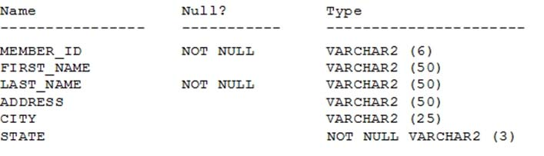  
Which query can be used to display the last names and city names only for members from the states MO and MI?

* A. SELECT last_name, city FROM members WHERE state ='MO' AND state ='MI';
* B. SELECT last_name, city FROM members WHERE state LIKE 'M%';
* C. SELECT last_name, city FROM members WHERE state IN ('MO', 'MI');
* D. SELECT DISTINCT last_name, city FROM members WHERE state ='MO' OR state ='MI';

**Correct Answer:** *C* 

# Question #34

Which statement is true about an inner join specified in a query's WHERE clause?

* A. It only applies for equijoin conditions.
* B. It applies for equijoin and nonequijoin conditions.
* C. It requires column names to be the same in all tables being joined.
* D. It must have primary-key and foreign-key constraints defined on the join columns.

**Correct Answer:** *B* 

# Question #35

Which task can be performed by using a single Data Manipulation Language (DML) statement?

* A. adding a column constraint while inserting a row into a table
* B. adding a column with a default value while inserting a row into a table
* C. removing all data only from a single column on which a unique constraint is defined
* D. removing all data only from a single column on which a primary key constraint is defined

**Correct Answer:** *C* 

# Question #36

Examine the structure of the BOOKS_TRANSACTIONS table:  
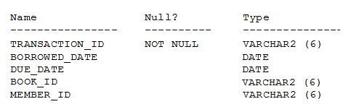  
You want to display the member IDs, due date, and late fee as $2 for all transactions.  
Which SQL statement must you execute?

* A. SELECT member_id AS MEMBER_ID, due_date AS DUE_DATE, $2 AS LATE_FEE FROM BOOKS_TRANSACTIONS;
* B. SELECT member_id 'MEMBER ID', due_date 'DUE DATE', '$2 AS LATE FEE' FROM BOOKS_TRANSACTIONS;
* C. SELECT member_id AS "MEMBER ID", due_date AS "DUE DATE", '$2' AS "LATE FEE" FROM BOOKS_TRANSACTIONS;
* D. SELECT member_id AS "MEMBER ID", due_date AS "DUE DATE", $2 AS "LATE FEE" FROM BOOKS_TRANSACTIONS;

**Correct Answer:** *C* 

# Question #37

In which three situations does a transaction complete?

* A. when a PL/SQL anonymous block is executed
* B. when a DELETE statement is executed
* C. when a ROLLBACK command is executed
* D. when a data definition language (DDL) statement is executed
* E. when a TRUNCATE statement is executed after the pending transaction

**Correct Answer:** *CDE*   
References:  
<https://docs.oracle.com/cd/B19306_01/server.102/b14220/transact.htm>

# Question #38

View the exhibit and examine the data in ORDERS_MASTER and MONTHLY_ORDERS tables.  
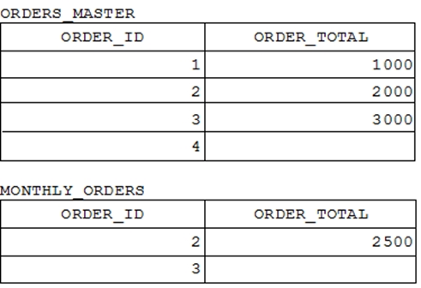  
Evaluate the following MERGE statement:  
  
MERGE_INTO orders_master o -  
  
USING monthly_orders m -  
ON (o.order_id = m.order_id)  
  
WHEN MATCHED THEN -  
UPDATE SET o.order_total = m.order_total  
DELETE WHERE (m.order_total IS NULL)  
  
WHEN NOT MATCHED THEN -  
INSERT VALUES (m.order_id, m.order_total)  
What would be the outcome of the above statement?

* A. The ORDERS_MASTER table would contain the ORDER_IDs 1, 2, 3 and 4.
* B. The ORDERS_MASTER table would contain the ORDER_IDs 1, 2 and 4.
* C. The ORDERS_MASTER table would contain the ORDER_IDs 1, 2 and 3.
* D. The ORDERS_MASTER table would contain the ORDER_IDs 1 and 2.

**Correct Answer:** *B*   
References:  
https://docs.oracle.com/cd/B28359_01/server.111/b28286/statements_9016.htm

# Question #39

Evaluate the following SQL statement:  
SELECT product_name || 'it's not available for order'  
  
FROM product_information -  
WHERE product_status = 'obsolete';  
You received the following error while executing the above query:  
  
ERROR -  
ORA-01756: quoted string not properly terminated  
What would you do to execute the query successfully?

* A. Remove the single quotation marks enclosing the character literal string in the SELECT clause
* B. Use the escape character to negate the single quotation mark within the literal character string in the SELECT clause
* C. Enclose the character literal string in the SELECT clause within double quotation marks
* D. Use the Oracle (q) operator and delimiter to allow the use of a single quotation mark within the literal character string in the SELECT clause

**Correct Answer:** *D*   
References:  
<http://docs.oracle.com/cd/B19306_01/server.102/b14200/sql_elements003.htm>

# Question #40

View the exhibit and examine the ORDERS table.  
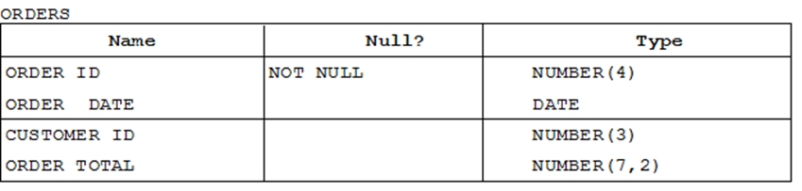  
The ORDERS table contains data and all orders have been assigned a customer ID. Which statement would add a NOT NULL constraint to the CUSTOMER_ID column?

* A. ALTER TABLE orders MODIFY CONSTRAINT orders_cust_id_nn NOT NULL (customer_id);
* B. ALTER TABLE orders ADD CONSTRAINT orders_cust_id_nn NOT NULL (customer_id);
* C. ALTER TABLE orders MODIFY customer_id CONSTRAINT orders_cust_nn NOT NULL ~~(customer_id)~~;
* D. ALTER TABLE orders ADD customer_id NUMBER(6)CONSTRAINT orders_cust_id_nn NOT NULL;

~~Correct Answer:~~*~~C~~*

ALTER TABLE orders MODIFY customer_id CONSTRAINT orders_cust_nn NOT NULL;

ALTER TABLE orders ADD CONSTRAINT orders_cust_id_nn **CHECK** (customer_id IS NOT NULL);

# Question #41

Examine the structure of the INVOICE table.  
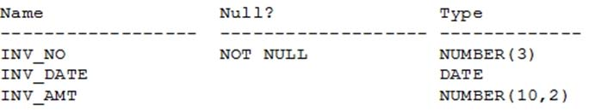  
Which two SQL statements would execute successfully?

* A. SELECT inv_no, NVL2(inv_date, 'Pending', 'Incomplete') FROM invoice;
* B. SELECT inv_no, NVL2(inv_amt, inv_date, 'Not Available') FROM invoice;
* C. SELECT inv_no, NVL2(inv_date, sysdate-inv_date, sysdate) FROM invoice;
* D. SELECT inv_no, NVL2(inv_amt, inv_amt*.25, 'Not Available') FROM invoice;

**Correct Answer:** *AC* 

# Question #42

Which three statements are true about the ALTER TABLE....DROP COLUMN.... command?

* A. A column can be dropped only if it does not contain any data.
* B. A column can be dropped only if another column exists in the table.
* C. A dropped column can be rolled back.
* D. The column in a composite PRIMARY KEY with the CASCADE option can be dropped.
* E. A parent key column in the table cannot be dropped.

**Correct Answer:** *BDE* 

# Question #43

View the exhibit and examine the description of the PRODUCT_INFORMATION table.  
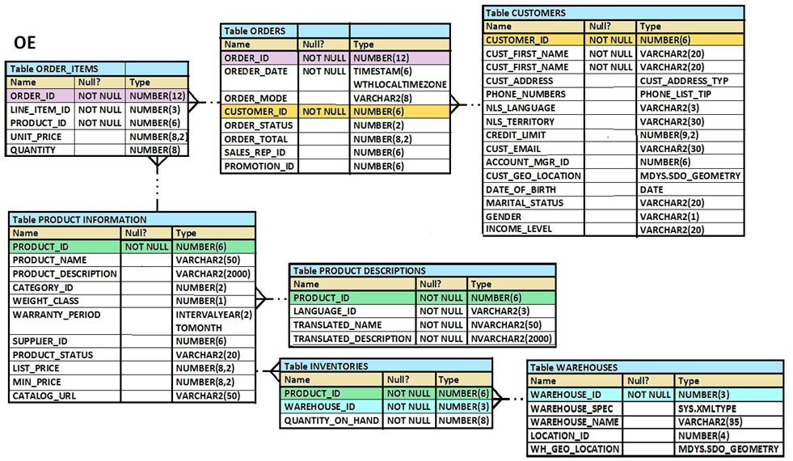  
Which SQL statement would retrieve from the table the number of products having LIST_PRICE as NULL?

* A. SELECT COUNT (DISTINCT list_price) FROM product_information WHERE list_price is NULL
* B. SELECT COUNT (NVL(list_price, 0)) FROM product_information WHERE list_price is NULL
* C. SELECT COUNT (list_price) FROM product_information WHERE list_price i= NULL
* D. SELECT COUNT (list_price) FROM product_information WHERE list_price is NULL

**Correct Answer:** *B* 

# Question #44

Which three tasks can be performed using SQL functions built into Oracle Database?

* A. displaying a date in a nondefault format
* B. finding the number of characters in an expression
* C. substituting a character string in a text expression with a specified string
* D. combining more than two columns or expressions into a single column in the output

**Correct Answer:** *ABC* 

# Question #45

The user SCOTT who is the owner of ORDERS and ORDER_ITEMS tables issues this GRANT command:  
  
GRANT ALL -  
  
ON orders, order_items -  
TO PUBLIC;  
What must be done to fix the statement?

* A. PUBLIC should be replaced with specific usernames.
* B. ALL should be replaced with a list of specific privileges.
* C. WITH GRANT OPTION should be added to the statement.
* D. Separate GRANT statements are required for the ORDERS and ORDER_ITEMS tables.

**Correct Answer:** *D*   
References:  
<http://docs.oracle.com/javadb/10.8.3.0/ref/rrefsqljgrant.html>

# Question #46

You are designing the structure of a table in which two columns have the specifications: "" must be able to contain a maximum of 12 alphanumeric characters and must uniquely identify the row  
  
COMPONENT_ID -  
"" contains Century, Year, Month, Day, Hour, Minute, Second to the maximum precision and is used for calculations and comparisons  
  
EXECUTION_DATETIME -  
between components.  
Which two options define the data types that satisfy these requirements most efficiently? (Choose two.)

* A. The EXECUTION_DATETIME must be of INTERVAL DAY TO SECOND data type.
* B. The EXECUTION_DATETIME must be of TIMESTAMP data type.
* C. The EXECUTION_DATETIME must be of DATE data type.
* D. The COMPONENT_ID must be of ROWID data type.
* E. The COMPONENT_ID must be of VARCHAR2 data type.
* F. The COMPONENT_ID column must be of CHAR data type.

**~~Correct Answer:~~***~~CF~~*

# Question #47

You want to display the date for the first Monday of the next month and issue the following command:  
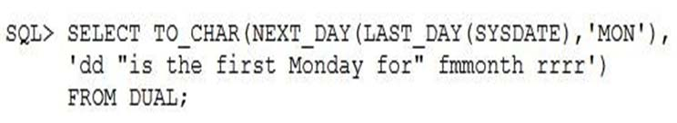  
What is the outcome?

* A. In generates an error because rrrr should be replaced by rr in the format string.
* B. It executes successfully but does not return the correct result.
* C. It executes successfully and returns the correct result.
* D. In generates an error because TO_CHAR should be replaced with TO_DATE.
* E. In generates an error because fm and double quotation marks should not be used in the format string.

**Correct Answer:** *cause.C* 

# Question #48

Which two statements are true regarding the GROUP BY clause in a SQL statement? (Choose two.)

* A. You can use column alias in the GROUP BY clause.
* B. Using the WHERE clause after the GROUP BY clause excludes the rows after creating groups.
* C. The GROUP BY clause is mandatory if you are using an aggregate function in the SELECT clause.
* D. Using the WHERE clause before the GROUP BY clause excludes the rows before creating groups.
* E. If the SELECT clause has an aggregate function, then those individual columns without an aggregate function in the SELECT clause should be included in the GROUP BY

**Correct Answer:** *DE* 

# Question #49

Examine the commands used to create DEPARTMENT_DETAILS and COURSE_DETAILS tables:  
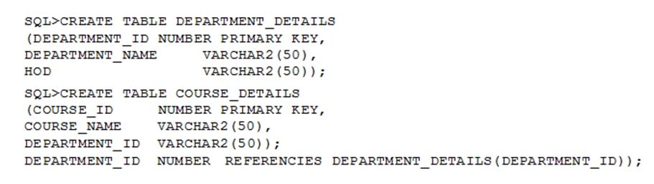  
You want to generate a list of all department IDs along with any course IDs that may have been assigned to them.  
Which SQL statement must you use?

* A. SELECT d.department_id, c.course_id FROM department_details d RIGHT OUTER JOIN course_details c ON (d.department_id=c. department_id);
* B. SELECT d.department_id, c.course_id FROM department_details d LEFT OUTER JOIN course_details c ON (d.department_id=c. department_id);
* C. SELECT d.department_id, c.course_id FROM course_details c LEFT OUTER JOIN department_details d ON (c.department_id=d. department_id);
* D. SELECT d.department_id, c.course_id FROM department_details d RIGHT OUTER JOIN course_details c ON (c.department_id=d. department_id);

**Correct Answer:** *B* 

# Question #50

Which two tasks can be performed by using Oracle SQL statements? (Choose two.)

* A. changing the password for an existing database user
* B. connecting to a database instance
* C. querying data from tables in different databases
* D. starting up a database instance
* E. executing operating system (OS) commands in a session

**Correct Answer:** *AC*   
References:  
http://www.techonthenet.com/oracle/password.php  
https://docs.oracle.com/cd/B28359_01/server.111/b28324/tdpii_distdbs.htm

# Question #51

View the exhibit for the structure of the STUDENT and FACULTY tables.  
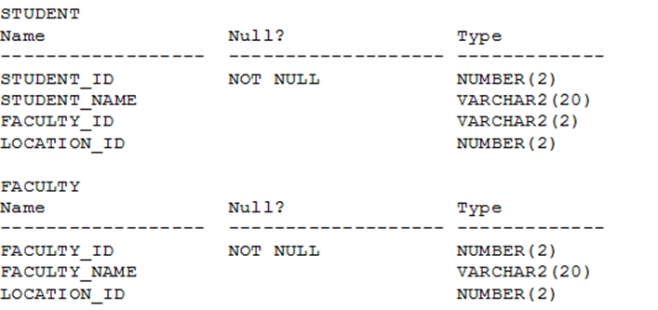  
You need to display the faculty name followed by the number of students handled by the faculty at the base location.  
Examine the following two SQL statements:  
  
Statement 1 -  
SQL>SELECT faculty_name, COUNT(student_id)  
  
FROM student JOIN faculty -  
USING (faculty_id, location_id)  
GROUP BY faculty_name;  
  
Statement 2 -  
SQL>SELECT faculty_name, COUNT(student_id)  
FROM student NATURAL JOIN faculty  
GROUP BY faculty_name;  
Which statement is true regarding the outcome?

* A. Only statement 2 executes successfully and gives the required result.
* B. Only statement 1 executes successfully and gives the required result.
* C. Both statements 1 and 2 execute successfully and give different results.
* D. Both statements 1 and 2 execute successfully and give the same required result.

**Correct Answer:** *~~B~~* >> D

# Question #52

Which statement correctly grants a system privilege?

* A. GRANT CREATE VIEW ON table1 TO user1;
* B. GRANT ALTER TABLE TO PUBLIC;
* C. GRANT CREATE TABLE TO user1, user2;
* D. GRANT CREATE SESSION TO ALL;

**Correct Answer:** *C* 

# Question #53

View the exhibit and examine the structure of ORDERS and CUSTOMERS tables.  
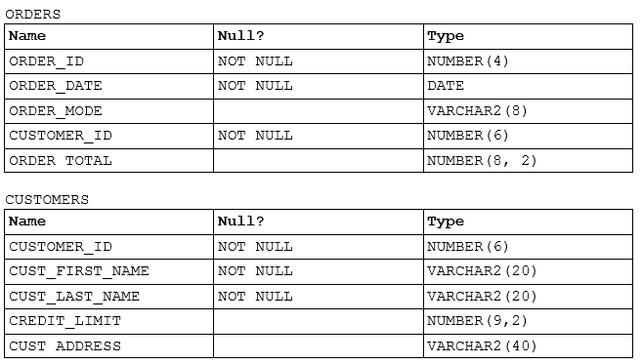  
Which INSERT statement should be used to add a row into the ORDERS table for the customer whose CUST_LAST_NAME is Roberts and CREDIT_LIMIT is  
? Assume there exists only one row with CUST_LAST_NAME as Roberts and CREDIT_LIMIT as 600.  
600

* A. INSERT INTO (SELECT o.order_id, o.order_date, o.order_mode, c.customer_id, o.order_total FROM orders o, customers c WHERE o.customer_id = c.customer_id AND c.cust_last_name='Roberts' AND c.credit_limit=600) VALUES (1,'10-mar-2007', 'direct', (SELECT customer_id FROM customers WHERE cust_last_name='Roberts' AND credit_limit=600), 1000);
* B. INSERT INTO orders (order_id, order_date, order_mode, (SELECT customer_id FROM customers WHERE cust_last_name='Roberts' AND credit_limit=600), order_total) VALUES (1,'10-mar-2007', 'direct', &customer_id, 1000);
* C. INSERT INTO orders VALUES (1,'10-mar-2007', 'direct', (SELECT customer_id FROM customers WHERE cust_last_name='Roberts' AND credit_limit=600), 1000);
* D. INSERT INTO orders (order_id, order_date, order_mode, (SELECT customer_id FROM customers WHERE cust_last_name='Roberts' AND credit_limit=600), order_total) VALUES (1,'10-mar-2007', 'direct', &&customer_id, 1000);

**Correct Answer:** *C* 

# Question #54

Which three statements are correct regarding indexes? (Choose three.)

* A. A non-deferrable PRIMARY KEY or UNIQUE KEY constraint in a table automatically attempts to create a unique index.
* B. Indexes should be created on columns that are frequently referenced as part of any expression.
* C. When a table is dropped, corresponding indexes are automatically dropped.
* D. For each DML operation performed on a table, the corresponding indexes are automatically updated if required.

**Correct Answer:** *ACD*   
References:  
<http://viralpatel.net/blogs/understanding-primary-keypk-constraint-in-oracle/>

# Question #55

View the exhibit and examine the description of the DEPARTMENTS and EMPLOYEES tables.  
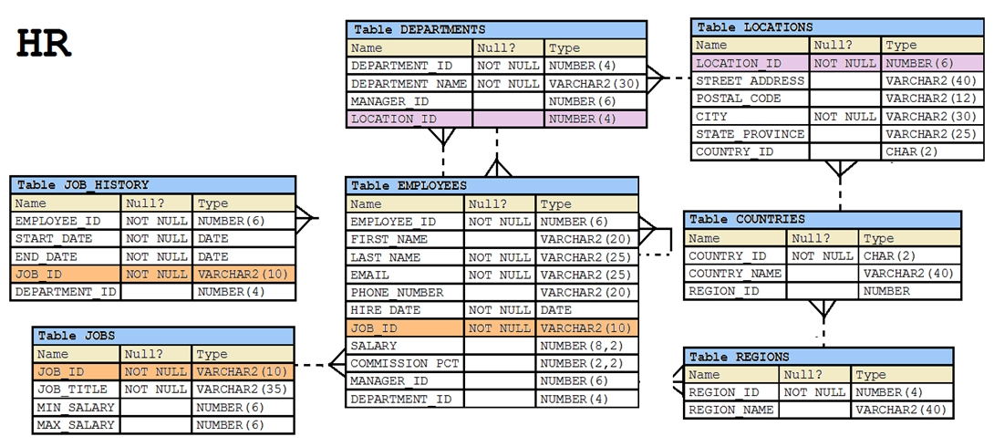  
You wrote this SQL statement to retrieve EMPLOYEE_ID, FIRST_NAME, and DEPARTMENT NAME, for all employees:  
SELECT employee_id, first_name, department_name  
  
FROM employees -  
NATURAL JOIN departments;  
The desired output is not obtained after executing the above SQL statement. What could be the reason for this?

* A. The table prefix is missing for the column names in the SELECT clause.
* B. The NATURAL JOIN clause is missing the USING clause.
* C. The DEPARTMENTS table is not used before the EMPLOYEES table in the FROM clause.
* D. The EMPLOYEES and DEPARTMENTS tables have more than one column with the same column name and data type.

**Correct Answer:** *D*   
Natural join needs only one column to be the same in each table. The EMPLOYEES and DEPARTMENTS tables have two columns that are the same  
(Department_ID and Manager_ID)

# Question #56

Which two statements are true about sequences created in a single instance Oracle database? (Choose two.)

* A. When the MAXVALUE limit for a sequence is reached, it can be subtitu
* ased by using the ALTER SEQUENCE statement. > would remove a sequence from the database.
* C. The numbers generated by an explicitly defined sequence can only be used to insert data in one table.
* D. CURRVAL is used to refer to the most recent sequence number that has been generated for a particular sequence.
* E. When a database instance shuts down abnormally, sequence numbers that have been cached but not used are available again when the instance is restarted.

**Correct Answer:** *AD*   
References:  
http://docs.oracle.com/cd/E11882_01/server.112/e41084/statements_2012.htm#SQLRF00817 https://docs.oracle.com/cd/A84870_01/doc/server.816/a76989/ch26.htm

# Question #57

View the exhibit and examine the structure of the CUSTOMERS table.  
  
Which two tasks would require subqueries or joins to be executed in a single statement?

* A. finding the number of customers, in each city, whose credit limit is more than the average credit limit of all the customers
* B. finding the average credit limit of male customers residing in 'Tokyo' or 'Sydney'
* C. listing of customers who do not have a credit limit and were born before 1980
* D. finding the number of customers, in each city, whose marital status is 'married'.
* E. listing of those customers, whose credit limit is the same as the credit limit of customers residing in the city 'Tokyo'.

**Correct Answer:** *AE* 

# Question #58

Which statement is true about transactions?

* A. A set of Data Manipulation Language (DML) statements executed in a sequence ending with a SAVEPOINT forms a single transaction.
* B. Each Data Definition Language (DDL) statement executed forms a single transaction.
* C. A set of DDL statements executed in a sequence ending with a COMMIT forms a single transaction.
* D. A combination of DDL and DML statements executed in a sequence ending with a COMMIT forms a single transaction.

**Correct Answer:** *B*   
References:  
https://docs.oracle.com/database/121/CNCPT/transact.htm#CNCPT038

# Question #59

View the exhibit and examine the structure in ORDERS and ORDER_ITEMS tables.  
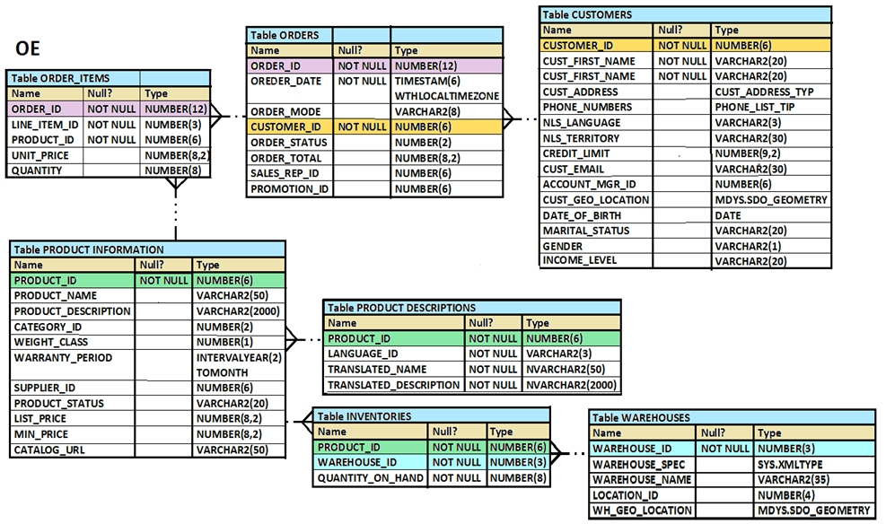  
You need to create a view that displays the ORDER_ID, ORDER_DATE, and the total number of items in each order.  
Which CREATE VIEW statement would create the view successfully?

* A. CREATE OR REPLACE VIEW ord_vu AS SELECT o.order_id, o.order_date, COUNT (i.line_item_id) FROM orders o JOIN order_items i ON (o.order_id = i.order_id) GROUP BY o.order_id, o.order_date;
* B. CREATE OR REPLACE VIEW ord_vu (order_id, order_date) AS SELECT o.order_id, o.order_date, COUNT (i.line_item_id) "NO OF ITEMS" FROM orders o JOIN order_items i ON (o.order_id = i.order_id) GROUP BY o.order_id, o.order_date;
* C. CREATE OR REPLACE VIEW ord_vu AS SELECT o.order_id, o.order_date, COUNT (i.line_item_id) "NO OF ITEMS" FROM orders o JOIN order_items i ON (o.order_id = i.order_id) GROUP BY o.order_id, o.order_date;
* D. CREATE OR REPLACE VIEW ord_vu AS SELECT o.order_id, o.order_date, COUNT (i.line_item_id) || "NO OF ITEMS" FROM orders o JOIN order_items i ON (o.order_id = i.order_id) GROUP BY o.order_id, o.order_date WHITH CHECK OPTION;

**Correct Answer:** *C* 

# Question #60

Which statement is true about an inner join specified in the WHERE clause of a query?

* A. It must have primary-key and foreign-key constraints defined on the columns used in the join condition.
* B. It requires the column names to be the same in all tables used for the join conditions.
* C. It is applicable for equijoin and nonequijoin conditions.
* D. It is applicable for only equijoin conditions.

Correct Answer: *C*

# Question #61

Which statement is true regarding the INTERSECT operator?

* A. The names of columns in all SELECT statements must be identical.
* B. It ignores NULL values.
* C. Reversing the order of the intersected tables alters the result.
* D. The number of columns and data types must be identical for all SELECT statements in the query.

**Correct Answer:** *D*   
INTERSECT Returns only the rows that occur in both queries' result sets, sorting them and removing duplicates.  
The columns in the queries that make up a compound query can have different names, but the output result set will use the names of the columns in the first query.

<https://docs.oracle.com/database/121/SQLRF/queries004.htm#SQLRF52341>

# Question #62

Examine the following query:  
SQL> SELECT prod_id, amount_sold  
  
FROM sales -  
  
ORDER BY amount_sold -  
FETCH FIRST 5 PERCENT ROWS ONLY;  
What is the output of this query?

* A. It displays 5 percent of the products with the highest amount sold.
* B. It displays the first 5 percent of the rows from the SALES table.
* C. It displays 5 percent of the products with the lowest amount sold.
* D. It results in an error because the ORDER BY clause should be the last clause.

**Correct Answer:** *C*   
References:  
https://oracle-base.com/articles/12c/row-limiting-clause-for-top-n-queries-12cr1

# Question #63

The first DROP operation is performed on PRODUCTS table using this command:  
DROP TABLE products PURGE;  
Then a FLASHBACK operation is performed using this command:  
FLASHBACK TABLE products TO BEFORE DROP;  
Which is true about the result of the FLASHBACK command?

* A. It recovers only the table structure.
* B. It recovers the table structure, data, and the indexes.
* C. It recovers the table structure and data but not the related indexes.
* D. It is not possible to recover the table structure, data, or the related indexes.

**Correct Answer:** *D*   
References:  
https://docs.oracle.com/cd/B19306_01/server.102/b14200/statements_9003.htm

# Question #64

These are the steps for a correlated subquery, listed in random order:  
1. The WHERE clause of the outer query is evaluated.  
2. A candidate row is fetched from the table specified in the outer query.  
3. This is repeated for the subsequent rows of the table, until all the rows are processed.  
4. Rows are returned by the inner query, after being evaluated with the value from the candidate row in the outer query.  
Which is the correct sequence in which the Oracle server evaluates a correlated subquery?

* A. 2, 1, 4, 3
* B. 4, 1, 2, 3
* C. 4, 2, 1, 3
* D. 2, 4, 1, 3

**Correct Answer:** *D*   
References:  
<http://rajanimohanty.blogspot.co.uk/2014/01/correlated-subquery.html>

<https://docs.oracle.com/database/121/SQLRF/queries007.htm#SQLRF52357>

# Question #65

Evaluate the following query:  
SQL> SELECT TRUNC (ROUND(156.00, -1),-1)  
FROM DUAL;  
What would be the outcome?

* A. 150
* B. 200
* C. 160
* D. 16
* E. 100

**Correct Answer:** *C*   
References:  
https://docs.oracle.com/cd/B19306_01/server.102/b14200/functions135.htm https://docs.oracle.com/cd/B28359_01/olap.111/b28126/dml_functions_2127.htm

# Question #66

Examine the data in the CUST_NAME column of the CUSTOMERS table.  
  
CUST_NAME -  
-------------------  
  
Renske Ladwig -  
  
Jason Mallin -  
  
Samuel McCain -  
  
Allan MCEwen -  
  
Irene Mikkilineni -  
  
Julia Nayer -  
You need to display customers' second names where the second name starts with "Mc" or "MC".  
Which query gives the required output?

* A. SELECT SUBSTR(cust_name, INSTR (cust_name, ' ')+1) FROM customers WHERE SUBSTR(cust_name, INSTR (cust_name, ' ')+1) LIKE INITCAP ('MC%');
* B. SELECT SUBSTR(cust_name, INSTR (cust_name, ' ')+1) FROM customers WHERE INITCAP(SUBSTR(cust_name, INSTR (cust_name, ' ')+1)) = 'Mc';
* C. SELECT SUBSTR(cust_name, INSTR (cust_name, ' ')+1) FROM customers WHERE INITCAP(SUBSTR(cust_name, INSTR (cust_name, ' ')+1)) LIKE 'Mc%';
* D. SELECT SUBSTR(cust_name, INSTR (cust_name, ' ')+1) FROM customers WHERE INITCAP(SUBSTR(cust_name, INSTR (cust_name, ' ')+1)) = INITCAP ('MC%');

**Correct Answer:** *C* 

# Question #67

View the exhibit and examine the structure of the SALES, CUSTOMERS, PRODUCTS and TIMES tables.  
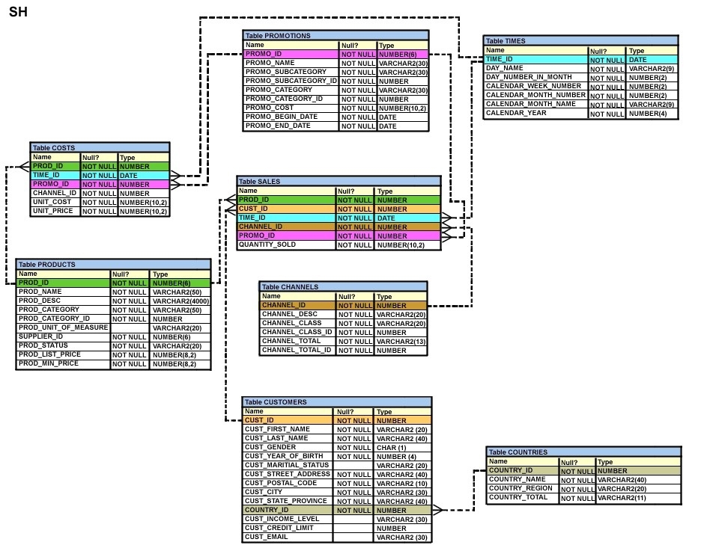  
The PROD_ID column is the foreign key in the SALES table, which references the PRODUCTS table.  
Similarly, the CUST_ID and TIME_ID columns are also foreign keys in the SALES table referencing the CUSTOMERS and TIMES tables, respectively.  
Evaluate the following CREATE TABLE command:  
CREATE TABLE new_sales (prod_id, cust_id, order_date DEFAULT SYSDATE)  
  
AS -  
SELECT prod_id, cust_id, time_id  
FROM sales;  
Which statement is true regarding the above command?

* A. The NEW_SALES table would get created and all the NOT NULL constraints defined on the specified columns would be passed to the new table.
* B. The NEW_SALES table would not get created because the DEFAULT value cannot be specified in the column definition.
* C. The NEW_SALES table would not get created because the column names in the CREATE TABLE command and the SELECT clause do not match.
* D. The NEW_SALES table would get created and all the FOREIGN KEY constraints defined on the specified columns would be passed to the new table.

**Correct Answer:** *A* 

# Question #68

Which two statements are true regarding the USING and ON clauses in table joins?

* A. Both USING and ON clauses can be used for equijoins and nonequijoins.
* B. A maximum of one pair of columns can be joined between two tables using the ON clause.
* C. The ON clause can be used to join tables on columns that have different names but compatible data types.
* D. The WHERE clause can be used to apply additional conditions in SELECT statements containing the ON or the USING clause.

**Correct Answer:** *CD* 

# Question #69

Which three statements are true regarding group functions? (Choose three.)

* A. They can be used on columns or expressions.
* B. They can be passed as an argument to another group function.
* C. They can be used only with a SQL statement that has the GROUP BY clause.
* D. They can be used on only one column in the SELECT clause of a SQL statement.
* E. They can be used along with the single-row function in the SELECT clause of a SQL statement.

**Correct Answer:** *ABE*   
References:  
https://www.safaribooksonline.com/library/view/mastering-oracle-sql/0596006322/ch04.html

# Question #70

Which three statements are true? (Choose three.)

* A. The data dictionary is created and maintained by the database administrator.
* B. The data dictionary views consist of joins of dictionary base tables and user-defined tables.
* C. The usernames of all the users including database administrators are stored in the data dictionary.
* D. The USER_CONS_COLUMNS view should be queried to find the names of columns to which constraints apply.
* E. Both USER_OBJECTS and CAT views provide the same information about all objects that are owned by the user.
* F. Views with the same name but different prefixes, such as DBA, ALL and USER, reference the same base tables from the data dictionary.

**Correct Answer:** *CDF*   
References:  
https://docs.oracle.com/cd/B10501_01/server.920/a96524/c05dicti.htm

# Question #71

View the exhibits and examine the structures of the COSTS and PROMOTIONS tables.  
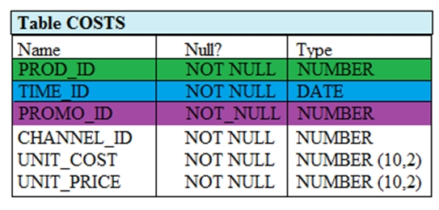  
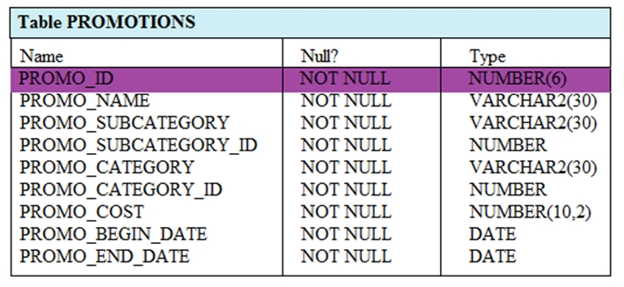  
Evaluate the following SQL statement:  
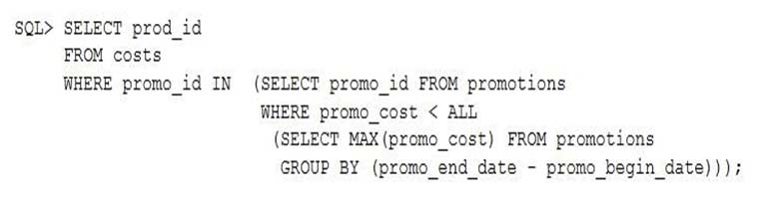  
What would be the outcome of the above SQL statement?

* A. It displays prod IDs in the promo with the lowest cost.
* B. It displays prod IDs in the promos with the lowest cost in the same time interval.
* C. It displays prod IDs in the promos with the highest cost in the same time interval.
* D. It displays prod IDs in the promos which cost less than the highest cost in the same time interval.

**Correct Answer:** *D* 

# Question #72

View the exhibit and examine the descriptions of the DEPT and LOCATIONS tables.  
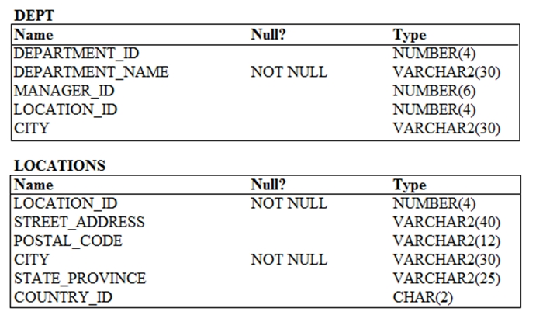  
You want to update the CITY column of the DEPT table for all the rows with the corresponding value in the CITY column of the LOCATIONS table for each department.  
Which SQL statement would you execute to accomplish the task?

* A. UPDATE dept d SET city = ALL (SELECT city FROM locations l WHERE d.location_id = l.location_id);
* B. UPDATE dept d SET city = (SELECT city FROM locations l) WHERE d.location_id = l.location_id;
* C. UPDATE dept d SET city = ANY (SELECT city FROM locations l)
* D. UPDATE dept d SET city = (SELECT city FROM locations l WHERE d.location_id = l.location_id);

**Correct Answer:** *D* 

# Question #73

The BOOKS_TRANSACTIONS table exists in your schema in this database.  
You execute this SQL statement when connected to your schema in your database instance.  
SQL> SELECT * FROM books_transactions ORDER BY 3;  
What is the result?

* A. The execution fails unless the numeral 3 in the ORDER BY clause is replaced by a column name.
* B. All table rows are displayed sorted in ascending order of the values in the third column.
* C. The first three rows in the table are displayed in the order that they are stored.
* D. Only the three rows with the lowest values in the key column are displayed in the order that they are stored.

**Correct Answer:** *B* 

# Question #74

Which statement is true about Data Manipulation Language (DML)?

* A. DML automatically disables foreign ley constraints when modifying primary key values in the parent table.
* B. Each DML statement forms a transaction by default.
* C. A transaction can consist of one or more DML statements.
* D. DML disables foreign key constraints when deleting primary key values in the parent table, only when the ON DELETE CASCADE option is set for the foreign key constraint.

**Correct Answer:** *C* 

# Question #75

View the exhibit and examine the structure of the PROMOTIONS table.  
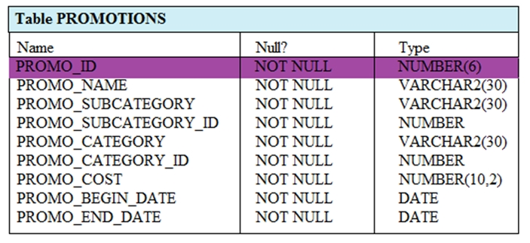  
You have to generate a report that displays the promo name and start date for all promos that started after the last promo in the "˜INTERNET' category.  
Which query would give you the required output?

* A. SELECT promo_name, promo_begin_date FROM promotions WHERE promo_begin_date> ALL (SELECT MAX (promo_begin_date) FROM promotions) AND promo_category= "˜INTERNET';
* B. SELECT promo_name, promo_begin_date FROM promotions WHERE promo_begin_date IN (SELECT promo_begin_date FROM promotions WHERE promo_category= "˜INTERNET');
* C. SELECT promo_name, promo_begin_date FROM promotions WHERE promo_begin_date > ALL (SELECT promo_begin_date FROM promotions WHERE promo_category = "˜INTERNET');
* D. SELECT promo_name, promo_begin_date FROM promotions WHERE promo_begin_date> ANY (SELECT promo_begin_date FROM promotions WHERE promo_category= "˜INTERNET');

**Correct Answer:** *C* 

# Question #76

View the Exhibit and examine the structure of the ORDER_ITEMS table.  
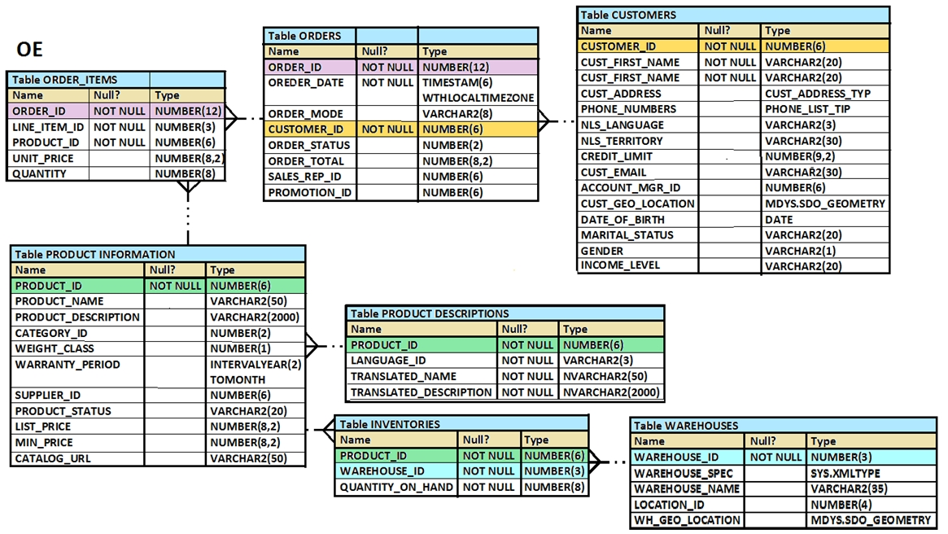  
Examine the following SQL statement:  
SELECT order_id, product_id, unit_price  
  
FROM order_items -  
WHERE unit_price =  
(SELECT MAX(unit_price)  
  
FROM order_items -  
GROUP BY order_id);  
You want to display the PRODUCT_ID of the product that has the highest UNIT_PRICE per ORDER_ID. What correction should be made in the above SQL statement to achieve this?

* A. Remove the GROUP BY clause from the subquery and place it in the main query
* B. Replace = with the >ANY operator
* C. Replace = with the >ALL operator
* D. Replace = with the IN operator

**Correct Answer:** *D* 

# Question #77

Evaluate the following CREATE TABLE command:  
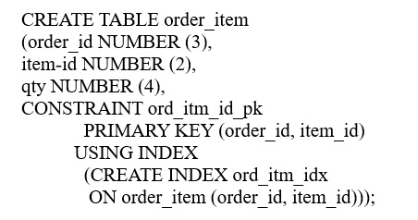  
Which statement is true regarding the above SQL statement?

* A. It would execute successfully and only ORD_ITM_IDX index would be created.
* B. It would give an error because the USING INDEX clause cannot be used on a composite primary.
* C. It would execute successfully and two indexes ORD_ITM_IDX and ORD_ITM_ID_PK would be created.
* D. It would give an error because the USING INDEX clause is not permitted in the CREATE TABLE command.

**Correct Answer:** *A* 

# Question #78

Using the CUSTOMERS table, you need to generate a report that shows 50% of each credit amount in each income level. The report should NOT show any repeated credit amounts in each income level.  
Which query would give the required result?

* A. SELECT cust_income_level || "˜ ' || cust_credit_limit * 0.50 AS "50% Credit Limit" FROM customers.
* B. SELECT DISTINCT cust_income_level || "˜ ' || cust_credit_limit * 0.50 AS "50% Credit Limit" FROM customers.
* C. SELECT DISTINCT cust_income_level, DISTINCT cust_credit_limit * 0.50 AS "50% Credit Limit" FROM customers.
* D. SELECT cust_income_level, DISTINCT cust_credit_limit * 0.50 AS "50% Credit Limit" FROM customers

**Correct Answer:** *B* 

# Question #79

Which three statements are true regarding the SQL WHERE and HAVING clauses?

* A. The HAVING clause conditions can have aggregating functions.
* B. The HAVING clause conditions can use aliases for the columns.
* C. The WHERE and HAVING clauses cannot be used together in a SQL statement.
* D. The WHERE clause is used to exclude rows before grouping data.
* E. The HAVING clause is used to exclude one or more aggregated results after grouping data.

**Correct Answer:** *ADE*

# Question #80

You need to display the date 11-oct-2007 in words as "˜Eleventh of October, Two Thousand Seven'.  
Which SQL statement would give the required result?

* A. SELECT TO_CHAR (TO_DATE ('11-oct-2007'), "˜fmDdthsp "of" Month, Year') FROM DUAL
* B. SELECT TO_CHAR ("˜11-oct-2007', "˜fmDdspth "of" Month, Year') FROM DUAL
* C. SELECT TO_CHAR (TO_DATE ("˜11-oct-2007'), "˜fmDdspth of month, year') FROM DUAL
* D. SELECT TO_DATE (TO_CHAR ('11-oct-2007'), "˜fmDdspth "of" Month, Year')) FROM DUAL

Correct Answer: *A*

# Question #81

Examine the commands used to create DEPARTMENT_DETAILS and COURSE_DETAILS:  
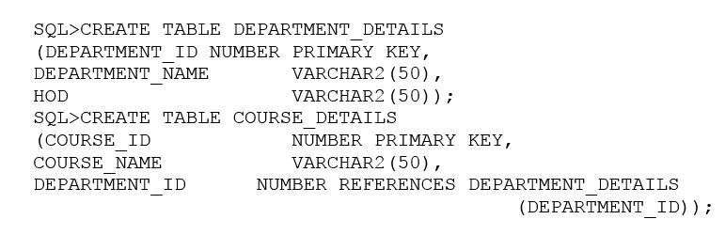  
You want to generate a report that shows all course IDs irrespective of whether they have corresponding department IDs or not but no department IDs if they do not have any courses.  
Which SQL statement must you use?

* A. SELECT course_id, department_id, FROM department_details d RIGHT OUTER JOIN course_details c USING (department_id)
* B. SELECT c.course_id, d.department_id FROM course_details c RIGHT OUTER JOIN .department_details d ON (c.depatrment_id=d.department_id)
* C. SELECT c.course_id, d.department_id FROM course_details c FULL OUTER JOIN department_details d ON (c.department_id=d. department_id)
* D. SELECT c.course_id, d.department_id FROM course_details c FULL OUTER JOIN department_details d ON (c.department_id<>d. department_id)

**Correct Answer:** *C* 

# Question #82

View the exhibit and examine the structure of the SALES, CUSTOMERS, PRODUCTS and TIMES tables.  
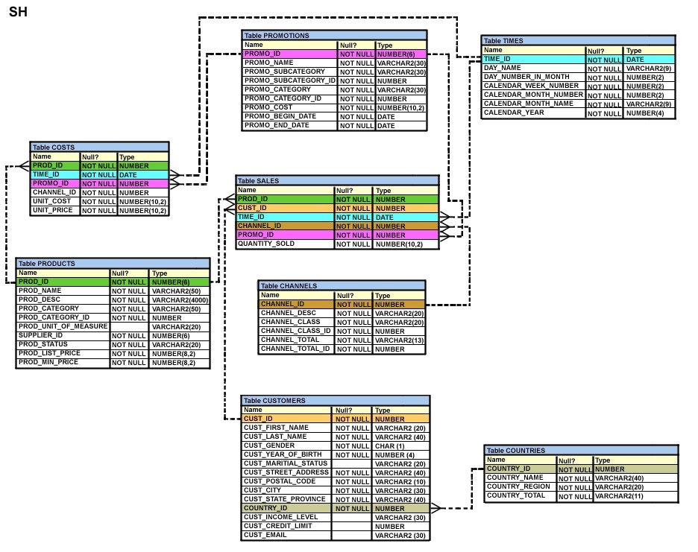  
The PROD_ID column is the foreign key in the SALES table referencing the PRODUCTS table.  
The CUST_ID and TIME_ID columns are also foreign keys in the SALES table referencing the CUSTOMERS and TIMES tables, respectively.  
Examine this command:  
CREATE TABLE new_sales (prod_id, cust_id, order_date DEFAULT SYSDATE)  
  
AS -  
SELECT prod_id, cust_id, time_id  
FROM sales;  
Which statement is true?

* A. The NEW_SALES table would get created and all the FOREIGN KEY constraints defined on the selected columns from the SALES table would be created on the corresponding columns in the NEW_SALES table.
* B. The NEW_SALES table would not get created because the column names in the CREATE TABLE command and the SELECT clause do not match.
* C. The NEW_SALES table would not get created because the DEFAULT value cannot be specified in the column definition.
* D. The NEW_SALES table would get created and all the NOT NULL constraints defined on the selected columns from the SALES table would be created on the corresponding columns in the NEW_SALES table.

**Correct Answer:** *D* 

# Question #83

View the Exhibit and examine the structure of the ORDERS table. The ORDER_ID column is the PRIMARY KEY in the ORDERS table.  
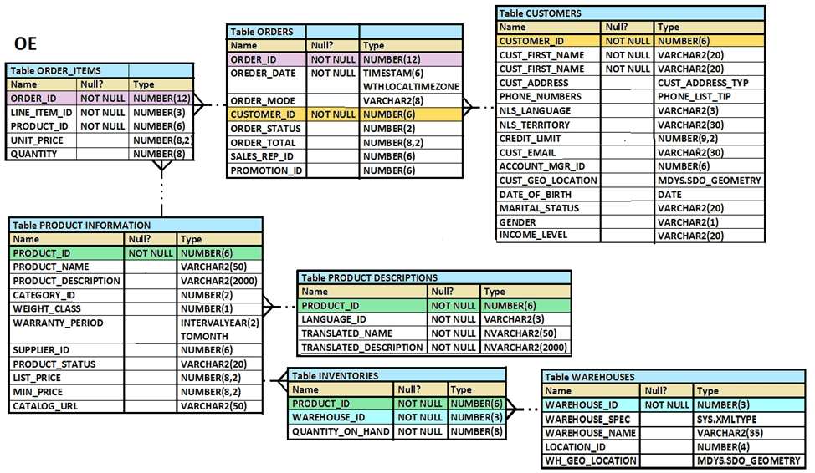  
Evaluate the following CREATE TABLE command:  
CREATE TABLE new_orders(ord_id, ord_date DEFAULT SYSDATE, cus_id)  
  
AS -  
SELECT order_id.order_date,customer_id  
FROM orders;  
Which statement is true regarding the above command?

* A. The NEW_ODRDERS table would not get created because the DEFAULT value cannot be specified in the column definition.
* B. The NEW_ODRDERS table would get created and only the NOT NULL constraint defined on the specified columns would be passed to the new table.
* C. The NEW_ODRDERS table would not get created because the column names in the CREATE TABLE command and the SELECT clause do not match.
* D. The NEW_ODRDERS table would get created and all the constraints defined on the specified columns in the ORDERS table would be passed to the new table.

**Correct Answer:** *B* 

# Question #84

Evaluate the following statement.  
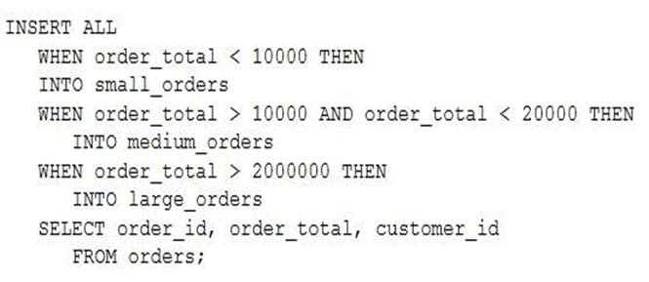  
Which statement is true regarding the evaluation of rows returned by the subquery in the INSERT statement?

* A. Each row is evaluated by the first WHEN clause and if the condition is false then the row would be evaluated by the subsequent when clauses.
* B. All rows are evaluated by all the three WHEN clauses.
* C. Each row is evaluated by the first WHEN clause and if the condition is true, then the row would be evaluated by the subsequent when clauses.
* D. The INSERT statement will return an error because the ELSE clause is missing.

**Correct Answer:** *B* 

# Question #85

Which two statements are true regarding the SQL GROUP BY clause?

* A. You can use a column alias in the GROUP BY clause.
* B. Using the WHERE clause after the GROUP BY clause excludes rows after creating groups.
* C. The GROUP BY clause is mandatory if you are using an aggregating function in the SELECT clause.
* D. Using the WHERE clause before the GROUP BY clause excludes rows before creating groups.
* E. If the SELECT clause has an aggregating function, then columns without an aggregating function in the SELECT clause should be included in the GROUP BY clause.

**Correct Answer:** *DE* 

# Question #86

You issue this command which succeeds:  
SQL> DROP TABLE products;  
Which three statements are true?

* A. All existing views and synonyms that refer to the table are invalidated but retained.
* B. Any uncommitted transaction in the session is committed.
* C. Table data and the table structure are deleted.
* ~~D. All the table's indexes if any exist, are invalidated but retained.~~
* E. Table data is deleted but the table structure is retained.

**Correct Answer:** *AC~~D~~* >> ABC  
<https://docs.oracle.com/database/121/SQLRF/statements_9003.htm#SQLRF01806>

<http://www.dba-oracle.com/t_concurrent_dml_ddl.htm>

# Question #87

You execute the SQL statement:  
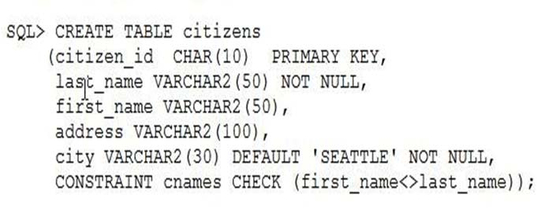  
What is the outcome?

* ~~A. It fails because the NOT NULL and DEFAULT options cannot be combined for the same column.~~
* B. It succeeds and CITY can contain only "˜SEATTLE' or null for all rows.
* C. It fails because the condition for the CNAMES constraint is not valid.
* D. It succeeds and an index is created for CITIZEN_ID.

**Correct Answer:** *~~A~~* >> D

# Question #88

Evaluate the following CREATE TABLE commands:  
  
CREATE_TABLE orders -  
(ord_no NUMBER (2) CONSTRAINT ord_pk PRIMARY KEY,  
ord_date DATE,  
cust_id NUMBER (4) );  
  
CREATE TABLE ord_items -  
(ord _no NUMBER (2),  
item_no NUMBER(3),  
qty NUMBER (3) CHECK (qty BETWEEEN 100 AND 200),  
expiry_date date CHECK (expiry_date> SYSDATE),  
CONSTRAINT it_pk PRIMARY KEY (ord_no, item_no),  
CONSTARAINT ord_fk FOREIGN KEY (ord_no) REFERENCES orders (ord_no) );  
The above command fails when executed. What could be the reason?

* A. SYSDATE cannot be used with the CHECK constraint.
* B. The BETWEEN clause cannot be used for the CHECK constraint.
* C. The CHECK constraint cannot be placed on columns having the DATE data type.
* D. ORD_NO and ITEM_NO cannot be used as a composite primary key because ORD_NO is also the FOREIGN KEY.

**Correct Answer:** *A*   
<https://docs.oracle.com/database/121/SQLRF/clauses002.htm#SQLRF52180>

# Question #89

Examine the structure of the PROGRAMS table:  
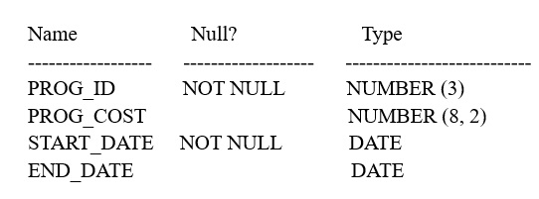  
Which two SQL statements would execute successfully?

* A. SELECT NVL (ADD_MONTHS (END_DATE,1) SYSDATE) FROM programs;
* ~~B. SELECT TO_DATE (NVL (SYSDATE-END_DATE, SYSDATE)) FROM programs;~~
* C. SELECT NVL (MONTHS_BETWEEN (start_date, end_date), "˜Ongoing') FROM programs;
* D. SELECT NVL (TO_CHAR (MONTHS_BETWEEN (start-date, end_date)), "˜Ongoing') FROM programs

**Correct Answer:** *~~B~~D* >> AD

# Question #90

View the Exhibit and examine the structure of the CUSTOMERS table.  
  
Using the CUSTOMERS table, you must generate a report that displays a credit limit increase of 15% for all customers.  
Customers with no credit limit should have "Not Available" displayed.  
Which SQL statement would produce the required result?

* A. SELECT NVL(TO_CHAR(cust_credit_limit*.15), "˜Not Available') "NEW CREDIT" FROM customers;
* B. SELECT TO_CHAR(NVL(cust_credit_limit*.15, "˜Not Available')) "NEW CREDIT" FROM customers;
* C. SELECT NVL(cust_credit_limit*.15, "˜Not Available') "NEW CREDIT" FROM customers;
* D. SELECT NVL(cust_credit_limit, "˜Not Available')*.15 "NEW CREDIT" FROM customers;

Correct Answer: *A*

# Question #91

Examine these SQL statements that are executed in the given order:  
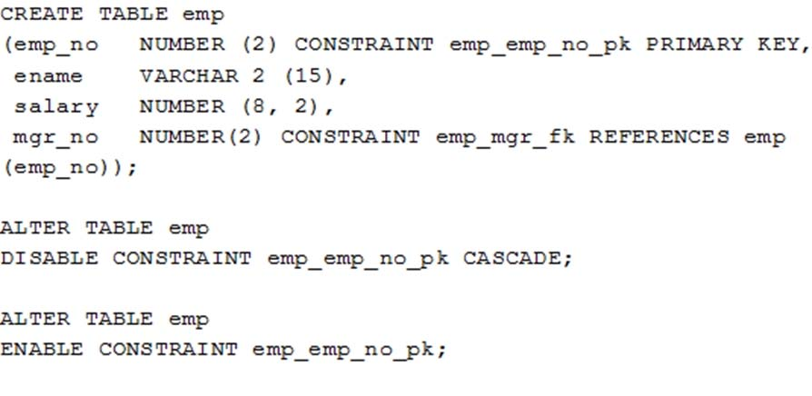  
What will be the status of the foreign key EMP_MGR_FK?

* A. It will be enabled and immediate.
* B. It will be enabled and deferred.
* C. It will remain disabled and can be re-enabled manually.
* D. It will remain disabled and can be enabled only by dropping the foreign key constraint and re-creating it.

**Correct Answer:** *C* 

# Question #92

View the Exhibit and examine the structure in the EMPLOYEES tables.  
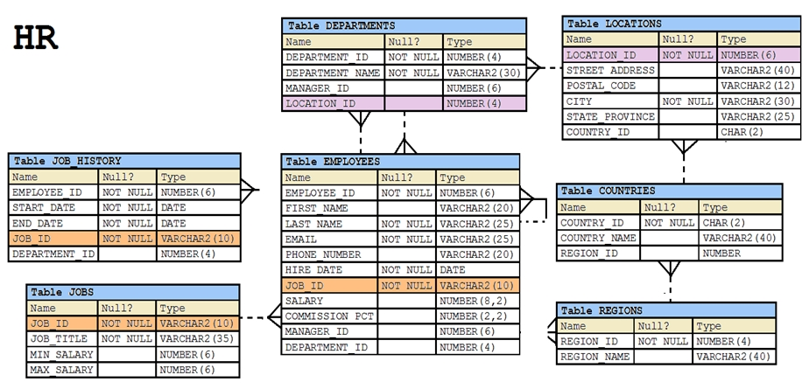  
Evaluate the following SQL statement:  
SELECT employee_id, department_id  
  
FROM employees -  
WHERE department_id= 50 ORDER BY department_id  
  
UNION -  
SELECT employee_id, department_id  
  
FROM employees -  
  
WHERE department_id=90 -  
  
UNION -  
SELECT employee_id, department_id  
  
FROM employees -  
WHERE department_id=10;  
  
What would be the outcome of the above SQL statement?

* A. The statement would not execute because the positional notation instead of the column name should be used with the ORDER BY clause.
* B. The statement would execute successfully and display all the rows in the ascending order of DEPARTMENT_ID.
* C. The statement would execute successfully but it will ignore the ORDER BY clause and display the rows in random order.
* D. The statement would not execute because the ORDER BY clause should appear only at the end of the SQL statement, that is, in the last SELECT statement.

**Correct Answer:** *D* 

# Question #93

View the Exhibit and examine the description for the SALES and CHANNELS tables. (Choose the best answer.)  
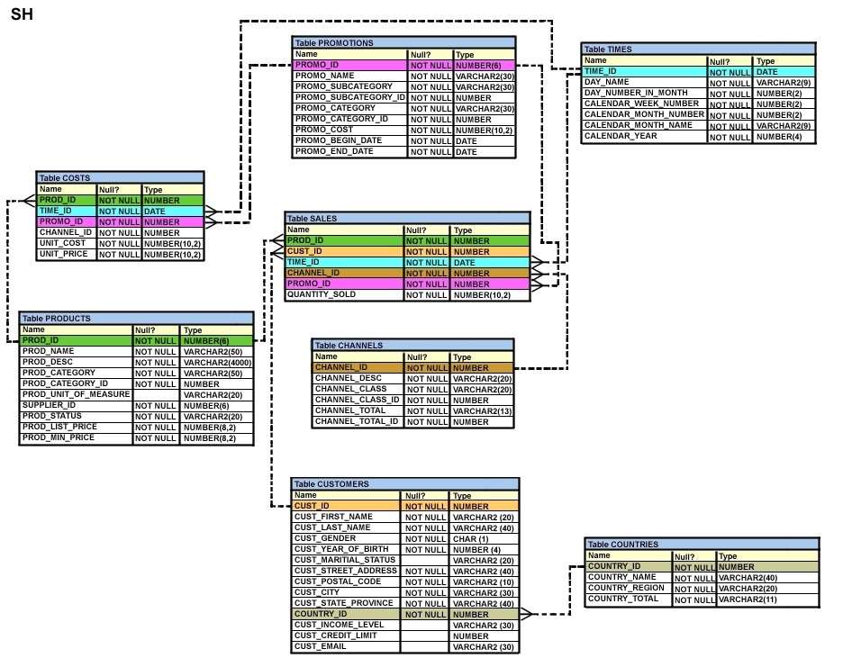  
  
You issued this SQL statement:  
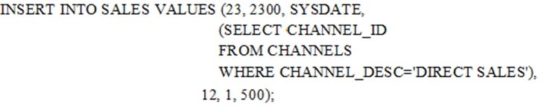  
Which statement is true regarding the result?

* A. The statement will fail because the subquery in the VALUES clause is not enclosed within single quotation marks.
* B. The statement will fail because a subquery cannot be used in a VALUES clause.
* C. The statement will execute and a new row will be inserted in the SALES table.
* D. The statement will fail because the VALUES clause is not required with the subquery.

**Correct Answer:** *C* 

# Question #94

View the Exhibit and examine the description of the ORDERS table.  
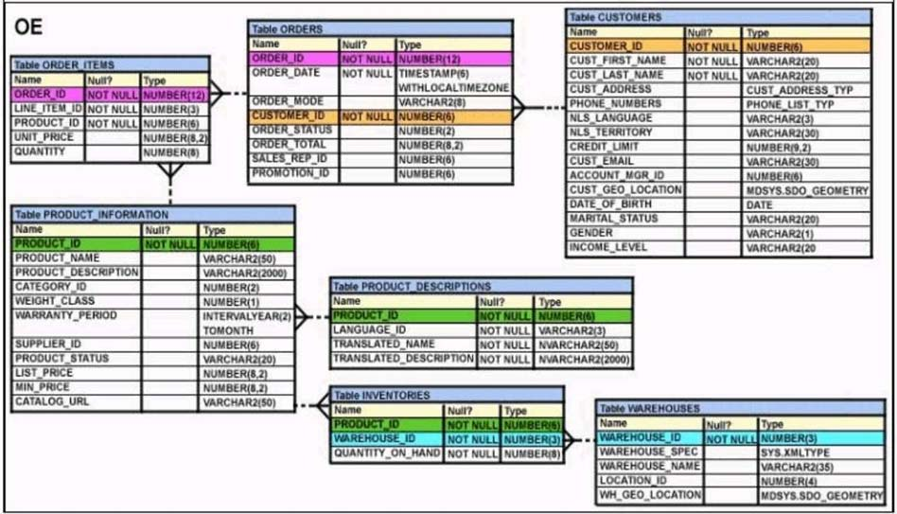  
Which two WHERE clause conditions demonstrate the correct usage of conversion functions? (Choose two.)

* A. WHERE order_date_IN ( TO_DATE('OCT 21 2003','MON DD YYYY'), TO_CHAR('NOV 21 2003','MON DD YYYY') )
* B. WHERE order_date > TO_CHAR(ADD_MONTHS(SYSDATE,6),'MON DD YYYY')
* C. WHERE TO_CHAR(order_date,'MON DD YYYY') = 'JAN 20 2003'
* D. WHERE order_date > TO_DATE('JUL 10 2006','MON DD YYYY')

**Correct Answer:** *CD* 

# Question #95

Which three arithmetic operations can be performed on a column by using a SQL function that is built into Oracle database? (Choose three.)

* A. Finding the lowest value
* B. Finding the quotient
* C. Raising to a power
* D. Subtraction
* E. Addition

**Correct Answer:** *ACE* 

# Question #96

View the Exhibit and examine the structure of the EMPLOYEES and JOB_HISTORY tables.  
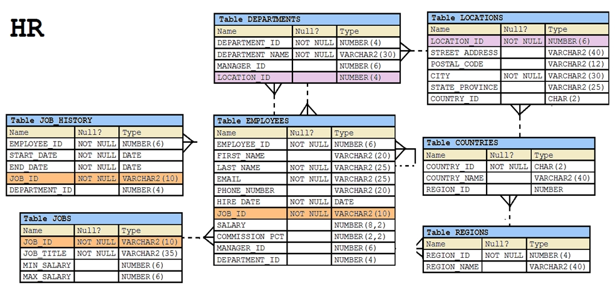  
Examine this query which must select the employee IDs of all the employees who have held the job SA_MAN at any time during their employment.  
  
SELECT EMPLOYEE_ID -  
  
FROM EMPLOYEES -  
WHERE JOB_ID = 'SA_MAN'  
-------------------------------------  
  
SELECT EMPLOYEE_ID -  
  
FROM JOB_HISTORY -  
WHERE JOB_ID = 'SA_MAN';  
Choose two correct SET operators which would cause the query to return the desired result.

* A. UNION
* B. MINUS
* C. INTERSECT
* D. UNION ALL

**Correct Answer:** *AD* 

# Question #97

You must create a SALES table with these column specifications and data types: (Choose the best answer.)  
  
SALESID: Number -  
  
STOREID: Number -  
  
ITEMID: Number -  
QTY: Number, should be set to 1 when no value is specified  
SLSDATE: Date, should be set to current date when no value is specified  
PAYMENT: Characters up to 30 characters, should be set to CASH when no value is specified  
Which statement would create the table?

* A. CREATE TABLE sales( salesid NUMBER(4), storeid NUMBER(4), itemid NUMBER(4), qty NUMBER DEFAULT = 1, slsdate DATE DEFAULT SYSDATE, payment VARCHAR2(30) DEFAULT = "CASH");
* B. CREATE TABLE sales( salesid NUMBER(4), storeid NUMBER(4), itemid NUMBER(4), qty NUMBER DEFAULT 1, slsdate DATE DEFAULT 'SYSDATE', payment VARCHAR2(30) DEFAULT CASH);
* C. CREATE TABLE sales( salesid NUMBER(4), storeid NUMBER(4), itemid NUMBER(4), qty NUMBER DEFAULT = 1, slsdate DATE DEFAULT SYSDATE, payment VARCHAR2(30) DEFAULT = "CASH");
* D. CREATE TABLE sales( salesid NUMBER(4), storeid NUMBER(4), itemid NUMBER(4), qty NUMBER DEFAULT 1, slsdate DATE DEFAULT SYSDATE, payment VARCHAR2(30) DEFAULT 'CASH');

**Correct Answer:** *D* 

# Question #98

View the Exhibit and examine the details of the PRODUCT_INFORMATION table.  
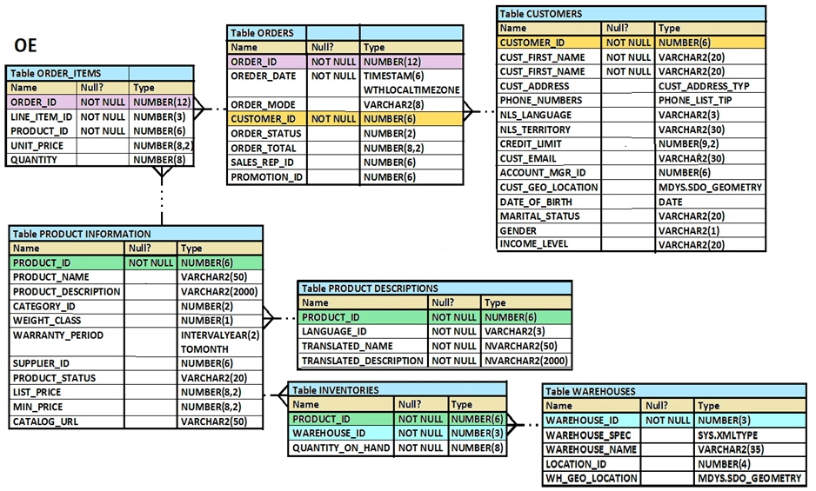  
Evaluate this SQL statement:  
SELECT TO_CHAR (list_price, '$9,999')  
From product_information;  
Which two statements are true regarding the output? (Choose two.)

* A. A row whose LIST_PRICE column contains value 11235.90 would be displayed as #######.
* B. A row whose LIST_PRICE column contains value 1123.90 would be displayed as $1,123.
* C. A row whose LIST_PRICE column contains value 1123.90 would be displayed as $1,124.
* D. A row whose LIST_PRICE column contains value 11235.90 would be displayed as $1,123.

**Correct Answer:** *AC* 

# Question #99

Which statement is true about SQL query processing in an Oracle database instance? (Choose the best answer.)

* A. During parsing, a SQL statement containing literals in the WHERE clause that has been executed by any session and which is cached in memory, is always reused for the current execution.
* B. During execution, the Oracle server may read data from storage if the required data is not already in memory.
* C. During row source generation, rows that satisfy the query are retrieved from the database and stored in memory.
* D. During optimization, execution plans are formulated based on the statistics gathered by the database instance, and the lowest cost plan is selected for execution.

**Correct Answer:** *B*   
<https://docs.oracle.com/database/121/TGSQL/tgsql_sqlproc.htm#TGSQL178>

# Question #100

Examine the structure of the ORDERS table: (Choose the best answer.)  
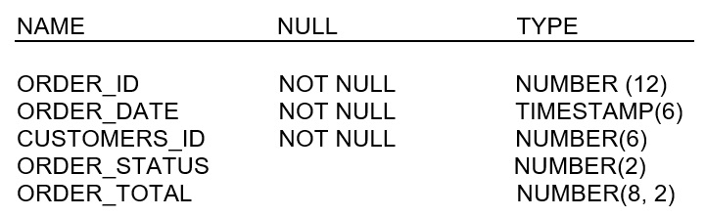  
You want to find the total value of all the orders for each year and issue this command:  
SQL> SELECT TO_CHAR(order_date,'rr'), SUM(order_total) FROM orders  
GROUP BY TO_CHAR(order_date, 'yyyy');  
Which statement is true regarding the result?

* A. It executes successfully but does not give the correct output.
* B. It executes successfully and gives the correct output.
* C. It returns an error because the TO_CHAR function is not valid.
* D. It return an error because the datatype conversion in the SELECT list does not match the data type conversion in the GROUP BY clause.

Correct Answer: *D*

# Question #101

View the Exhibit and examine the structure of the ORDER_ITEMS table.  
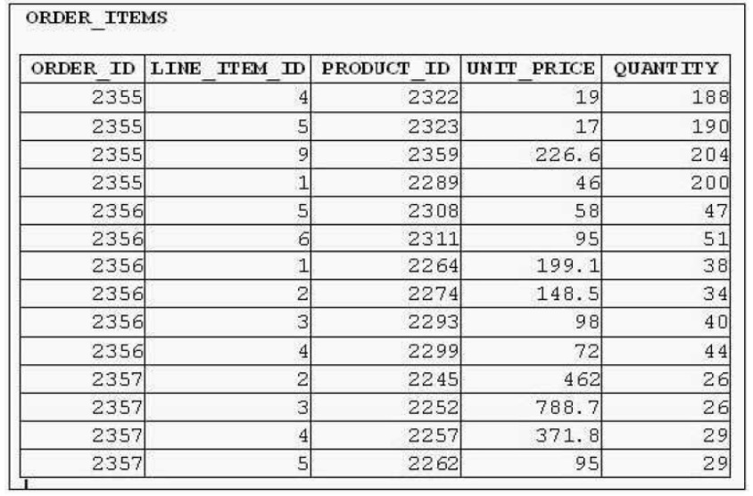  
You must select the ORDER_ID of the order that has the highest total value among all the orders in the ORDER_ITEMS table.  
Which query would produce the desired result?

* A. SELECT order_id FROM order_items GROUP BY order_id HAVING SUM(unit_price*quantity) = (SELECT MAX(SUM(unit_price*quantity)) FROM order_items GROUP BY order_id);
* B. SELECT order_id FROM order_items WHERE(unit_price*quantity) = (SELECT MAX(unit_price*quantity) FROM order_items) GROUP BY order_id;
* C. SELECT order_id FROM order_items WHERE(unit_price*quantity) = MAX(unit_price*quantity) GROUP BY order_id;
* D. SELECT order_id FROM order_items WHERE (unit_price*quantity) = (SELECT MAX(unit_price*quantity) FROM order_items GROUP BY order_id)

**Correct Answer:** *A* 

# Question #102

View the Exhibit and examine the structure of the EMP table which is not partitioned and not an index-organized table. (Choose two.)  
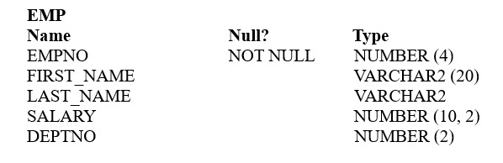  
Evaluate this SQL statement:  
  
ALTER TABLE emp -  
DROP COLUMN first_name;  
Which two statements are true?

* A. The FIRST_NAME column can be dropped even if it is part of a composite PRIMARY KEY provided the CASCADE option is added to the SQL statement.
* B. The FIRST_NAME column would be dropped provided at least one column remains in the table.
* C. The FIRST_NAME column would be dropped provided it does not contain any data.
* D. The drop of the FIRST_NAME column can be rolled back provided the SET UNUSED option is added to the SQL statement.

**Correct Answer:** *B* 

# Question #103

View the exhibit and examine the structure and data in the INVOICE table.  
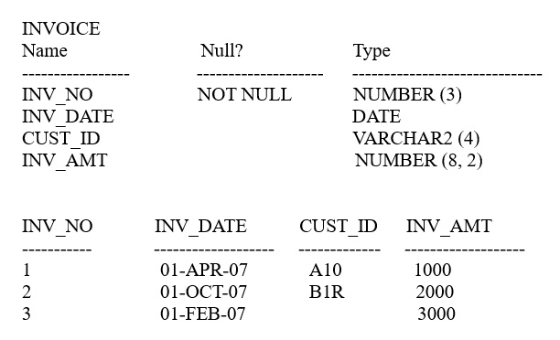  
Which two SQL statements would execute successfully? (Choose two.)

* A. SELECT MAX(AVG(SYSDATE -inv_date)) FROM invoice
* B. SELECT AVG(inv_date) FROM invoice
* C. SELECT MAX(inv_date), MIN(cust_id) FROM invoice
* D. SELECT AVG( inv_date -SYSDATE), AVG(inv_amt) FROM invoice

**Correct Answer:** *CD* 

# Question #104

Which two statements best describe the benefits of using the WITH clause? (Choose two.)

* A. It can improve the performance of a large query by storing the result of a query block having the WITH clause in the session's temporary tablespace.
* B. It enables sessions to reuse the same query block in a SELECT statement, if it occurs more than once in a complex query.
* C. It enables sessions to store a query block permanently in memory and use it to create complex queries.
* D. It enables sessions to store the results of a query permanently.

**Correct Answer:** *AB*   
<https://oracle-base.com/articles/misc/with-clause>

<https://asktom.oracle.com/pls/asktom/asktom.search?tag=oracle-12c-sql-query-with-inline-plsql-function>

# Question #105

Which three statements are true regarding subqueries? (Choose three.)

* A. The ORDER BY Clause can be used in a subquery.
* B. A subquery can be used in the FROM clause of a SELECT statement.
* C. If a subquery returns NULL, the main query may still return rows.
* D. A subquery can be placed in a WHERE clause, a GROUP BY clause, or a HAVING clause.
* E. Logical operators, such as AND, OR and NOT, cannot be used in the WHERE clause of a subquery.

**Correct Answer:** *ABC* 

# Question #106

Which two statements are true regarding single row functions? (Choose two.)

* A. MOD : returns the quotient of a division.
* B. TRUNC : can be used with NUMBER and DATE values.
* C. CONCAT : can be used to combine any number of values.
* D. SYSDATE : returns the database server current date and time.
* E. INSTR : can be used to find only the first occurrence of a character in a string.
* F. TRIM : can be used to remove all the occurrences of a character from a string.

**Correct Answer:** *BD* 

# Question #107

View the Exhibit and examine the structure of the ORDERS table.  
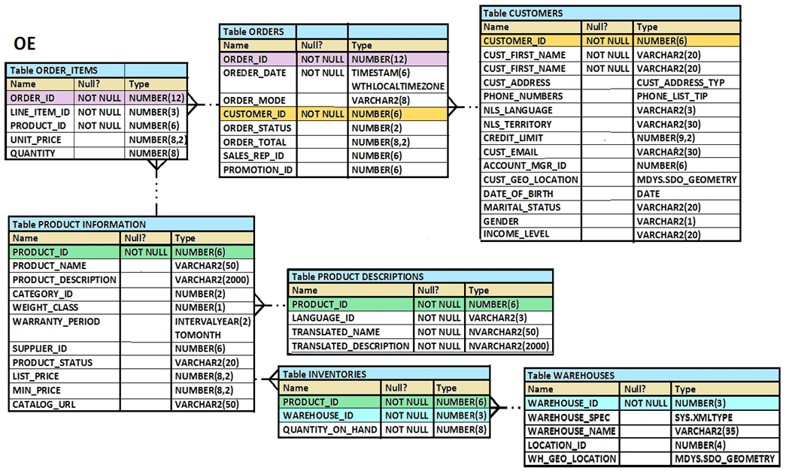  
You must select ORDER_ID and ORDER_DATE for all orders that were placed after the last order placed by CUSTOMER_ID 101.  
Which query would give you the desired result?

* A. SELECT order_id, order_date FROM orders WHERE order_date > ANY (SELECT order_date FROM orders WHERE customer_id = 101);
* B. SELECT order_id, order_date FROM orders WHERE order_date > ALL (SELECT MAX(order_date) FROM orders ) AND customer_id = 101;
* C. SELECT order_id, order_date FROM orders WHERE order_date > ALL (SELECT order_date FROM orders WHERE customer_id = 101);
* D. SELECT order_id, order_date FROM orders WHERE order_date > IN (SELECT order_date FROM orders WHERE customer_id = 101);

**Correct Answer:** *C* 

# Question #108

You must display details of all users whose username contains the string 'ch_'. (Choose the best answer.)  
Which query generates the required output?

* A. SELECT * FROM users Where user_name LIKE '%ch_';
* ~~B. SELECT * FROM users Where user_name LIKE '%ch_%'ESCAPE'%';~~
* C. SELECT * FROM users Where user_name LIKE 'ch\_%' ESCAPE '_';
* D. SELECT * FROM users Where user_name LIKE '%ch\_%' ESCAPE '\';

**Correct Answer:** *~~B~~* >> D  
<http://www.dba-oracle.com/tips_oracle_escape_characters.htm>

<http://www.dba-oracle.com/t_special_characters_like_sql_query.htm>

# Question #109

Which three statements are true regarding the usage of the WITH clause in complex correlated subqueries? (Choose three.)

* A. It can be used only with the SELECT clause.
* B. The WITH clause can hold more than one query.
* C. If the query block name and the table name are the same, then the table name takes precedence.
* D. The query name in the WITH clause is visible to other query blocks in the WITH clause as well as to the main query block

**Correct Answer:** *ABD*   
<https://asktom.oracle.com/pls/apex/f?p=100:11:0::::P11_QUESTION_ID:9535447900346915417>

# Question #110

View the Exhibit and examine the data in the PRODUCTS table.  
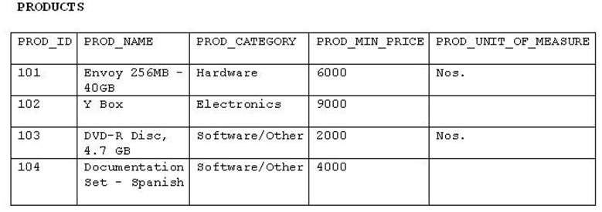  
You must display product names from the PRODUCTS table that belong to the 'Software/other' category with minimum prices as either $2000 or $4000 and with no unit of measure.  
You issue this query:  
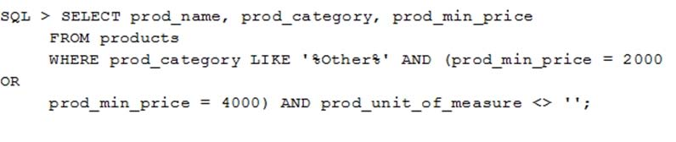  
Which statement is true?

* A. It executes successfully but returns no result.
* B. It executes successfully and returns the required result.
* C. It generates an error because the condition specified for PROD_UNIT_OF_MEASURE is not valid.
* D. It generates an error because the condition specified for the PROD_CATEGORY column is not valid.

Correct Answer: *A*

<https://www.techonthenet.com/oracle/questions/empty_null.php>

# Question #111

Examine the structure of the EMPLOYEES table.  
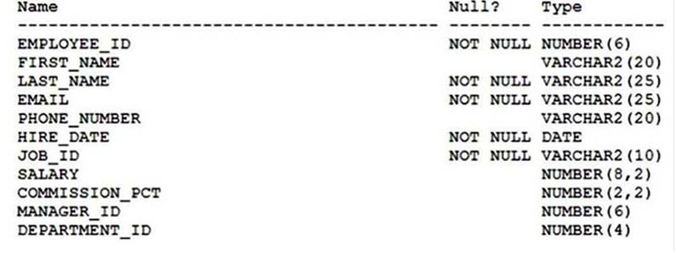  
  
You must display the maximum and minimum salaries of employees hired 1 year ago.  
Which two statements would provide the correct output? (Choose two.)

* A. SELECT MIN(Salary) minsal, MAX(salary) maxsal FROM employees WHERE hire_date < SYSDATE-365 GROUP BY MIN(salary), MAX(salary);
* B. SELECT minsal, maxsal FROM (SELECT MIN(salary) minsal, MAX(salary) maxsal FROM employees WHERE hire_date < SYSDATE-365) GROUP BY maxsal, minsal;
* C. SELECT minsal, maxsal FROM (SELECT MIN(salary) minsal, MAX(salary) maxsal FROM employees WHERE hire_date < SYSDATE-365 GROUP BY MIN(salary), MAX(salary));
* D. SELECT MIN(Salary), MAX(salary) FROM (SELECT salary FROM employees WHERE hire_date < SYSDATE-365);

**Correct Answer:** *BD* 

# Question #112

Which two statements are true regarding subqueries? (Choose two.)

* A. A subquery can appear on either side of a comparison operator.
* B. Only two subqueries can be placed at one level.
* C. A subquery can retrieve zero or more rows.
* D. A subquery can be used only in SQL query statements.
* E. There is no limit on the number of subquery levels in the WHERE clause of a SELECT statement.

**Correct Answer:** *AC* 

# Question #113

Which two statements are true regarding the execution of the correlated subqueries? (Choose two.)

* A. The nested query executes after the outer query returns the row.
* B. The nested query executes first and then the outer query executes.
* C. The outer query executes only once for the result returned by the inner query.
* D. Each row returned by the outer query is evaluated for the results returned by the inner query.

**Correct Answer:** *AD* 

# Question #114

Which two statement are true regarding table joins available in the Oracle Database server? (Choose two.)

* A. You can use the ON clause to specify multiple conditions while joining tables.
* B. You can explicitly provide the join condition with a NATURAL JOIN.
* C. You can use the JOIN clause to join only two tables.
* D. You can use the USING clause to join tables on more than one column.

**Correct Answer:** *AD* 

# Question #115

You issued this command:  
SQL > DROP TABLE employees;  
Which three statements are true? (Choose three.)

* A. Sequences used in the EMPLOYEES table become invalid.
* B. If there is an uncommitted transaction in the session, it is committed.
* C. All indexes and constraints defined on the table being dropped are also dropped.
* D. The space used by the EMPLOYEES table is always reclaimed immediately.
* E. The EMPLOYEES table can be recovered using the ROLLBACK command.
* F. The EMPLOYEES table may be moved to the recycle bin.

**Correct Answer:** *BCF* 

# Question #116

View the exhibit and examine the data in the PROJ_TASK_DETAILS table. (Choose the best answer.)  
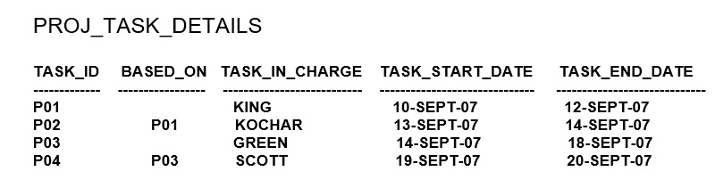  
The PROJ_TASK_DETAILS table stores information about project tasks and the relation between them.  
The BASED_ON column indicates dependencies between tasks.  
Some tasks do not depend on the completion of other tasks.  
You must generate a report listing all task IDs, the task ID of any task upon which it depends and the name of the employee in charge of the task upon which it depends.  
Which query would give the required result?

* A. SELECT p.task_id, p.based_on, d.task_in_charge FROM proj_task_details p JOIN proj_task_details d ON (p.task_id = d.task_id);
* B. SELECT p.task_id, p.based_on, d.task_in_charge FROM proj_task_details p FULL OUTER JOIN proj_task_details d ON (p.based_on = d.task_id);
* C. SELECT p.task_id, p.based_on, d.task_in_charge FROM proj_task_details p JOIN proj_task_details d ON (p.based_on = d.task_id);
* D. SELECT p.task_id, p.based_on, d.task_in_charge FROM proj_task_details p LEFT OUTER JOIN proj_task_details d ON (p.based_on = d.task_id);

**Correct Answer:** *D* 

# Question #117

View the Exhibit and examine the structure of the SALES and PRODUCTS tables. (Choose two.)  
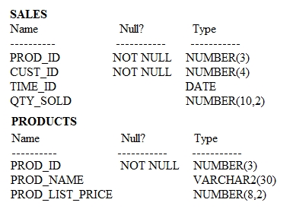  
In the SALES table, PROD_ID is the foreign key referencing PROD_ID in the PRODUCTS table. You must list each product ID and the number of times it has been sold.  
Examine this query which is missing a JOIN operator:  
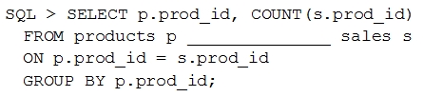  
Which two JOIN operations can be used to obtain the required output?

* A. FULL OUTER JOIN
* B. JOIN
* C. LEFT OUTER JOIN
* D. RIGHT OUTER JOIN

**Correct Answer:** *AC*   
<https://docs.oracle.com/database/121/SQLRF/functions046.htm#SQLRF00624>

# Question #118

View the exhibit and examine the description of the EMPLOYEES table. (Choose two.)  
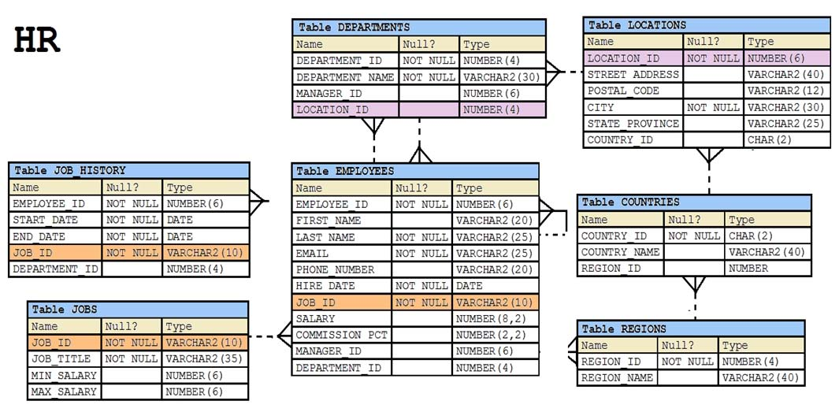  
You executed this SQL statement:  
SELECT first_name, department_id, salary  
  
FROM employees -  
ORDER BY department_id, first_name, salary desc;  
Which two statements are true regarding the result? (Choose two.)

* A. The values in the SALARY column would be returned in descending order for all employees having the same value in the DEPARTMENT_ID and FIRST_NAME column.
* B. The values in the FIRST_NAME column would be returned in ascending order for all employees having the same value in the DEPARTMENT_ID column.
* C. The values in the SALARY column would be returned in descending order for all employees having the same value in the DEPARTMENT_ID column.
* D. The values in all columns would be returned in descending order.
* E. The values in the FIRST_NAME column would be returned in descending order for all employees having the same value in the DEPARTMENT_ID column.

**Correct Answer:** *AB* 

# Question #119

Examine the structure of the SALES table.  
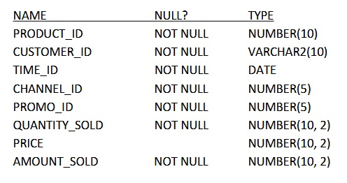  
Examine this statement:  
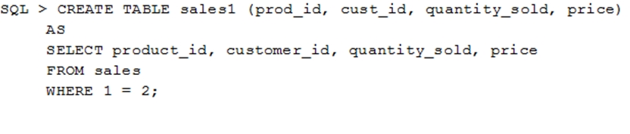  
Which two statements are true about the SALES1 table? (Choose two.)

* A. It will not be created because the column-specified names in the SELECT and CREATE TABLE clauses do not match.
* B. It will have NOT NULL constraints on the selected columns which had those constraints in the SALES table.
* C. It will not be created because of the invalid WHERE clause.
* D. It is created with no rows.
* E. It has PRIMARY KEY and UNIQUE constraints on the selected columns which had those constraints in the SALES table.

**Correct Answer:** *BD* 

# Question #120

Examine this SELECT statement and view the Exhibit to see its output:  
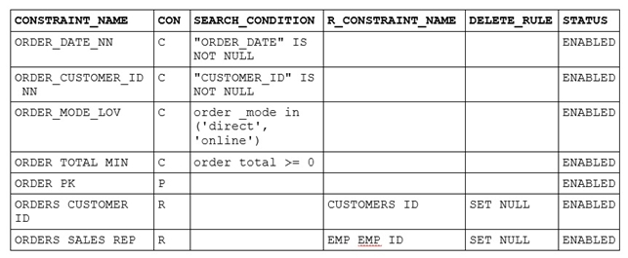  
SELECT constraints_name, constraints_type, search_condition, r_constraints_name, delete_rule, status,  
  
FROM user_constraints -  
WHERE table_name = 'ORDERS';  
Which two statements are true about the output? (Choose two.)

* A. The DELETE_RULE column indicates the desired state of related rows in the child table when the corresponding row is deleted from the parent table.
* B. The R_CONSTRAINT_NAME column contains an alternative name for the constraint.
* C. In the second column, 'c' indicates a check constraint.
* D. The STATUS column indicates whether the table is currently in use.

Correct Answer: *AC*

<https://docs.oracle.com/en/database/oracle/oracle-database/12.2/refrn/ALL_CONSTRAINTS.html#GUID-9C96DA92-CFE0-4A3F-9061-C5ED17B43EFE>

# Question #121

Which two statements are true regarding constraints? (Choose two.)

* A. All constraints can be defined at the column level and at the table level.
* B. A constraint can be disabled even if the constraint column contains data.
* C. A column with the UNIQUE constraint can contain NULLS.
* D. A foreign key column cannot contain NULLS.
* E. A constraint is enforced only for INSERT operations.

**Correct Answer:** *BC*   
<https://docs.oracle.com/database/121/SQLRF/clauses002.htm#SQLRF52180>

# Question #122

Which two statements are true regarding working with dates? (Choose two.)

* A. The RR date format automatically calculates the century from the SYSDATE function but allows the session user to enter the century.
* B. The RR date format automatically calculates the century from the SYSDATE function and does not allow a session user to enter the century.
* C. The default internal storage of dates is in character format.
* D. The default internal storage of dates is in numeric format.

**Correct Answer:** *AD*   
<https://asktom.oracle.com/pls/apex/f?p=100:11:0::::P11_QUESTION_ID:9536366100346454084#:~:text=The%20RR%20datetime%20format%20element%20is%20similar%20to%20the%20YY,two%20digits%20of%20the%20year>.

# Question #123

View the Exhibit and examine the structure of ORDERS and CUSTOMERS tables. (Choose the best answer.)  
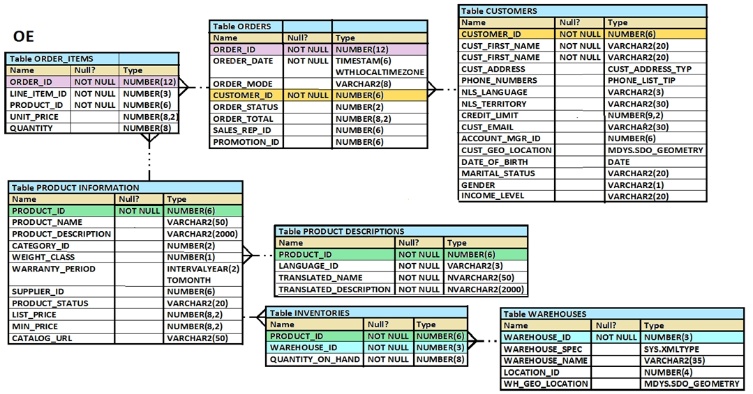  
You executed this UPDATE statement:  
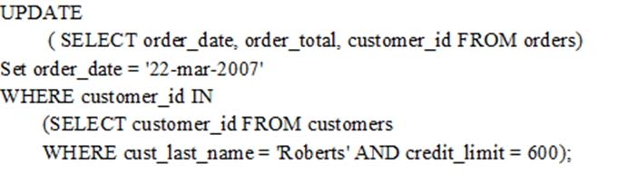  
Which statement is true regarding the execution?

* A. It would not execute because a subquery cannot be used in the WHERE clause of an UPDATE statement.
* B. It would not execute because two tables cannot be referenced in a single UPDATE statement.
* C. It would execute and restrict modifications to the columns specified in the SELECT statement.
* D. It would not execute because a SELECT statement cannot be used in place of a table name.

**Correct Answer:** *C* 

# Question #124

View the Exhibit and examine the structure of the PRODUCTS table.  
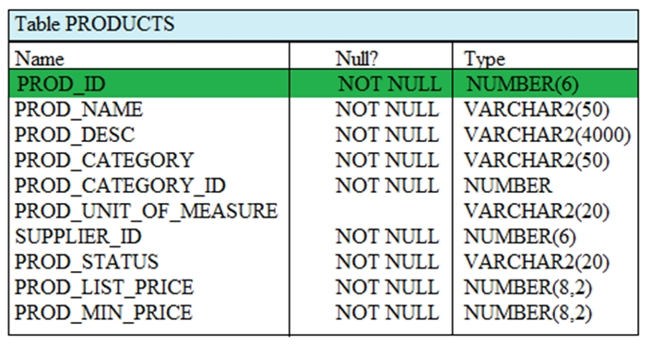  
You must display the category with the maximum number of items.  
You issue this query:  
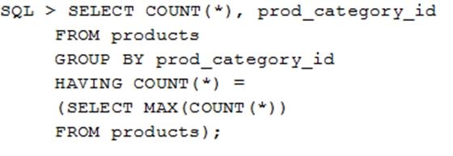  
What is the result?

* A. It generates an error because = is not valid and should be replaced by the IN operator.
* B. It executes successfully but does not give the correct output.
* C. It executes successfully and gives the correct output.
* D. It generate an error because the subquery does not have a GROUP BY clause.

**Correct Answer:** *D* 

# Question #125

Examine the structure of the MEMBERS table: (Choose the best answer.)  
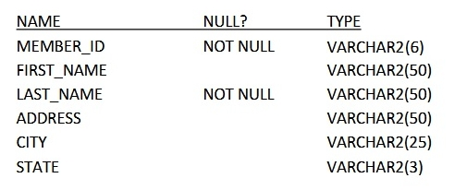  
Examine the SQL statement:  
SQL > SELECT city, last_name LNAME FROM MEMBERS ORDER BY 1, LNAME DESC;  
What would be the result execution?

* A. It displays all cities in descending order, within which the last names are further sorted in descending order.
* B. It fails because a column alias cannot be used in the ORDER BY clause.
* C. It fails because a column number and a column alias cannot be used together in the ORDER BY clause.
* D. It displays all cities in ascending order, within which the last names are further sorted in descending order.

**Correct Answer:** *D* 

# Question #126

View and Exhibit and examine the structure and data in the INVOICE table.  
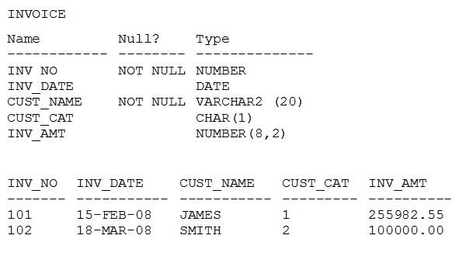  
Which two statements are true regarding data type conversion in query expressions? (Choose two.)

* A. inv_date = '15-february-2008' :uses implicit conversion
* B. inv_amt = '0255982' : requires explicit conversion
* C. inv_date > '01-02-2008' : uses implicit conversion
* D. CONCAT(inv_amt, inv_date) : requires explicit conversion
* E. inv_no BETWEEN '101' AND '110' : uses implicit conversion

**Correct Answer:** *AE* 

# Question #127

Examine the structure of the EMPLOYEES table.  
  
You must display the details of employees who have manager with MANAGER_ID 100, who were hired in the past 6 months and who have salaries greater than  
10000.  
Which query would retrieve the required result?

* A. SELECT last_name, hire_date, salary FROM employees WHERE salary > 10000 UNION ALL SELECT last_name, hire_date, salary FROM employees WHERE manager_ID = (SELECT employee_id FROM employees WHERE employee_id = 100) INTERSECT SELECT last_name, hire_date, salary FROM employees WHERE hire_date > SYSDATE- 180;
* B. SELECT last_name, hire_date, salary FROM employees WHERE manager_id = (SELECT employee_id FROM employees WHERE employee_id = 100) UNION ALL (SELECT last_name, hire_date, salary FROM employees WHERE hire_date > SYSDATE -180 INTERSECT SELECT last_name, hire_date, salary FROM employees WHERE salary > 10000);
* C. SELECT last_name, hire_date, salary FROM employees WHERE manager_id = (SELECT employee_id FROM employees WHERE employee_id = '100') UNION SELECT last_name, hire_date, salary FROM employees WHERE hire_date > SYSDATE -180 INTERSECT SELECT last_name, hire_date, salary FROM employees WHERE salary > 10000;
* D. (SELECT last_name, hire_date, salary FROM employees WHERE salary > 10000 UNION ALL SELECT last_name, hire_date, salary FROM employees WHERE manager_ID = (SELECT employee_id FROM employees WHERE employee_id = 100)) UNION SELECT last_name, hire_date, salary FROM employees WHERE hire_date > SYSDATE -180;

**Correct Answer:** *C* 

# Question #128

Examine the structure of the PROMOTIONS table: (Choose the best answer.)  
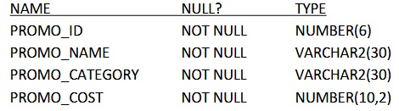  
Management requires a report of unique promotion costs in each promotion category.  
Which query would satisfy this requirement?

* A. SELECT DISTINCT promo_category, promo_cost FROM promotions ORDER BY 1
* B. SELECT promo_category, DISTINCT promo_cost FROM promotions
* C. SELECT DISTINCT promo_cost, promo_category FROM promotions
* D. SELECT DISTINCT promo_cost, DISTINCT promo_category FROM promotions;

**Correct Answer:** *A* 

# Question #129

You must create a table for a banking application.  
One of the columns in the table has these requirements:  
1: A column to store the duration of a short team loan  
2: The data should be stored in a format supporting DATE arithmetic with DATE datatypes without using conversion functions.  
3: The maximum loan period is 30 days.  
4: Interest must be calculated based on the number of days for which the loan remains unpaid.  
Which data type would you use?

* A. DATE
* B. NUMBER
* C. TIMESTAMP
* D. INTERVAL DAY TO SECOND
* E. INTERVAL YEAR TO MONTH

**Correct Answer:** *D* 

# Question #130

Examine the structure of the CUSTOMERS table: (Choose two.)  
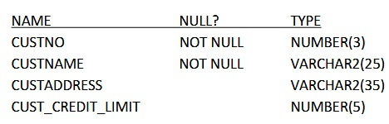  
CUSTNO is the PRIMARY KEY.  
You must determine if any customers' details have been entered more than once using a different CUSTNO, by listing all duplicate names.  
Which two methods can you use to get the required result?

* A. Subquery
* B. Self-join
* C. Full outer-join with self-join
* D. Left outer-join with self-join
* E. Right outer-join with self-join

Correct Answer: *AB*

# Question #131

Which two are the minimal requirements for a self-join? (Choose two.)

* A. Only equijoin conditions may be used in the query.
* B. Outer joins must not be used in the query.
* C. There must be a condition on which the self-join is performed.
* D. No other condition except the self-join may be specified.
* E. The table used for the self-join must have two different alias names in the query.

**Correct Answer:** *CE* 

# Question #132

Examine the SQL statement used to create the TRANSACTION table.  
  
SQL > CREATE TABLE transaction -  
(trn_id char(2) primary key,  
Start_date date DEFAULT SYSDATE,  
End_date date NOT NULL);  
The value 'A1' does not exist for trn_id in this table.  
Which SQL statement successfully inserts a row into the table with the default value for START_DATE?

* A. INSERT INTO transaction VALUES ('A1', DEFAULT, TO_DATE(DEFAULT+10))
* B. INSERT INTO transaction VALUES ('A1', DEFAULT, TO_DATE('SYSDATE+10'))
* C. INSERT INTO transaction (trn_id, end_date) VALUES ('A1', '10-DEC-2014')
* D. INSERT INTO transaction (trn_id, start_date, end_date) VALUES ('A1', , '10-DEC-2014')

**Correct Answer:** *C* 

# Question #133

Which three SQL statements would display the value 1890.55 as $1,890.55? (Choose three.)

* A. SELECT TO_CHAR (1890.55, '$99G999D00') FROM DUAL
* B. SELECT TO_CHAR (1890.55, '$9,999V99') FROM DUAL;
* C. SELECT TO_CHAR (1890.55, '$0G000D00') FROM DUAL;
* D. SELECT TO_CHAR (1890.55, '$99,999D99') FROM DUAL;
* E. SELECT TO_CHAR (1890.55, '$99G999D99') FROM DUAL

**Correct Answer:** *ACE*   
<https://docs.oracle.com/cd/B19306_01/server.102/b14200/sql_elements004.htm>

# Question #134

A subquery is called a single-row subquery when _______.

* A. There is only one subquery in the outer query and the inner query returns one or more values
* B. The inner query returns a single value to the outer query.
* C. The inner query uses an aggregating function and returns one or more values.
* D. The inner query returns one or more values and the outer query returns a single value.

**Correct Answer:** *B* 

# Question #135

You must write a query that prompts users for column names and conditions every time it is executed.  
The user must be prompted only once for the table name.  
Which statement achieves those objectives?

* A. SELECT &col1, '&col2' FROM &table WHERE &&condition = '&cond';
* B. SELECT &col1, &col2 FROM "&table" WHERE &condition = &cond;
* C. SELECT &col1, &col2 FROM &&table WHERE &condition = &cond;
* D. SELECT &col1, &col2 FROM &&table WHERE &condition = &&cond

**Correct Answer:** *C* 

# Question #136

Which three statements are true regarding single-row functions? (Choose three.)

* A. The data type returned, can be different from the data type of the argument that is referenced.
* B. They can return multiple values of more than one data type.
* C. They can accept only one argument.
* D. They can be nested up to only two levels.
* E. They can be used in SELECT, WHERE, and ORDER BY clauses.
* F. They can accept column names, expressions, variable names, or a user-supplied constants as arguments.

**Correct Answer:** *AEF* 

# Question #137

View the Exhibit and examine the structure in the DEPARTMENTS tables. (Choose two.)  
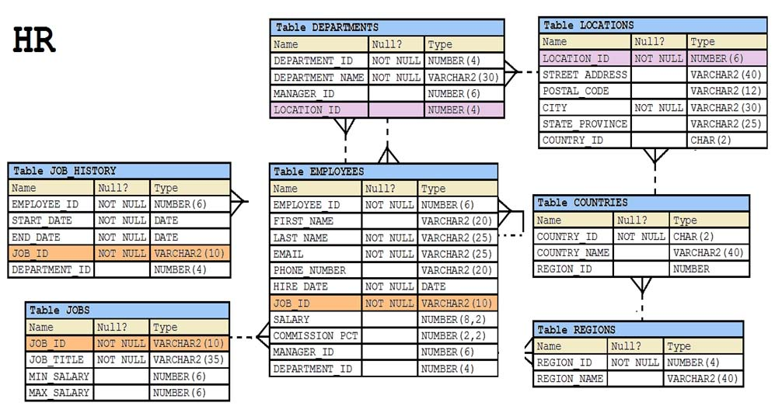  
Examine this SQL statement:  
SELECT department_id "DEPT_ID", department_name, 'b' FROM  
departments  
  
WHERE departments_id=90 -  
  
UNION -  
SELECT department_id, department_name DEPT_NAME, 'a' FROM  
departments  
  
WHERE department_id=10 -  
Which two ORDER BY clauses can be used to sort the output?

* A. ORDER BY DEPT_NAME;
* B. ORDER BY DEPT_ID;
* C. ORDER BY 'b';
* D. ORDER BY 3;

**Correct Answer:** *BD* 

# Question #138

Which two statements are true regarding the WHERE and HAVING clauses in a SELECT statement? (Choose two.)

* A. The WHERE and HAVING clauses can be used in the same statement only if they are applied to different columns in the table.
* B. The aggregate functions and columns used in the HAVING clause must be specified in the SELECT list of the query.
* C. The WHERE clause can be used to exclude rows after dividing them into groups.
* D. The HAVING clause can be used with aggregate functions in subqueries.
* E. The WHERE clause can be used to exclude rows before dividing them into groups.

**Correct Answer:** *CD* 

# Question #139

You must create a table EMPLOYEES in which the values in the columns EMPLOYEES_ID and LOGIN_ID must be unique and not null.  
Which two SQL statements would create the required table? (Choose two.)

* A. CREATE TABLE employees (employee_id NUMBER, login_id NUMBER, employee_name VARCHAR2(100), hire_date DATE, CONSTRAINT emp_id_uk UNIQUE (employee_id, login_id));
* B. CREATE TABLE employees (employee_id NUMBER, login_id NUMBER, employee_name VARCHAR2(25), hire_date DATE, CONSTRAINT emp_id_pk PRIMARY KEY (employee_id, login_id));
* C. CREATE TABLE employees (employee_id NUMBER CONSTRAINT emp_id_pk PRIMARY KEY, login_id NUMBER UNIQUE, employee_name VARCHAR2(25), hire_date DATE);
* D. CREATE TABLE employees (employee_id NUMBER, login_id NUMBER, employee_name VARCHAR2(100), hire_date DATE, CONSTRAINT emp_id_uk UNIQUE (employee_id, login_id); CONSTRAINT emp_id_nn NOT NULL (employee_id, login_id));
* E. CREATE TABLE employees (employee_id NUMBER CONSTRAINT emp_id_nn NOT NULL, login_id NUMBER CONSTRAINT login_id_nn NOT NULL, employee_name VARCHAR2(100), hire_date DATE, CONSTRAINT emp_num_id_uk UNIQUE (employee_id, login_id));

**Correct Answer:** *BE* 

# Question #140

View the Exhibit and examine the structure of the PRODUCT_INFORMATION table. (Choose the best answer.)  
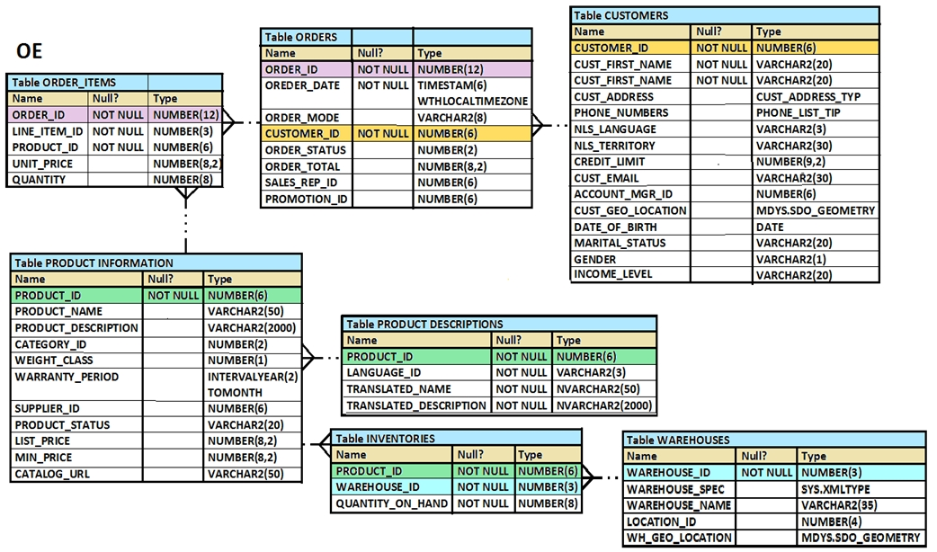  
PRODUCT_ID column is the primary key.  
You create an index using this command:  
SQL > CREATE INDEX upper_name_idx  
ON product_information(UPPER(product_name));  
No other indexes exist on the PRODUCT_INFORMATION table.  
Which query would use the UPPER_NAME_IDX index?

* A. SELECT product_id, UPPER(product_name) FROM product_information WHERE UPPER(product_name) = 'LASERPRO' OR list_price > 1000;
* B. SELECT UPPER(product_name) FROM product_information;
* C. SELECT UPPER(product_name) FROM product_information WHERE product_id = 2254;
* D. SELECT product_id FROM product_information WHERE UPPER(product_name) IN ('LASERPRO', 'CABLE');

Correct Answer: *D*

# Question #141

Examine the types and examples of relationship that follow:  
1 One-to-one a) teacher to Student  
2 One-to-many b) Employees to Manager  
3 Many-to-one c) Person to SSN  
4 Many-to-many d) Customers to Products  
Which option indicates correctly matched relationships?

* A. 1-d, 2-b, 3-a, and 4-c
* B. 1-c, 2-d, 3-a, and 4-b
* ~~C. 1-a, 2-b, 3-c, and 4-d~~
* D. 1-c, 2-a, 3-b, and 4-d

**Correct Answer:** *~~C~~* >> D

# Question #142

A non-correlated subquery can be defined as __________. (Choose the best answer.)

* A. A set of one or more sequential queries in which generally the result of the inner query is used as the search value in the outer query.
* B. A set of sequential queries, all of which must return values from the same table.
* C. A set of sequential queries, all of which must always return a single value.
* D. A SELECT statement that can be embedded in a clause of another SELECT statement only.

**Correct Answer:** *A* 

# Question #143

Which three statements are true reading subqueries? (Choose three.)

* A. A Main query can have many subqueries.
* B. A subquery can have more than one main query.
* C. The subquery and main query must retrieve date from the same table.
* D. The subquery and main query can retrieve data from different tables.
* E. Only one column or expression can be compared between the subquery and main query.
* F. Multiple columns or expressions can be compared between the subquery and main query.

**Correct Answer:** *ADF* 

# Question #144

See the Exhibit and examine the structure of the PROMOTIONS table:  
  
Using the PROMOTIONS table,  
you need to find out the average cost for all promos in the range $0-2000 and $2000-5000 in category A.  
You issue the following SQL statements:  
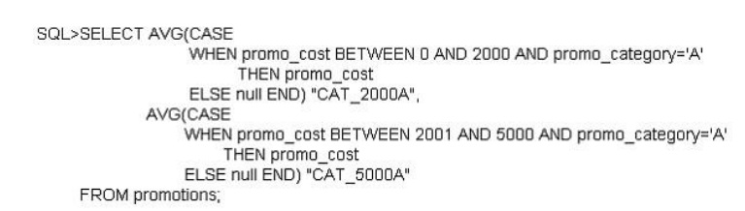  
What would be the outcome?

* A. It generates an error because multiple conditions cannot be specified for the WHEN clause.
* B. It executes successfully and gives the required result.
* C. It generates an error because CASE cannot be used with group functions.
* D. It generates an error because NULL cannot be specified as a return value.

**Correct Answer:** *B*   
CASE Expression -  
Facilitates conditional inquiries by doing the work of an IF-THEN-ELSE statement:  
CASE expr WHEN comparison_expr1 THEN return_expr1  
[WHEN comparison_expr2 THEN return_expr2  
WHEN comparison_exprn THEN return_exprn  
ELSE else_expr]  
END

# Question #145

Which two statements are true regarding multiple-row subqueries? (Choose two.)

* A. They can contain group functions.
* B. They always contain a subquery within a subquery.
* C. They use the < ALL operator to imply less than the maximum.
* D. They can be used to retrieve multiple rows from a single table only.
* E. They should not be used with the NOT IN operator in the main query if NULL is likely to be a part of the result of the subquery.

**Correct Answer:** *AE* 

Question #146

View the Exhibit and examine the structure of the CUSTOMERS and CUST_HISTORY tables.  
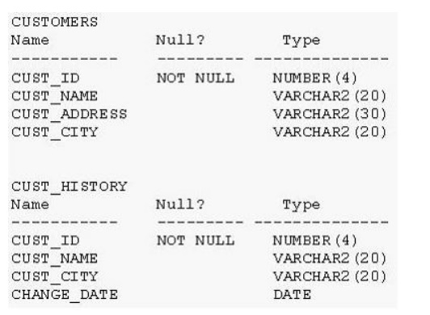  
The CUSTOMERS table contains the current location of all currently active customers.  
The CUST_HISTORY table stores historical details relating to any changes in the location of all current as well as previous customers who are no longer active with the company.  
You need to find those customers who have never changed their address.  
Which SET operator would you use to get the required output?

* A. INTERSECT
* B. UNION ALL
* C. MINUS
* D. UNION

**Correct Answer:** *C* 

# Question #147

View the Exhibit and examine PRODUCTS and ORDER_ITEMS tables.  
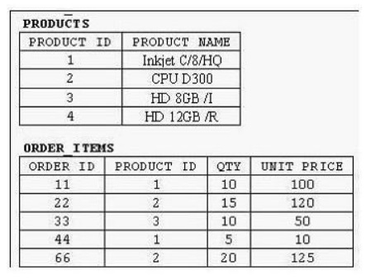  
You executed the following query to display PRODUCT_NAME and the number of times the product has been ordered:  
SELECT p.product_name, i.item_cnt  
FROM (SELECT product_id, COUNT (*) item_cnt  
  
FROM order_items -  
GROUP BY product_id) i RIGHT OUTER JOIN products p  
ON i.product_id = p.product_id;  
What would happen when the above statement is executed?

* A. The statement would execute successfully to produce the required output.
* B. The statement would not execute because inline views and outer joins cannot be used together.
* C. The statement would not execute because the ITEM_CNT alias cannot be displayed in the outer query.
* D. The statement would not execute because the GROUP BY clause cannot be used in the inline.

**Correct Answer:** *A* 

# Question #148

Which statement is true regarding the UNION operator?

* A. By default, the output is not sorted.
* B. Null values are not ignored during duplicate checking.
* C. Names of all columns must be identical across all select statements.
* D. The number of columns selected in all select statements need not be the same.

**Correct Answer:** *B* 

# Question #149

You issued the following command:  
SQL> DROP TABLE employees;  
Which three statements are true?

* A. All uncommitted transactions are committed.
* B. All indexes and constraints defined on the table being dropped are also dropped.
* C. Sequences used in the employees table become invalid.
* D. The space used by the employees table is reclaimed immediately.
* E. The employees table can be recovered using the rollback command.
* F. The employees table is moved to the recycle bin

**Correct Answer:** *ABF* 

# Question #150

Examine the create table statements for the stores and sales tables.  
SQL> CREATE TABLE stores(store_id NUMBER(4) CONSTRAINT store_id_pk PRIMARY KEY, store_name VARCHAR2(12), store_address VARCHAR2(20), start_date DATE);  
SQL> CREATE TABLE sales(sales_id NUMBER(4) CONSTRAINT sales_id_pk PRIMARY KEY, item_id NUMBER(4), quantity NUMBER(10), sales_date DATE, store_id NUMBER(4), CONSTRAINT store_id_fk FOREIGN KEY(store_id) REFERENCES stores(store_id));  
You executed the following statement:  
  
SQL> DELETE from stores -  
WHERE store_id=900;  
The statement fails due to the integrity constraint error:  
ORA-02292: integrity constraint (HR.STORE_ID_FK) violated  
Which three options ensure that the statement will execute successfully?

* A. Disable the primary key in the STORES table.
* B. Use CASCADE keyword with DELETE statement.
* C. DELETE the rows with STORE_ID = 900 from the SALES table and then delete rows from STORES table.
* D. Disable the FOREIGN KEY in SALES table and then delete the rows.
* E. Create the foreign key in the SALES table on SALES_ID column with on DELETE CASCADE option.

Correct Answer: *CDE*

# Question #151

In the customers table, the CUST_CITY column contains the value 'Paris' for the  
CUST_FIRST_NAME 'Abigail'.  
Evaluate the following query:  
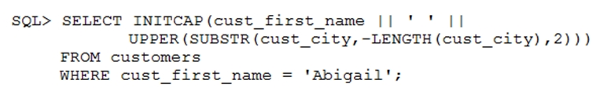  
What would be the outcome?

* A. Abigail PA
* B. Abigail Pa
* C. Abigail IS
* D. An error message

**Correct Answer:** *B* 

# Question #152

Which two statements are true regarding constraints?

* A. A foreign key column cannot contain null values.
* B. A column with the UNIQUE constraint can contain null values.
* C. A constraint is enforced only for INSERT operation on the table.
* D. A constraint can be disabled even if the constraint column contains data.
* E. All constraints can be defined at the column level and at the table level.

**Correct Answer:** *BD* 

# Question #153

On your Oracle 12c database, you invoked SQL *Loader to load data into the EMPLOYEES table in the HR schema by issuing the following command:  
$> sqlldr hr/hr@pdb table=employees  
Which two statements are true regarding the command?

* A. It succeeds with default settings if the EMPLOYEES table belonging to HR is already defined in the database.
* B. It fails because no SQL *Loader data file location is specified.
* C. It fails if the HR user does not have the CREATE ANY DIRECTORY privilege.
* D. It fails because no SQL *Loader control file location is specified.

**Correct Answer:** *AC*

<https://docs.oracle.com/en/database/oracle/oracle-database/12.2/sutil/oracle-sql-loader-express-mode.html#GUID-0F35B551-861B-450D-8BF3-2312893A67D7>

# Question #154

You notice a performance change in your production Oracle 12c database. You want to know which change caused this performance difference.  
Which method or feature should you use?

* A. Compare Period ADDM report.
* B. AWR Compare Period report.
* C. Active Session History (ASH) report.
* D. Taking a new snapshot and comparing it with a preserved snapshot.

**Correct Answer:** *B* A

Question #155

Which statement is true about Enterprise Manager (EM) express in Oracle Database 12c?

* A. By default, EM express is available for a database after database creation.
* B. You can use EM express to manage multiple databases running on the same server.
* C. You can perform basic administrative tasks for pluggable databases by using the EM express interface.
* D. You cannot start up or shut down a database Instance by using EM express.
* E. You can create and configure pluggable databases by using EM express.

**Correct Answer:** *A* 

# Question #156

Which two partitioned table maintenance operations support asynchronous Global Index Maintenance in Oracle database 12c?

* A. ALTER TABLE SPLIT PARTITION
* B. ALTER TABLE MERGE PARTITION
* C. ALTER TABLE TRUNCATE PARTITION
* D. ALTER TABLE ADD PARTITION
* E. ALTER TABLE DROP PARTITION
* F. ALTER TABLE MOVE PARTITION

**Correct Answer:** *CE*   
<https://docs.oracle.com/database/121/VLDBG/GUID-087B87A6-959A-40C6-82AF-36E401FD089B.htm#VLDBG14107>

<https://oracle-base.com/articles/12c/asynchronous-global-index-maintenance-for-drop-and-truncate-partition-12cr1>

<https://richardfoote.wordpress.com/2013/08/02/12c-asynchronous-global-index-maintenance-part-i-where-are-we-now/>

# Question #157

View the Exhibits and examine PRODUCTS and SALES tables.  
  
Exhibit 1 -  
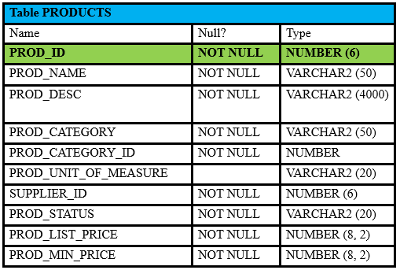  
  
Exhibit 2 -  
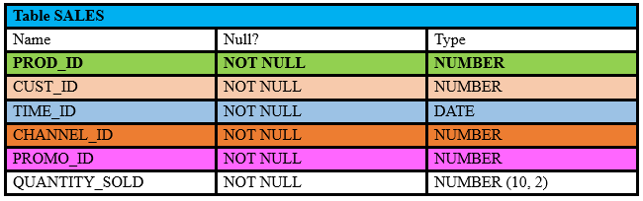  
You issue the following query to display product name the number of times the product has been sold:  
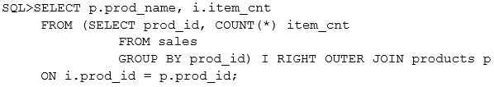  
What happens when the above statement is executed?

* A. The statement executes successfully and produces the required output.
* B. The statement produces an error because a subquery in the FROM clause and outer-joins cannot be used together.
* C. The statement produces an error because the GROUP BY clause cannot be used in a subquery in the FROM clause.
* D. The statement produces an error because ITEM_CNT cannot be displayed in the outer query.

**Correct Answer:** *A* 

# Question #158

Examine the structure of the BOOKS_TRANSACTIONS table:  
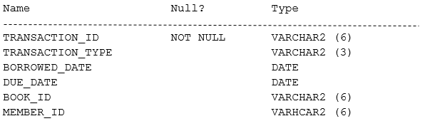  
Examine the SQL statement:  
  
Which statement is true about the outcome?

* A. It displays details only for members who have borrowed before today with RM as TRANSACTION_TYPE.
* B. It displays details for members who have borrowed before today's date with either RM as TRANSACTION_TYPE or MEMBER_ID as A101 and A102.
* C. It displays details for only members A101 and A102 who have borrowed before today with RM TRANSACTION_TYPE.
* D. It displays details for members who have borrowed before today with RM as TRANSACTION_TYPE and the details for members A101 or A102.

**Correct Answer:** *D* 

# Question #159

View the Exhibit and examine the data in the EMPLOYEES table.  
  
Exhibit -  
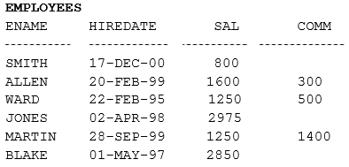  
You want to generate a report showing the total compensation paid to each employee to date.  
You issue the following query:  
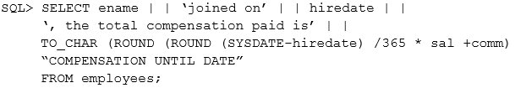  
What is the outcome?

* A. It executes successfully but does not give the correct output.
* B. It generates an error because the concatenation operator can be used to combine only two items.
* C. It generates an error because the usage of the ROUND function in the expression is not valid.
* D. It generates an error because the alias is not valid.
* E. IT executes successfully and gives the correct output.

**Correct Answer:** *A* 

# Question #160

Evaluate the following query -  
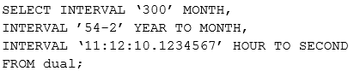  
What is the correct output of the above query?

* A. +00-300, +00-650, +00 11:12:10.123457
* B. +25-00, +54-02, +00 11:12:10.123457
* C. +00-300, +54-02, +00 11:12:10.123457
* D. +25-00, +00-650, +00 11:12:10.123457

Correct Answer: *B*

# Question #161

Which two statements are true regarding savepoints? (Choose two.)

* A. Savepoints may be used to ROLLBACK.
* B. Savepoints can be used for only DML statements.
* C. Savepoints are effective only for COMMIT.
* D. Savepoints are effective for both COMMIT and ROLLBACK.
* E. Savepoints can be used for both DML and DDL statements.

**Correct Answer:** *AB*   
Reference:  
https://docs.oracle.com/cd/B19306_01/server.102/b14200/statements_10001.htm#SQLRF01701

# Question #162

Examine the commands used to create DEPARTMENT_DETAILS and COURSE_DETAILS tables:  
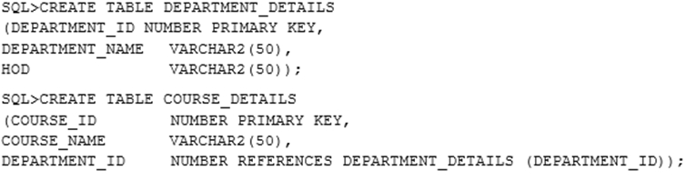  
You want to generate a list of all department IDs that do not exist in the COURSE_DETAILS table.  
You execute the SQL statement:  
  
What is the outcome?

* A. It fails because the join type used is incorrect.
* ~~B. It executes successfully and displays the required list.~~
* C. It executes successfully but displays an incorrect list.
* D. It fails because the ON clause condition is not valid.

**Correct Answer:** *~~B~~* >> C

# Question #163

View the Exhibit and examine the details of the PRODUCT_INFORMATION table.  
  
Exhibit -  
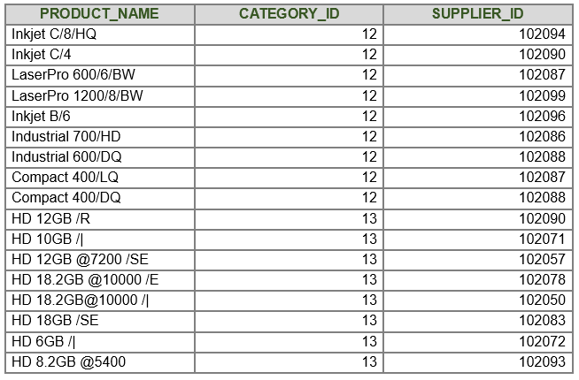  
You must display PRODUCT_NAME from the table where the CATEGORY_ID column has values 12 or 13, and the SUPPLIER_ID column has the value 102088.  
You executed this SQL statement:  
  
Which statement is true regarding the execution?

* A. It would not execute because the entire WHERE clause is not enclosed within parentheses.
* B. It would execute but would return no rows.
* C. It would not execute because the same column has been used twice with the AND logical operator.
* D. It would execute and return the desired result.

**Correct Answer:** *B* 

# Question #164

You need to produce a report where each customer's credit limit has been incremented by $1000. In the output, the customer's last name should have the heading Name and the incremented credit limit should be labeled New Credit Limit. The column headings should have only the first letter of each word in uppercase.  
Which statement would accomplish this requirement?

* A. SELECT cust_last_name AS "Name", cust_credit_limit + 1000 AS "New Credit Limit" FROM customers;
* B. SELECT cust_last_name AS Name, cust_credit_limit + 1000 AS New Credit Limit FROM customers;
* C. SELECT cust_last_name AS Name, cust_credit_limit + 1000 "New Credit Limit" FROM customers;
* D. SELECT INITCAP (cust_last_name) "Name", cust_credit_limit + 1000 INITCAP ("NEW CREDIT LIMIT") FROM customers;

**Correct Answer:** *A* 

# Question #165

View the Exhibit and examine the structure of the ORDERS table.  
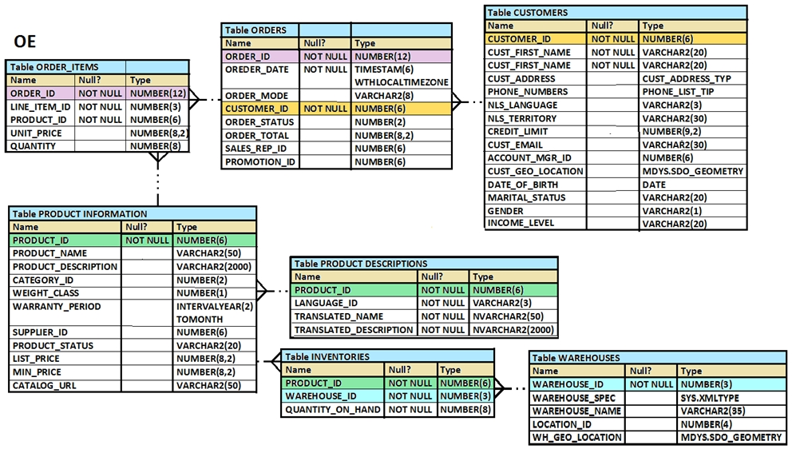  
Which UPDATE statement is valid?

* A. UPDATE orders SET order_date = '12-mar-2007', order_total IS NULL WHERE order_id = 2455;
* B. UPDATE orders SET order_date = '12-mar-2007', AND order_total = TO_NUMBER(NULL) WHERE order_id = 2455;
* C. UPDATE orders SET order_date = '12-mar-2007', order_total = NULL WHERE order_id = 2455;
* D. UPDATE orders SET order_date = TO_DATE('12-mar-2007','dd-mon-yyyy'), SET order_total = TO_NUMBER (NULL) WHERE order_id = 2455;

**Correct Answer:** *C* 

# Question #166

is a user in the database.  
  
SCOTT -  
Evaluate the commands issued by the DBA:  
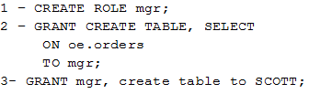  
Which statement is true regarding the execution of the above commands?

* A. Statement 1 would not execute because the WITH GRANT option is missing.
* B. Statement 2 would not execute because system privileges and object privileges cannot be granted together in a single GRANT command.
* C. Statement 3 would not execute because role and system privileges cannot be granted together in a single GRANT statement.
* D. Statement 1 would not execute because the IDENTIFIED BY <password> clause is missing.

**Correct Answer:** *B* 

# Question #167

View the Exhibit and examine the data in the PRODUCT_INFORMATION table.  
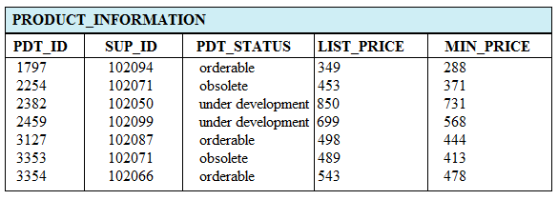  
Which two tasks would require subqueries? (Choose two.)

* A. displaying all the products whose minimum list prices are more than average list price of products having the status orderable
* B. displaying the total number of products supplied by supplier 102071 and having product status OBSOLETE
* C. displaying the number of products whose list prices are more than the average list price
* D. displaying all supplier IDs whose average list price is more than 500
* E. displaying the minimum list price for each product status

**Correct Answer:** *AC* 

# Question #168

View the Exhibit and examine the description of the EMPLOYEES table.  
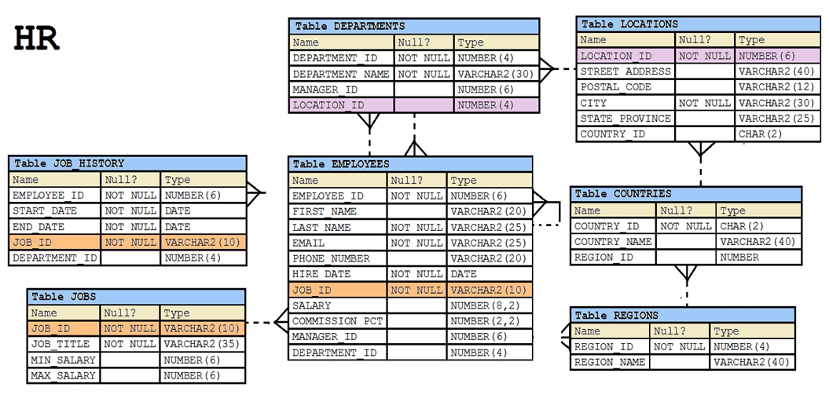  
You want to calculate the total remuneration for each employee. Total remuneration is the sum of the annual salary and the percentage commission earned for a year. Only a few employees earn commission.  
Which SQL statement would you execute to get the desired output?

* ~~A. SELECT first_name, salary, salary*12+(salary*NVL2 (commission_pct, salary,salary+commission_pct))"Total" FROM EMPLOYEES;~~
* B. SELECT first_name, salary, salary*12+salary*commission_pct "Total" FROM EMPLOYEES;
* C. SELECT first_name, salary, (salary + NVL (commission_pct, 0)*salary)*12 "Total" FROM EMPLOYEES;
* D. SELECT first_name, salary, salary*12 + NVL(salary,0)*commission_pct, "Total" FROM EMPLOYEES;

**Correct Answer:** *~~A~~* >> C

# Question #169

View the Exhibit and examine the structure of the PROMOTIONS table.  
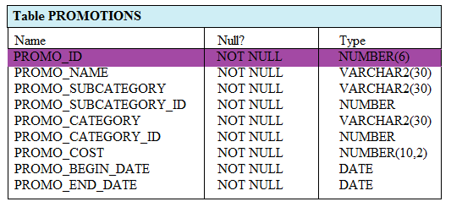  
Evaluate the following SQL statement:  
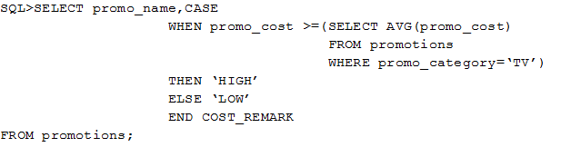  
Which statement is true regarding the outcome of the above query?

* A. It produces an error because subqueries cannot be used with the CASE expression.
* B. It shows COST_REMARK for all the promos in the promo category "˜TV'.
* C. It shows COST_REMARK for all the promos in the table.
* D. It produces an error because the subquery gives an error.

**Correct Answer:** *C* 

# Question #170

Which statement is true regarding the USING clause in table joins? (Choose two.)

* A. It can be used to join a maximum of three tables.
* B. It can be used to access data from tables through equijoins as well as nonequijoins.
* C. It can be used to join tables that have columns with the same name and compatible data types.
* D. It can be used to restrict the number of columns used in a NATURAL join.

Correct Answer: *CD*

# Question #171

Examine the structure proposed for the TRANSACTIONS table:  
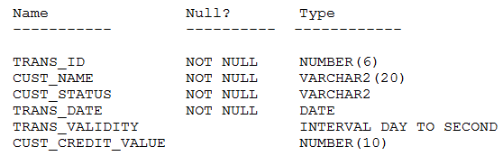  
Which two statements are true regarding the storage of data in the above table structure? (Choose two.)

* A. The CUST_CREDIT_VALUE column would allow storage of positive and negative integers.
* B. The TRANS_VALIDITY column would allow storage of a time interval in days, hours, minutes, and seconds.
* C. The CUST_STATUS column would allow storage of data up to the maximum VARCHAR2 size of 4,000 characters.
* D. The TRANS_DATE column would allow storage of dates only in the dd-mon-yyyy format.

**Correct Answer:** *AB*   
<https://docs.oracle.com/cd/B28359_01/server.111/b28320/limits001.htm#i287903>

# Question #172

Examine the structure of the MARKS table:  
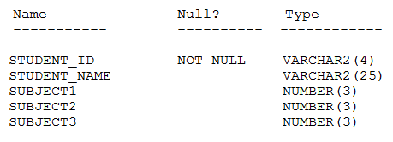  
Which two statements would execute successfully? (Choose two.)

* A. SELECT SUM(DISTINCT NVL(subject1,0)), MAX(subject1) FROM marks WHERE subject1 > subject2;
* B. SELECT student_name subject1 FROM marks WHERE subject1 > AVG(subject1);
* C. SELECT SUM(subject1+subject2+subject3) FROM marks WHERE student_name IS NULL;
* D. SELECT student_name,SUM(subject1) FROM marks WHERE student_name LIKE "˜R%';

**Correct Answer:** *AC* 

# Question #173

Examine the data in the CUSTOMERS table:  
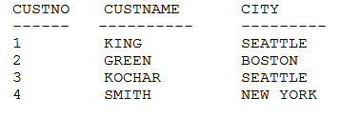  
You want to list all cities that have more than one customer along with the customer details.  
Evaluate the following query:  
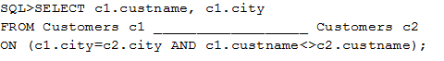  
Which two JOIN options can be used in the blank in the above query to give the correct output? (Choose two.)

* A. LEFT OUTER JOIN
* B. JOIN
* C. NATURAL JOIN
* D. RIGHT OUTER JOIN
* E. FULL OUTER JOIN

**Correct Answer:** *BD* 

# Question #174

Examine the structure proposed for the TRANSACTIONS table:  
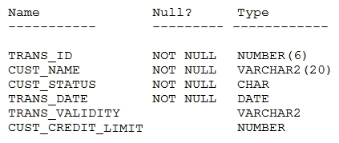  
Which two statements are true regarding the creation and storage of data in the above table structure? (Choose two.)

* A. The CUST_STATUS column would store exactly one character.
* B. The TRANS_VALIDITY column would have a maximum size of one character.
* C. The CUST_CREDIT_LIMIT column would be able to store decimal values.
* D. The CUST_STATUS column would give an error.
* E. The TRANS_DATE column would be able to store day, month, century, year, hour, minutes, seconds, and fractions of seconds.
* F. The TRANS_VALIDITY column would give an error.

**Correct Answer:** *AF* 

# Question #175

View the Exhibit and examine the structure of the PRODUCT_INFORMATION and INVENTORIES tables.  
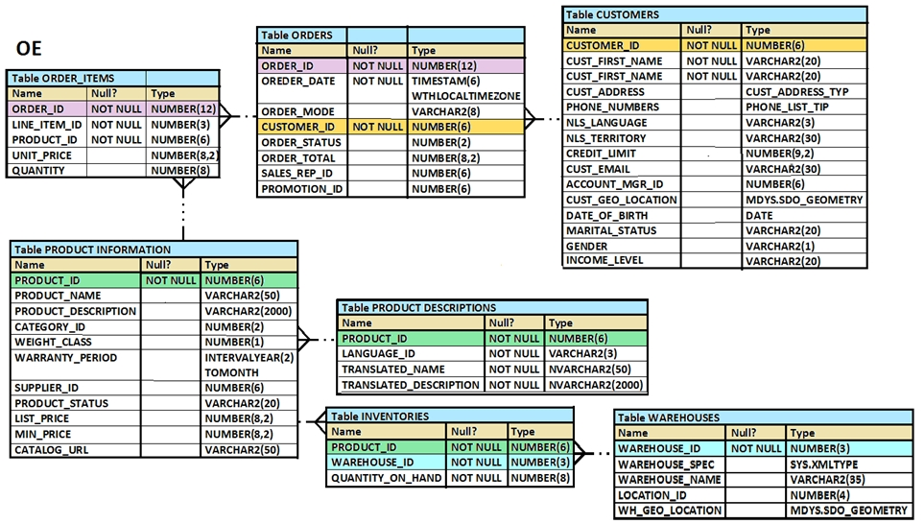  
You have a requirement from the supplies department to give a list containing PRODUCT_ID, SUPPLIER_ID, and QUANTITY_ON_HAND for all the products wherein QUANTITY_ON_HAND is less than five.  
Which two SQL statements can accomplish the task? (Choose two.)

* A. SELECT i.product_id, i.quantity_on_hand, pi.supplier_id FROM product_information pi JOIN inventories i ON (pi.product_id=i.product_id) WHERE quantity_on_hand < 5;
* B. SELECT product_id, quantity_on_hand, supplier_id FROM product_information NATURAL JOIN inventories AND quantity_on_hand < 5;
* C. SELECT i.product_id, i.quantity_on_hand, pi.supplier_id FROM product_information pi JOIN inventories i ON (pi.product_id=i.product_id) AND quantity_on_hand < 5;
* D. SELECT i.product_id, i.quantity_on_hand, pi.supplier_id FROM product_information pi JOIN inventories i USING (product_id) AND quantity_on_hand < 5;

**Correct Answer:** *AC* 

# Question #176

In the EMPLOYEES table there are 1000 rows and employees are working in the company for more than 10 years.  
Evaluate the following SQL statement:  
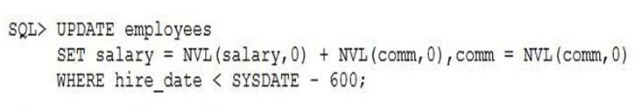  
What would be the result?

* A. It executes successfully but no rows updated.
* B. It executes successfully and updates the records of those employees who have been working in the company for more than 600 days.
* C. It gives an error because multiple NVL functions are used in an expression.
* D. It gives an error because NVL function cannot be used with UPDATE.

**Correct Answer:** *B* 

# Question #177

Which statement adds a column called SALARY to the EMPLOYEES table having 100 rows, which cannot contain null?

* A. ALTER TABLE EMPLOYEES ADD SALARY NUMBER(8,2) DEFAULT 0 NOT NULL;
* B. ALTER TABLE EMPLOYEES ADD SALARY NUMBER(8,2) DEFAULT CONSTRAINT p_nn NOT NULL;
* C. ALTER TABLE EMPLOYEES ADD SALARY NUMBER(8,2) DEFAULT NOT NULL;
* D. ALTER TABLE EMPLOYEES ADD SALARY NUMBER(8,2) NOT NULL;

**Correct Answer:** *A* 

# Question #178

View the Exhibit and examine the data in the PROMOTIONS table.  
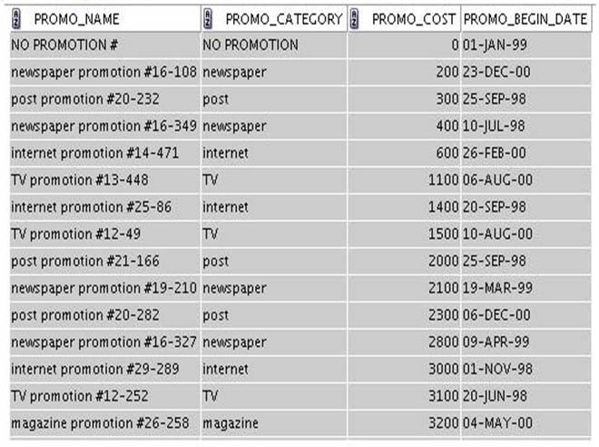 is stored in the default date format, dd-mon-rr.  
  
PROMO_BEGIN_DATE -  
You need to produce a report that provides the name, cost, and start date of all promos in the POST category that were launched before January 1, 2000.  
Which SQL statement would you use?

* A. SELECT promo_name, promo_cost, promo_begin_date FROM promotions WHERE promo_category = 'post' AND promo_begin_date < '01-01-00';
* B. SELECT promo_name, promo_cost, promo_begin_date FROM promotions WHERE promo_category LIKE 'P%' AND promo_begin_date < '1-JANUARY-00';
* C. SELECT promo_name, promo_cost, promo_begin_date FROM promotions WHERE promo_cost LIKE 'post%' AND promo_begin_date < '01-01-2000';
* D. SELECT promo_name, promo_cost, promo_begin_date FROM promotions WHERE promo_category LIKE '%post%' AND promo_begin_date < '1-JAN-00';

**Correct Answer:** *D* 

# Question #179

Which two statements are true regarding views? (Choose two.)

* A. The WITH CHECK OPTION constraint can be used in a view definition to restrict the columns displayed through the view.
* B. The OR REPLACE option is used to change the definition of an existing view without dropping and re-creating it.
* C. Rows cannot be deleted through a view if the view definition contains the DISTINCT keyword.
* D. Rows added through a view are deleted from the table automatically when the view is dropped.
* E. A simple view in which column aliases have been used cannot be updated.
* F. A subquery used in a complex view definition cannot contain group functions or joins.

**Correct Answer:** *BC* 

# Question #180

View the Exhibit and examine the structure of CUSTOMERS table.  
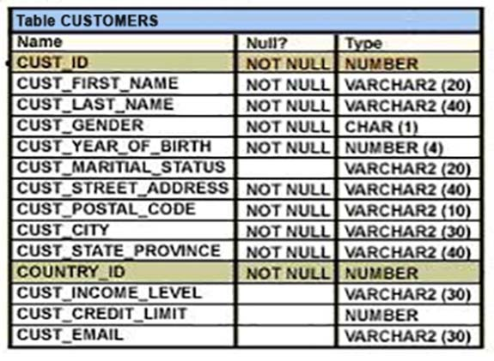  
Evaluate the following query:  
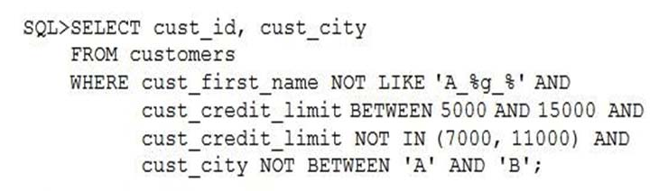  
Which statement is true regarding the above query?

* A. It produces an error because the condition on the CUST_CITY column is not valid.
* B. It produces an error because the condition on the CUST_FIRST_NAME column is not valid.
* C. It produces an error because conditions on the CUST_CREDIT_LIMIT column are not valid.
* D. It executes successfully.

Correct Answer: *D*

# Question #181

Evaluate the following CREATE SEQUENCE statement:  
  
CREATE SEQUENCE seq1 -  
  
START WITH 100 -  
  
INCREMENT BY 10 -  
  
MAXVALUE 200 -  
  
CYCLE -  
NOCACHE;  
The sequence SEQ1 has generated numbers up to the maximum limit of 200. You issue the following SQL statement:  
SELECT seq1.nextval FROM dual;  
What is displayed by the SELECT statement?

* A. 100
* B. an error
* C. 10
* D. 1

**Correct Answer:** *D* 

# Question #182

Which statement is true regarding the SESSION_PRIVS dictionary view?

* A. It contains the object privileges granted to other users by the current user session.
* B. It contains the system privileges granted to other users by the current user session.
* C. It contains the current object privileges available in the user session.
* D. It contains the current system privileges available in the user session.

**Correct Answer:** *D*   
<https://docs.oracle.com/cd/E11882_01/nav/catalog_views.htm>

# Question #183

Which three statements indicate the end of a transaction? (Choose three.)

* A. after a CREATE statement is issued
* B. after a SAVEPOINT is issued
* C. after a SELECT statement is issued
* D. after a ROLLBACK is issued
* E. after a COMMIT is issued

**Correct Answer:** *ADE* 

# Question #184

Examine the structure of the BOOKS_TRANSACTIONS table.  
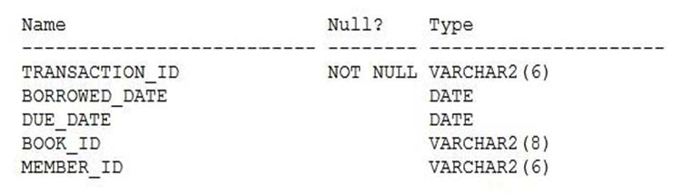  
You want to update this table such that BOOK_ID is set to 'INVALID' for all rows where no MEMBER_ID has been entered.  
Examine this partial SQL statement:  
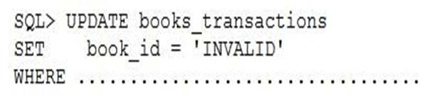  
Which condition must be used in the WHERE clause to perform the required update?

* A. MEMBER_ID = '';
* B. MEMBER_ID = NULL;
* C. MEMBER_ID IS NULL;
* D. MEMBER_ID = "";

**Correct Answer:** *C* 

# Question #185

Evaluate the following SQL commands:  
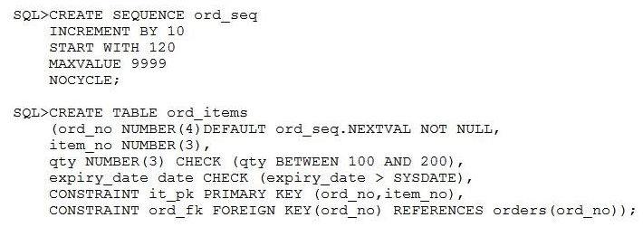  
The command to create a table fails. Identify the reason for the SQL statement failure.

* A. You cannot use ORD_NO and ITEM_NO columns as a composite primary key because ORD_NO is also the FOREIGN KEY.
* B. You cannot use the BETWEEN clause in the condition of a CHECK constraint.
* C. You cannot use the NEXTVAL sequence value as a DEFAULT value for a column.
* D. You cannot use SYSDATE in the condition of a CHECK constraint.

**Correct Answer:** *D* 

# Question #186

Evaluate the following query:  
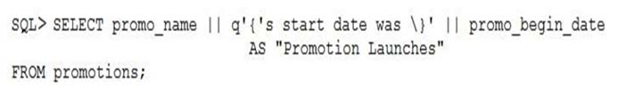  
What would be the outcome of the above query?

* A. It produces an error because the data types are not matching.
* B. It executes successfully and displays the literal " {'s start date was \> " for each row in the output.
* C. It executes successfully and introduces an 's at the end of each promo_name in the output.
* D. It produces an error because flower braces have been used.

**Correct Answer:** *C* 

# Question #187

View the exhibit and examine the description for the SALES and CHANNELS tables.  
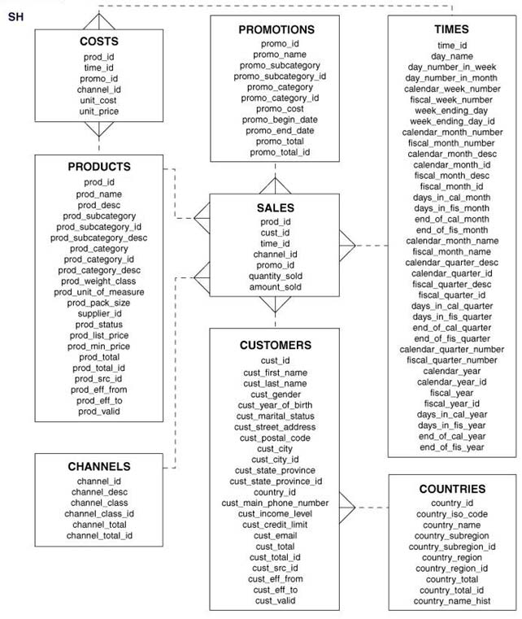  
You issued this SQL statement:  
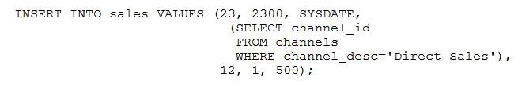  
Which statement is true regarding the result?

* A. The statement will fail because the subquery in the VALUES clause is not enclosed within single quotation marks.
* B. The statement will fail because a subquery cannot be used in a VALUES clause.
* C. The statement will fail because the VALUES clause is not required with a subquery.
* D. The statement will execute and a new row will be inserted in the SALES table.

**Correct Answer:** *D* 

# Question #188

View the Exhibit and examine the structure of the CUSTOMERS table.  
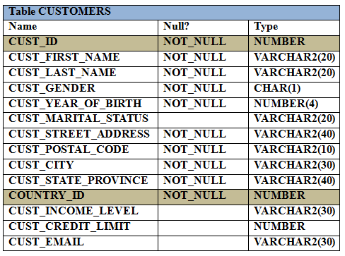  
Evaluate the following SQL statement:  
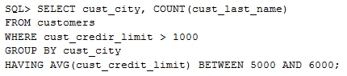  
Which statement is true regarding the outcome of the above query?

* A. It returns an error because the BETWEEN operator cannot be used in the HAVING clause.
* B. It returns an error because WHERE and HAVING clauses cannot be used in the same SELECT statement.
* C. It returns an error because WHERE and HAVING clauses cannot be used to apply conditions on the same column.
* D. It executes successfully.

**Correct Answer:** *D* 

# Question #189

View the Exhibit and examine the details of the ORDER_ITEMS table.  
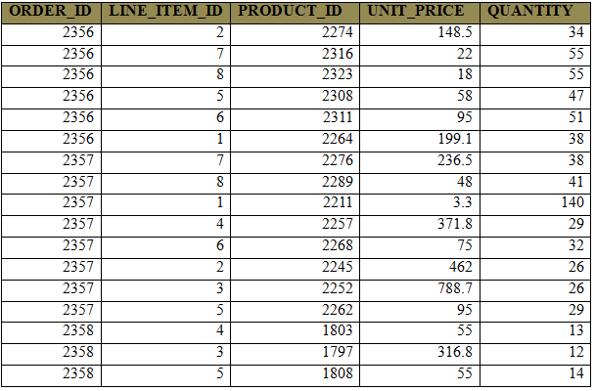  
Evaluate the following SQL statements:  
Statement 1:  
SELECT MAX(unit_price*quantity) "Maximum Order"  
FROM order_items;  
Statement 2:  
SELECT MAX(unit_price*quantity) "Maximum Order"  
  
FROM order_items -  
GROUP BY order_id;  
Which statements are true regarding the output of these SQL statements? (Choose all that apply.)

* A. Statement 2 would return multiple rows of output.
* B. Both statements would ignore NULL values for the UNIT_PRICE and QUANTITY columns.
* C. Statement 1 would not return give the same output.
* D. Both the statements would give the same output.
* E. Statement 1 would return only one row of output.

**Correct Answer:** *ABE* 

# Question #190

Which two statements are true regarding subqueries? (Choose two.)

* A. Only two subqueries can be placed at one level.
* B. A subquery in the WHERE clause of a SELECT statement can be nested up to three levels only.
* C. A subquery can be used to access data from one or more tables or views.
* D. The columns in a subquery must always be qualified with the name or alias of the table used.
* E. If the subquery returns 0 rows, then the value returned by the subquery expression is NULL.

Correct Answer: *CE*

# Question #191

Examine the description of the EMP_DETAILS table given below:  
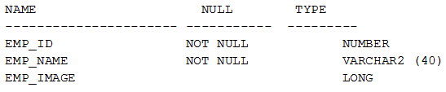  
Which two statements are true regarding SQL statements that can be executed on the EMP_DETAIL TABLE?

* A. An EMP_IMAGE column cannot be included in the ORDER BY clause.
* B. You can alter the table to include the NOT NULL constraint on the EMP_IMAGE column.
* C. You cannot add a new column to the table with LONG as the data type.
* D. An EMP_IMAGE column can be included in the GROUP BY clause.

**Correct Answer:** *AC* 

# Question #192

View the Exhibit and examine the structure of ORDER_ITEMS and ORDERS tables.  
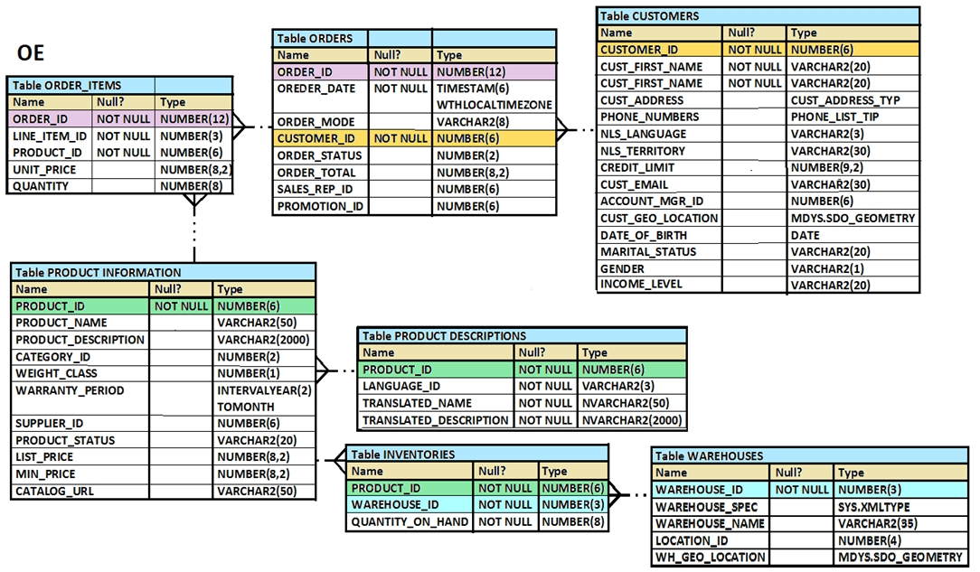  
You need to remove from the ORDER_ITEMS table those rows that have an order status of 0 or 1 in the ORDERS table.  
Which two DELETE statements are valid (Choose two.)

* A. DELETE * FROM order_items WHERE order_id IN (SELECT order_id) FROM orders WHERE order_status IN (0,1));
* B. DELETE FROM (SELECT * FROM order_items I,orders o WHERE i.order_id = o.order_id AND order_status IN (0,1));
* C. DELETE FROM order_items i WHERE order_id = (SELECT order_id FROM orders o WHERE i.order_id = o.order_id AND order_status IN (0,1));
* D. DELETE FROM order_items WHERE order_id IN (SELECT order_id FROM orders WHERE orders_status in (0,1));

**Correct Answer:** *BD* 

# Question #193

The PRODUCTS table has the following structure.  
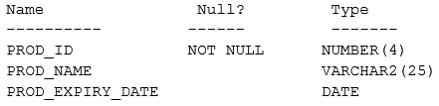  
Evaluate the following two SQL statements:  
SQL>SELECT prod_id, NVL2 (prod_expiry_date, prod_expiry_date + 15, "˜ "˜) FROM products;  
SQL>SELECT prod_id, NVL (prod_expiry_date, prod_expiry_date + 15) FROM products;  
Which statement is true regarding the outcome?

* A. Both the statements execute and give different results
* B. Only the second SQL statement executes successfully
* C. Both the statements execute and give the same result
* D. Only the first SQL statement executes successfully

**Correct Answer:** *A*   
Using the NVL2 Function -  
The NVL2 function examines the first expression. If the first expression is not null, the NVL2 function returns the second expression. If the first expression is null, the third expression is returned.  
  
Syntax -  
NVL2(expr1, expr2, expr3)  
In the syntax:  
Expr1 is the source value or expression that may contain a null  
Expr2 is the value that is returned if expr1 is not null  
Expr3 is the value that is returned if expr1 is null

# Question #194

You executed the following CREATE TABLE statement that resulted in an error:  
SQL> CREATE TABLE employees

(emp_id NUMBER(10) PRIMARY KEY,

ename VARCHAR2(20),

email NUMBER(3) UNIQUE,

address VARCHAR2  
(500),

phone VARCHAR2(20),

resume LONG,

hire_date DATE,

remarks LONG,

dept_id NUMBER(3) CONSTRAINT emp_dept_id_fk REFERENCES departments (dept_id),

CONSTRAINT ename_nn NOT NULL(ename));

Identify two reasons for the error.

* A. The NOT NULL constraint on the ENAME column must be defined as the column level
* B. FOREIGN KEY defined on the DEPT_ID column must be at the table level only
* C. Only one LONG column can be used per table
* D. The FOREIGN KEY keyword is missing in the constraint definition
* E. The PRIMARY KEY constraint in the EMP_ID column must have a name and must be defined at the table level only

**Correct Answer:** *AC* 

# Question #195

View the Exhibit and examine the structure of the CUSTOMERS table.  
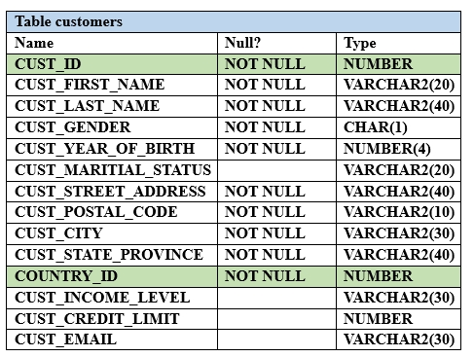  
You want to generate a report showing the last names and credit limits of all customers whose last names start with A, B, or C, and credit limit is below 10,000.  
Evaluate the following two queries:  
SQL> SELECT cust_last_name, cust_credit_limit FROM customers  
WHERE (UPPER(cust_last_name) LIKE "˜A%' OR  
UPPER (cust_last_name) LIKE "˜B%' OR UPPER (cust_last_name) LIKE "˜C%')  
AND cust_credit_limit < 10000;  
SQL>SELECT cust_last_name, cust_credit_limit FROM customers  
WHERE UPPER (cust_last_name) BETWEEN "˜A' AND "˜C'  
AND cust_credit_limit < 10000;  
Which statement is true regarding the execution of the above queries?

* A. Only the second query gives the correct result
* B. Both execute successfully but do not give the required result
* C. Only the first query gives the correct result
* D. Both execute successfully and give the same result

**Correct Answer:** *C*   
Between ‘A’ and ‘C’ means: AA…, AB…, ..,AZ..,…, BA..,BB…,…, BZ..,C  
If you put any sign after C it is not between A and C. It is then – starting with C, meaning like ‘C%’.

# Question #196

Evaluate the following CREATE TABLE commands:  
  
CREATE_TABLE orders -  
(ord_no NUMBER (2) CONSTRAINT ord_pk PRIMARY KEY,  
ord_date DATE,  
cust_id NUMBER (4));  
  
CREATE TABLE ord_items -  
(ord _no NUMBER (2),  
item_no NUMBER(3),  
qty NUMBER (3) CHECK (qty BETWEEEN 100 AND 200),  
expiry_date date CHECK (expiry_date> SYSDATE),  
CONSTRAINT it_pk PRIMARY KEY (ord_no, item_no),  
CONSTARAINT ord_fk FOREIGN KEY (ord_no) REFERENCES orders (ord_no) );  
Why would the ORD_ITEMS table not get created?

* A. SYSDATE cannot be used with the CHECK constraint.
* B. The BETWEEN clause cannot be used twice for the same table.
* C. The CHECK constraint cannot be placed on columns having the DATE data type.
* D. ORD_NO and ITEM_NO cannot be used as a composite primary key because ORD_NO is also the FOREIGN KEY.

**Correct Answer:** *A* 

# Question #197

View the Exhibit and examine the structure of the PRODUCT table.  
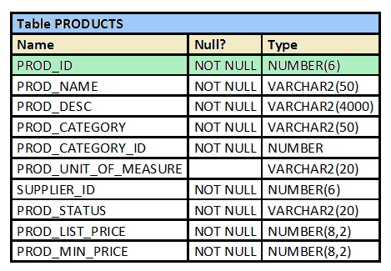  
Which two tasks would require subqueries? (Choose two.)

* A. display all products whose minimum list price is more than the average list price of products having the status "˜orderable'
* B. display the total number of products supplied by supplier 102 and have product status as "˜OBSOLETE'
* C. display the number of products whose list prices are more than the average list price
* D. display all suppliers whose list price is more than 1000
* E. display the minimum list price for each product status

**Correct Answer:** *AC* 

# Question #198

Examine the structure of the EMPLOYEES table:  
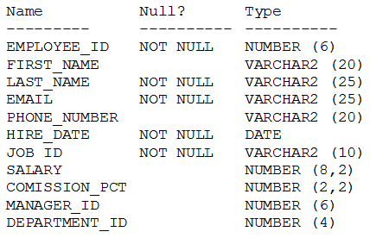  
There is a parent/child relationship between EMPLOYEE_ID and MANAGER_ID.  
You want to display the name, joining date, and manager for all employees. Newly hired employees are yet to be assigned a department or a manager. For them, "˜No Manager' should be displayed in the MANAGER column.  
Which SQL query gets the required output?

* A. SELECT e.last_name, e.hire_date, NVL(m.last_name, "˜No Manager') Manager FROM employees e JOIN employees m ON (e.manager_id = m.employee_id);
* B. SELECT e.last_name, e.hire_date, NVL(m.last_name, "˜No Manager') Manager FROM employees e LEFT OUTER JOIN employees m ON (e.manager_id = m.employee_id);
* C. SELECT e.last_name, e.hire_date, NVL(m.last_name, "˜No Manager') Manager FROM employees e RIGHT OUTER JOIN employees m ON (e.manager_id = m.employee_id);
* D. SELECT e.last_name, e.hire_date, NVL(m.last_name, "˜No Manager') Manager FROM employees e NATURAL JOIN employees m ON (e.manager_id = m.employee_id).

**Correct Answer:** *B* 

# Question #199

View the Exhibit and examine the structure of ORDERS and CUSTOMERS tables.  
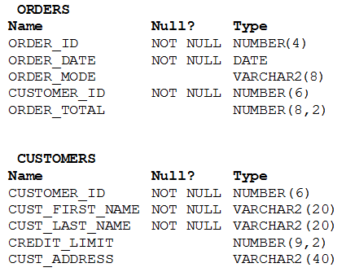  
There is only one customer with the cust_last_name column having value Roberts. Which INSERT statement should be used to add a row into the ORDERS table for the customer whose CUST_LAST_NAME is Roberts and CREDIT_LIMIT is 600?

* A. INSERT INTO orders VALUES(1, '10-mar-2007', "˜direct', (SELECT customer_id FROM customers WHERE cust_last_name='Roberts' AND credit_limit=600), 1000);
* B. INSERT INTO orders (order_id, order_data, order_mode, (SELECT customer_id FROM customers WHERE cust_last_name='Roberts' AND credit_limit=600), order_total) VALUES(1, '10-mar-2007', "˜direct', &&customer_id, 1000);
* C. INSERT INTO(SELECT o.order_id, o.order_date, o.order_mode, c.customer_id, o.order_total FROM orders o, customers c WHERE o.customer_id = c.customer_id AND c.cust_last_name='Roberts' AND c.credit_limit=600 ) VALUES (1, '10-mar-2007', "˜direct', (SELECT customer_id FROM customers WHERE cust_last_name='Roberts' AND credit_limit=600), 1000);
* D. INSERT INTO orders (order_id, order_data, order_mode, (SELECT customer_id FROM customers WHERE cust_last_name='Roberts' AND credit_limit=600), order_total) VALUES (1, '10-mar-2007', "˜direct', &customer_id, 1000).

**Correct Answer:** *A* 

# Question #200

View the Exhibit and examine the data in EMP and DEPT tables.  
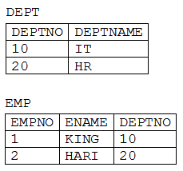  
In the DEPT table, DEPTNO is the PRIMARY KEY.  
In the EMP table, EMPNO is the PRIMARY KEY and DEPTNO is the FOREIGN KEY referencing the DEPTNO column in the DEPT table.  
What would be the outcome of the following statements executed in the given sequence?  
DROP TABLE emp;  
FLASHBACK TABLE emp TO BEFORE DROP;  
INSERT INTO emp VALUES (2, "˜SCOTT', 10);  
INSERT INTO emp VALUES (3, "˜KING', 55);

* A. Both the INSERT statements would fail because the constraints are automatically retrieved when the table is flashed back.
* B. Both the INSERT statements would succeed because none of the constraints on the table are automatically retrieved when the table is flashed back.
* C. Only the first INSERT statement would succeed because all constraints except the primary key constraint are automatically retrieved after a table is flashed back.
* D. Only the SECOND INSERT statement would succeed because all the constraints except referential integrity constraints that reference other tables are retrieved automatically after the table is flashed back.

Correct Answer: *D*

<https://docs.oracle.com/en/database/oracle/oracle-database/12.2/sqlrf/FLASHBACK-TABLE.html#GUID-FA9AF2FD-2DAD-4387-9E62-14AFC26EA85C>

At the completion of the Flashback Table operation, the data in *table* is consistent with *table* at the earlier time. However, FLASHBACK TABLE TO SCN or TIMESTAMP does not preserve rowids, and FLASHBACK TABLE TO BEFORE DROP does not recover referential constraints.

# Question #201

Which three tasks can be performed by DDL statements?

* A. providing an alternative name for a table
* B. modifying a table to prevent data that violate certain conditions from being entered in a column
* C. preventing any data modification to a table
* D. preventing data retrieval from a table outside of office hours
* E. creating multiple savepoints to enable partial rollback of a transaction

**Correct Answer:** *ABC* 

# Question #202

View the Exhibit and examine the structure of the ORDER_ITEMS and ORDERS tables.  
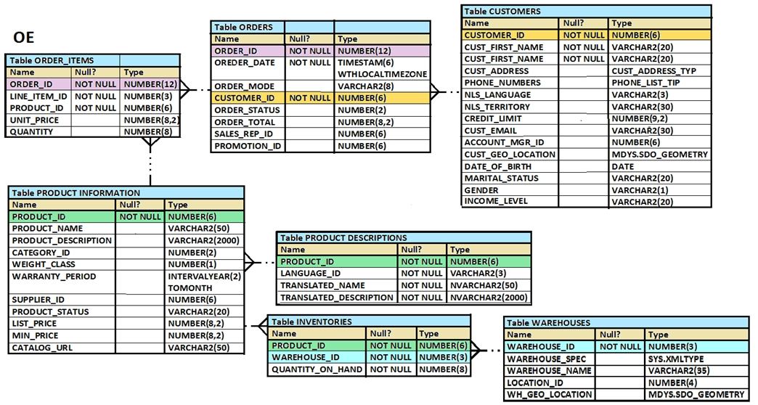  
You are asked to retrieve the ORDER_ID, product_ID, and total price (UNIT_PRICE multiplied by QUANTITY), where the total price is greater than 50,000.  
You executed the following SQL statement:  
prder_id, product_id, unit_price*quantity "Total Price"  
  
SELECT -  
  
FROM order_items -  
WHERE unit_price*quantity > 50000  
NATURAL JOIN orders;  
Which statement is true regarding the execution of the statement?

* A. The statement would execute and provide the desired result.
* B. The statement would not execute because the ON keyword is missing in the NATURAL JOIN clause.
* C. The statement would not execute because the WHERE clause is before the NATURAL JOIN clause.
* D. The statement would not execute because the USING keyword is missing in the NATURAL JOIN clause.

**Correct Answer:** *C* 

# Question #203

Which two statements are true regarding operators used with subqueries (Choose two.)

* A. The NOT IN operator is equivalent to IS NULL.
* B. The <ANY operator means less than the maximum.
* C. =ANY and =ALL operators have the same functionality.
* D. The IN operator cannot be used in single-row subqueries.
* E. The NOT operator can be used with IN, ANY and ALL operators.

**Correct Answer:** *BE* 

# Question #204

Examine the structure of the SHIPMENTS table:  
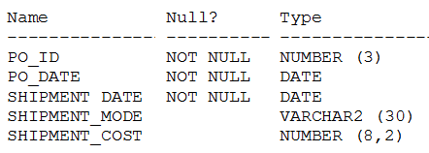  
You want to generate a report that displays the PO_ID and the penalty amount to be paid if the SHIPMENT_DATE is later than one month from the PO_DATE. The penalty is $20 per day.  
Evaluate the following two queries:  
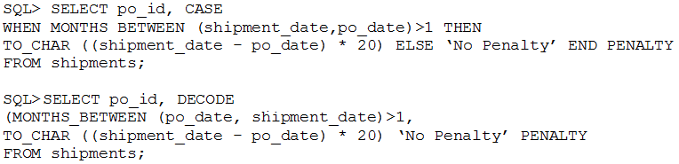  
Which statement is true regarding the above commands?

* A. Both execute successfully and give correct results.
* B. Only the first query executes successfully but gives a wrong result.
* C. Only the first query executes successfully and gives the correct result.
* D. Only the second query executes successfully but gives a wrong result.
* E. Only the second query executes successfully and gives the correct result.

**Correct Answer:** *C* 

# Question #205

Examine the structure and data in the PRICE_LIST table:  
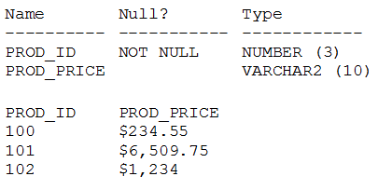  
You plan to give a discount of 25% on the product price and need to display the discount amount in the same format as the PROD_PRICE.  
Which SQL statement would give the required result?

* A. SELECT TO_CHAR (prod_price* .25, "˜$99,999.99') FROM PRICE_LIST
* B. SELECT TO_CHAR (TO_NUMBER(prod_price) * .25, "˜$99,999.00') FROM PRICE_LIST
* C. SELECT TO_CHAR (TO_NUMBER(prod_price, "˜$99,999.99') * . 25, "˜$99,999.00') FROM PRICE_LIST
* D. SELECT TO_NUMBER (TO_NUMBER(prod_price, "˜$99,999.99') * . 25, "˜$99,999.00') FROM PRICE_LIST

**Correct Answer:** *C* 

# Question #206

View the Exhibit and examine the data in the PRODUCTS table.  
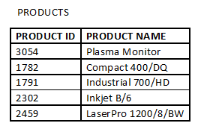  
Which statement would add a column called PRICE, which cannot contain NULL?

* A. ALTER TABLE products ADD price NUMBER(8,2) NOT NULL;
* B. ALTER TABLE products ADD price NUMBER(8,2) DEFAULT NOT NULL;
* C. ALTER TABLE products ADD price NUMBER(8,2) DEFAULT 0 NOT NULL;
* D. ALTER TABLE products ADD price NUMBER(8,2) DEFAULT CONSTRAINT p_nn NOT NULL.

**Correct Answer:** *C* 

Question #207

The customers table has the following structure:  
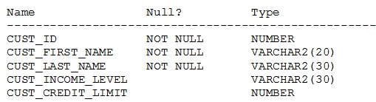  
You need to write a query that does the following tasks:  
1. Display the first name and tax amount of the customers. Tax is 5% of their credit limit.  
2. Only those customers whose income level has a value should be considered.  
3. Customers whose tax amount is null should not be considered.  
Which statement accomplishes all the required tasks?

* A. SELECT cust_first_name, cust_credit_limit * .05 AS TAX_AMOUNT FROM customers WHERE cust_income_level IS NOT NULL AND tax_amount IS NOT NULL;
* B. SELECT cust_first_name, cust_credit_limit * .05 AS TAX_AMOUNT FROM customers WHERE cust_income_level IS NOT NULL AND cust_credit_limit IS NOT NULL;
* C. SELECT cust_first_name, cust_credit_limit * .05 AS TAX_AMOUNT FROM customers WHERE cust_income_level <> NULL AND tax_amount <> NULL;
* D. SELECT cust_first_name, cust_credit_limit * .05 AS TAX_AMOUNT FROM customers WHERE (cust_income_level, tax_amount) IS NOT NULL;

**Correct Answer:** *B*   
The question is about tax_amount, so it cant be B. Therefore, it’s definitely A.

yeah, but tax_amount is not a column, it has been defined later..therefore you need to check cust_credit_limit in where clause…

# Question #208

View the Exhibit and examine the structure of the SALES table.  
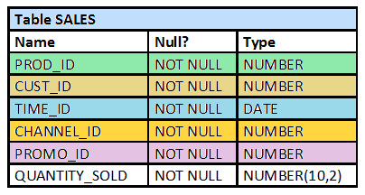  
The following query is written to retrieve all those product IDs from the SALES table that have more than 55000 sold and have been ordered more than 10 items.  
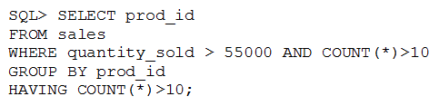  
Which statement is true regarding this SQL statement?

* A. It executes successfully and generates the required result.
* B. It produces an error because COUNT (*) should be specified in the SELECT clause also.
* C. It produces an error because COUNT (*) should be only in the HAVING clause and not in the WHERE clause.
* D. It executes successfully but produces no result because COUNT(prod_id) should be used instead of COUNT(*).

**Correct Answer:** *C* 

# Question #209

View the Exhibit and examine the description for the PRODUCTS and SALES table.  
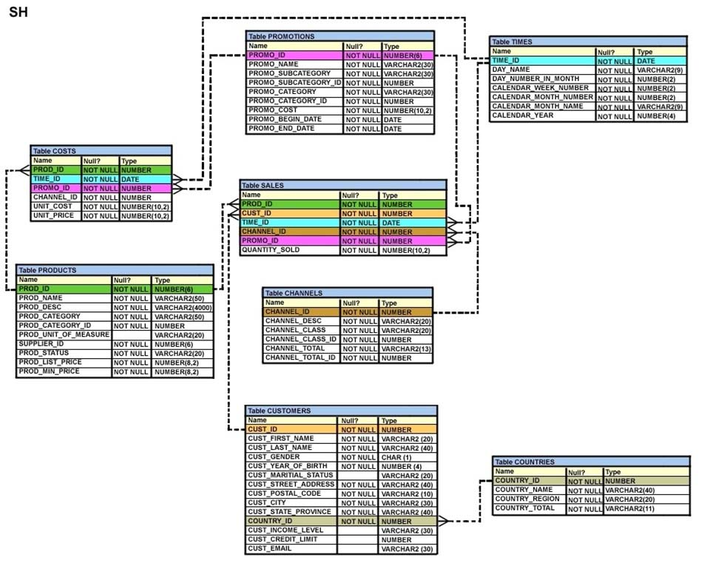 is a primary key in the PRODUCTS table and foreign key in the SALES table with ON DELETE CASCADE option. The SALES table contains data for the  
  
PROD_ID -  
last three years. You want to remove all the rows from the PRODUCTS table for which no sale was done for the last three years.  
Which is the valid DELETE statement?

* A. DELETE FROM products WHERE prod_id = (SELECT prod_id FROM sales WHERE time_id - 3*365 = SYSDATE );
* B. DELETE FROM products WHERE prod_id = (SELECT prod_id FROM sales WHERE SYSDATE >= time_id - 3*365 );
* C. DELETE FROM products WHERE prod_id IN (SELECT prod_id FROM sales WHERE SYSDATE - 3*365 >= time_id);
* D. DELETE FROM products WHERE prod_id IN (SELECT prod_id FROM sales WHERE time_id >= SYSDATE - 3*365 );

**Correct Answer:** *C* 

# Question #210

Examine the data in the CUST_NAME column of the CUSTOMERS table.  
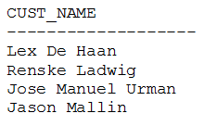  
You want to extract only those customer names that have three names and display the * symbol in place of the first name as follows:  
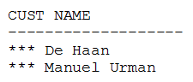  
Which two queries give the required output?

* A. SELECT LPAD(SUBSTR(cust_name, INSTR(cust_name, ' ')),LENGTH(cust_name),'*') "CUST NAME" FROM customers WHERE INSTR(cust_name, ' ',1,2)<>0;
* B. SELECT LPAD(SUBSTR(cust_name, INSTR(cust_name, ' ')),LENGTH(cust_name),'*') "CUST NAME" FROM customers WHERE INSTR(cust_name, ' ',-1,2)<>0;
* C. SELECT LPAD(SUBSTR(cust_name, INSTR (cust_name ' ')),LENGTH(cust_name) - INSTR(cust_name, ' '), '*') "CUST NAME" FROM customers WHERE INSTR(cust_name, ' ',1,-2)<>0;
* D. SELECT LPAD(SUBSTR(cust_name, INSTR (cust_name ' ')),LENGTH(cust_name) - INSTR(cust_name, ' '), '*') "CUST NAME" FROM customers WHERE INSTR(cust_name, ' ',1,2)<>0;

Correct Answer: *AB*

# Question #211

View the Exhibit and examine the structure of the BOOKS table.  
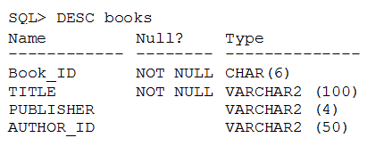  
The BOOKS table contains details of 100 books.  
Examine the commands executed and their outcome:  
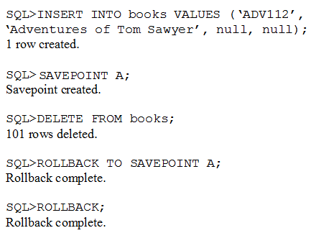  
Which statement is true?

* A. Both ROLLBACK commands restore the 101 rows that were deleted.
* B. Both ROLLBACK commands restore the 100 rows that were deleted.
* C. The first rollback restores the 101 rows that were deleted and the second rollback causes the row was inserted to be deleted and commits the changes.
* D. The first rollback restores the 100 rows that were deleted and the second rollback commits only the changes.

**Correct Answer:** *C* 

# Question #212

Which statement is true about the Oracle SQL, DELETE and TRUNCATE statements?

* A. DELTE and TRUNCATE statements can have a rollback done to restore data into a table.
* B. DELETE and TRUNCATE statements remove all indexes for the tables on which they are performed.
* C. DELETE but not TRUNCATE statement can be used to remove data from selective columns and rows of a table.
* D. DELETE but not TRUNCATE statement can be used to selectively remove rows from a table.

**Correct Answer:** *D* 

# Question #213

View the Exhibit and examine the description of the EMPLOYEES table.  
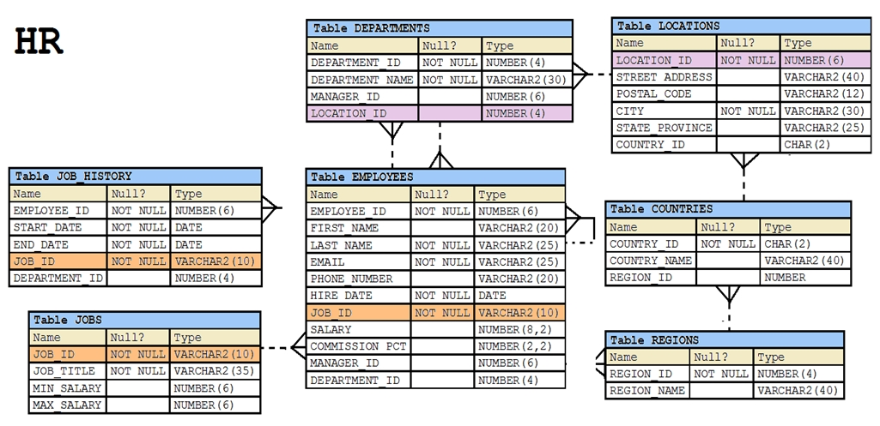  
Evaluate the following SQL statement:  
SELECT first_name, employee_id, NEXT_DAY(ADD_MONTHS(hire_date, 6), 1) "Review" FROM employees;  
The query was written to retrieve the FIRST_NAME, EMPLOYEE_ID, and review date for employees. The review date is the firsts Monday after the completion of six months of the hiring. The NLS_TERRITORY parameter is set to AMERICA in the session.  
Which statement is true regarding this query?

* A. The query would execute to give the desired output.
* B. The query would not execute because date functions cannot be nested.
* C. The query would execute but the output would give review dates that are Sundays.
* D. The query would not execute because the NEXT_DAY function accepts a string as argument.

**Correct Answer:** *C* 

# Question #214

View the Exhibit and examine the structure of the CUSTOMERS table.  
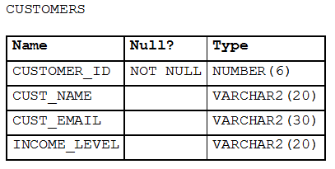

is a view based on CUSTOMERS_BR1 table which has the same structure as CUSTOMERS table.  
  
CUSTOMER_VU -  
need to be updated to reflect the latest information about the customers.  
  
CUSTOMERS -  
What is the error in the following MERGE statement?  
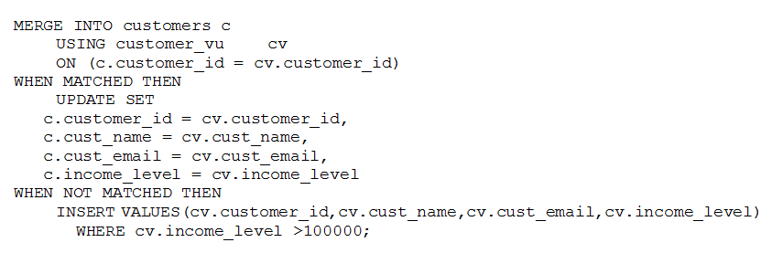

* A. The CUSTOMER_ID column cannot be updated.
* B. The INTO clause is misplaced in the command.
* C. The WHERE clause cannot be used with INSERT.
* D. CUSTOMER_VU cannot be used as a data source.

**Correct Answer:** *A*   
<https://docs.oracle.com/database/121/SQLRF/statements_9017.htm#SQLRF01606>

# Question #215

Evaluate the following SQL statement:  
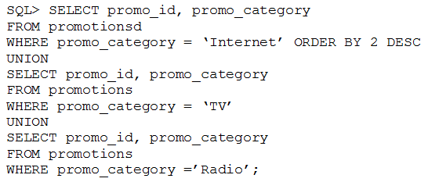  
Which statement is true regarding the outcome of the above query?

* A. It executes successfully and displays rows in the descending order of PROMO_CATEGORY.
* B. It produces an error because positional notation cannot be used in the ORDER BY clause with SET operators.
* C. It executes successfully but ignores the ORDER BY clause because it is not located at the end of the compound statement.
* D. It produces an error because the ORDER BY clause should appear only at the end of a compound query-that is, with the last SELECT statement.

**Correct Answer:** *D* 

# Question #216

View the Exhibit and examine the structure of the ORDERS table. The columns ORDER_MODE and ORDER_TOTAL have the default values "˜direct' and 0 respectively.  
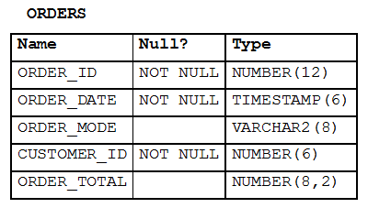  
Which two INSERT statements are valid? (Choose two.)

* A. INSERT INTO orders VALUES (1,'09-mar-2007', "˜online','', 1000);
* B. INSERT INTO orders (order_id,order_date,order_mode, (customer_id,order_total) VALUES (1,TO_DATE(NULL), "˜online', 101, NULL);
* C. INSERT INTO (SELECT order_id,order_date,customer_id FROM orders) VALUES (1,'09-mar-2007', 101);
* D. INSERT INTO orders VALUES (1,'09-mar-2007', DEFAULT, 101, DEFAULT);
* E. INSERT INTO orders (order_id,order_date,order_mode,order_total) VALUES (1,'10-mar-2007',"˜online',1000);

**Correct Answer:** *CD* 

# Question #217

Which two statements are true? (Choose two.)

* A. The USER_SYNONYMS view can provide information about private synonyms.
* B. The user SYSTEM owns all the base tables and user-accessible views of the data dictionary.
* C. All the dynamic performance views prefixed with v$ are accessible to all the database users.
* D. The USER_OBJECTS view can provide information about the tables and views created by the user who queries the view.
* E. DICTIONARY is a view that contains the names of all the data dictionary views that the user can access.

**Correct Answer:** *AD* 

# Question #218

What is the primary difference between the relational database (RDB) and object-oriented database (OODB) models?

* A. OODB supports multiple objects in the same database, whereas RDB supports only tables.
* B. RDB supports only E.F. Codd's rules, whereas OODB does not support them.
* C. OODB incorporates methods with data structure definition, whereas RDB does not allow this.
* D. RDB allows the definition of relationships between different tables, whereas OODB does not allow this.

**Correct Answer:** *C* 

# Question #219

Examine the command to create the BOOKS table.  
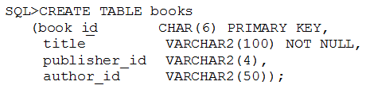  
The BOOK_ID value 101 does not exist in the table.  
Examine the SQL statement:  
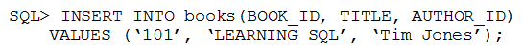  
Which statement is true?

* A. It executes successfully and the row is inserted with a rule PUBLISHER_ID.
* B. It executes successfully only if NULL is explicitly specified in the INSERT statement.
* C. It executes successfully only if the PUBLISHER_ID column name is added to the columns list in the INSERT statement.
* D. It executes successfully only if the PUBLISHER_ID column name is added to the columns list and NULL is explicitly specified in the INSERT statement.

**Correct Answer:** *A* 

# Question #220

You need to list the employees in DEPARTMENT_ID 20 days in a single row, ordered by HIRE_DATE.  
Examine the sample output:  
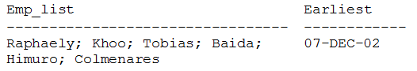  
Which query will provide the required output?

* A. SELECT LISTAGG(last_name) WITHIN GROUP ORDER BY (hire_date) "Emp_list", MIN(hire_date) "Earliest" FROM employees WHERE department_id = 30;
* B. SELECT LISTAGG(last_name, '; ') WITHIN GROUP ORDER BY (hire_date) "Emp_list", MIN(hire_date) "Earliest" FROM employees WHERE department_id = 30;
* C. SELECT LISTAGG(last_name, '; ') "Emp_list", MIN(hire_date) "Earliest" FROM employees WHERE department_id = 30; WITHIN GROUP ORDER BY (hire_date);
* D. SELECT LISTAGG(last_name, '; ') "Emp_list", MIN(hire_date) "Earliest" FROM employees WHERE department_id = 30; ORDER BY (hire_date);

Correct Answer: *B*

<https://www.red-gate.com/simple-talk/sql/oracle/introduction-to-analytic-functions-part-2/>

# Question #221

Examine the structure of the DEPARTMENTS table.  
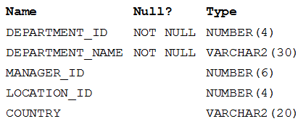  
You execute the following command:  
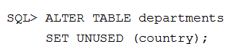  
Which two statements are true?

* A. Synonyms existing of the DEPARTMENTS table would have to be re-created.
* B. Unique key constraints defined on the COUNTRY column are removed.
* C. Views created in the DEPARTMENTS table that include the COUNTRY column are automatically modified and remain valid.
* D. Indexes created on the COUNTRY column exist until the DROP UNUSED COLUMNS command is executed.
* E. A new column, COUNTRY, can be added to the DEPARTMENTS table after executing the command.

**Correct Answer:** *BE* 

# Question #222

View the exhibit and examine the description of SALES and PROMOTIONS tables.  
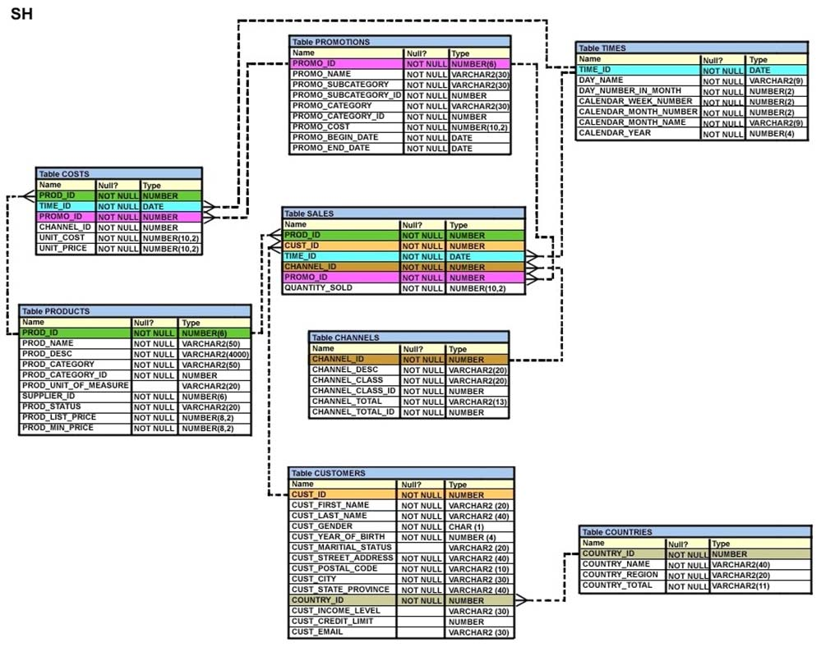  
You want to delete rows from the SALES table, where the PROMO_NAME column in the PROMOTIONS table has either blowout sale or everyday low price as values.  
Which three DELETE statements are valid? (Choose three.)

* A. DELETE FROM sales WHERE promo_id = (SELECT promo_id FROM promo_name = "˜blowout sale') AND promo_id = (SELECT promo_id FROM promotions WHERE promo_name = "˜everyday low price') FROM promotions WHERE promo_name = "˜everyday low price');
* B. DELETE FROM sales WHERE promo_id = (SELECT promo_id FROM promotions WHERE promo_name = "˜blowout sale') OR promo_id = (SELECT promo_id FROM promotions WHERE promo_name = "˜everyday low price')
* C. DELETE FROM sales WHERE promo_id = (SELECT promo_id FROM promotions WHERE promo_name = "˜blowout sale') OR promo_name = "˜everyday low price');
* D. DELETE FROM sales WHERE promo_id IN (SELECT promo_id FROM promotions WHERE promo_name IN = "˜blowout sale',"˜everyday low price'));

**Correct Answer:** *BCD* 

# Question #223

You need to display the first names of all customers from the CUSTOMERS table that contain the character "˜e' and have the character "˜a' in the second last position.  
Which query would give the required output?

* A. SELECT cust_first_name FROM customers WHERE INSTR(cust_first_name, "˜e')<>0 AND SUBSTR(cust_first_name, -2, 1)='a';
* B. SELECT cust_first_name FROM customers WHERE INSTR(cust_first_name, "˜e')<>'' AND SUBSTR(cust_first_name, -2, 1)='a';
* C. SELECT cust_first_name FROM customers WHERE INSTR(cust_first_name, "˜e')IS NOT NULL AND SUBSTR(cust_first_name, 1, -2)='a';
* D. SELECT cust_first_name FROM customers WHERE INSTR(cust_first_name, "˜e')<>0 AND SUBSTR(cust_first_name, LENGTH(cust_first_name), -2)='a';

**Correct Answer:** *A* 

# Question #224

Examine the data in the ORD_ITEMS table:  
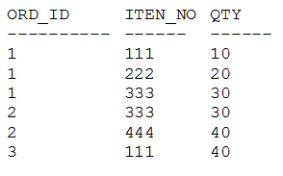  
Evaluate this query:  
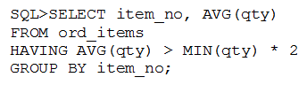  
Which statement is true regarding the result?

* A. It returns an error because the HAVING clause should be specified after the GROUP BY clause.
* B. It returns an error because all the aggregate functions used in the HAVING clause must be specified in the SELECT list.
* C. It displays the item nos with their average quantity where the average quantity is more than double the minimum quantity of that item in the table.
* D. It displays the item nos with their average quantity where the average quantity is more than double the overall minimum quantity of all the items in the table.

**Correct Answer:** *C* 

# Question #225

Which two statements are true regarding the DELETE and TRUNCATE commands?

* A. DELETE can be used to remove rows from only one table in one statement.
* B. DELETE can be used to remove rows from multiple tables in one statement.
* C. DELETE can be used to remove rows only for tables that are parents for a child table that has a referential integrity constraint referring to the parent.
* D. DELETE can be used to remove data from specific columns as well as complete rows.
* E. DELETE and TRUNCATE can be used for tables that are parents for a child table that has a referential integrity constraint having an ON DELETE rule.

**Correct Answer:** *AE* 

# Question #226

The SQL statements executed in a user session are as follows:  
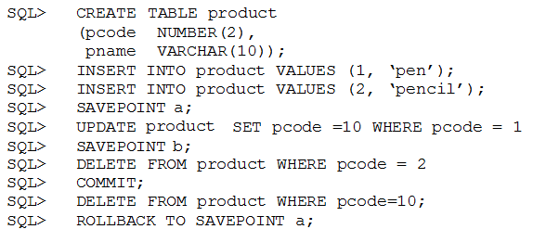  
Which two statements describe the consequences of issuing the ROLLBACK TO SAVE POINT a command in the session? (Choose two.)

* A. The rollback generates an error.
* B. No SQL statements are rolled back.
* C. Only the DELETE statements are rolled back.
* D. Only the second DELETE statement is rolled back.
* E. Both the DELETE statements and the UPDATE statement are rolled back.

**Correct Answer:** *AB* 

# Question #227

View the Exhibit and examine the structure of the PRODUCT_INFORMATION table.  
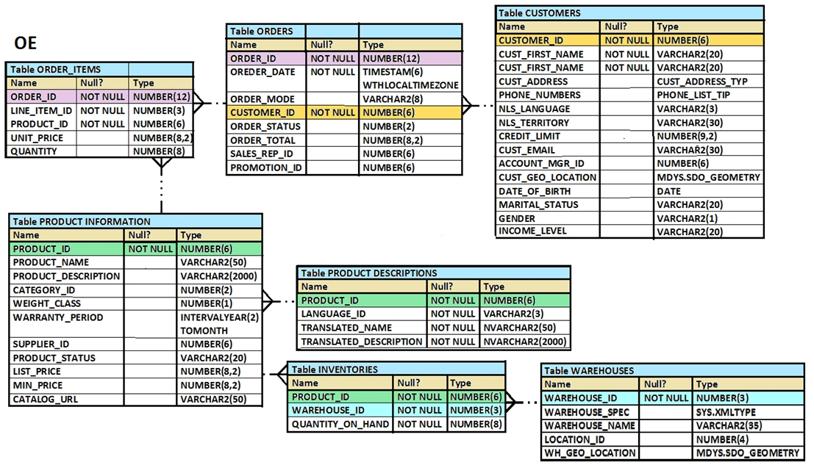  
You want to see the product names and the date of expiration of warranty for all the products, if the product is purchased today. The products that have no warranty should be displayed at the top and the products with maximum warranty period should be displayed at the bottom.  
Which SQL statement would you execute to fulfill this requirement?

* A. SELECT product_name, SYSDATE+warranty_period AS "Warranty expire date" FROM product_information ORDER BY SYSDATE-warranty_period
* B. SELECT product_name, SYSDATE+warranty_period AS "Warranty expire date" FROM product_information ORDER BY SYSDATE+warranty_period
* C. SELECT product_name, SYSDATE+warranty_period AS "Warranty expire date" FROM product_information ORDER BY SYSDATE
* D. SELECT product_name, SYSDATE+warranty_period AS "Warranty expire date" FROM product_information WHERE warranty_period > SYSDATE

**Correct Answer:** *B* 

# Question #228

Examine the description of the CUSTOMERS table:  
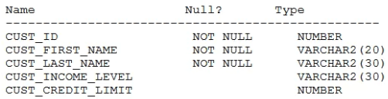  
For customers whose income level has a value, you want to display the first name and due amount as 5% of their credit limit. Customers whose due amount is null should not be displayed.  
Which query should be used?

1. 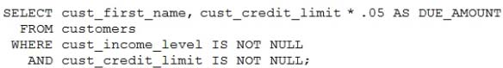
2. 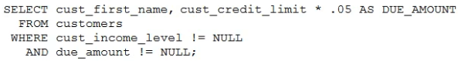
3. 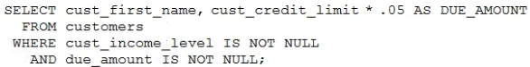
4. 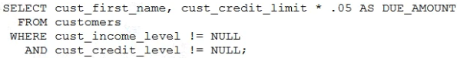
5. 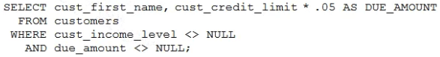

**Correct Answer:** *A* 

# Question #229

Examine the description of the PRODUCT_DETAILS table:  
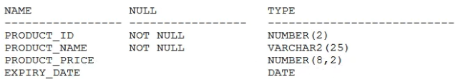  
Which two statements are true?

* A. PRODUCT_PRICE contains the value zero by default if no value is assigned to it.
* B. PRODUCT_PRICE can be used in an arithmetic expression even if it has no value stored in it.
* C. EXPIRY_DATE cannot be used in arithmetic expressions.
* D. PRODUCT_ID can be assigned the PRIMARY KEY constraint.
* E. EXPIRY_DATE contains the SYSDATE by default if no date is assigned to it.
* ~~F. PRODUCT_NAME cannot contain duplicate values.~~

**Correct Answer:** *~~CF~~* >> BD

# Question #230

Which two are true about the data dictionary?

* A. The SYS user owns all base tables and user-accessible views in the data dictionary.
* B. All users have permissions to access all information in the data dictionary by default.
* C. The data dictionary is constantly updated to reflect changes to database objects, permissions, and data.
* D. All user actions are recorded in the data dictionary.
* E. Base tables in the data dictionary have the prefix DBA_.

**Correct Answer:** *AC*  
Reference:  
https://docs.oracle.com/cd/B28359_01/server.111/b28318/datadict.htm#CNCPT1215

# Question #231

Which three statements are true about views in an Oracle Database?

* ~~A. Views can join tables only if they belong to the same schema.~~
* B. A view can be created that refers to a non-existent table in its defining query.
* ~~C. Views have no object number.~~
* D. Views have no segment.
* E. Rows inserted into a table using a view are retained in the table if the view is dropped.
* F. A SELECT statement cannot contain a WHERE clause when querying a view containing a WHERE clause in its defining query.

**Correct Answer:** *~~A~~B~~C~~* >> BDE  
Reference:  
https://docs.oracle.com/cd/B28359_01/server.111/b28286/statements_8004.htm#SQLRF01504 https://community.oracle.com/thread/2178948

Specify FORCE if you want to create the view regardless of whether the base tables of the view or the referenced object types exist or the owner of the schema containing the view has privileges on them.

# Question #232

Examine the description of the CUSTOMERS table:  
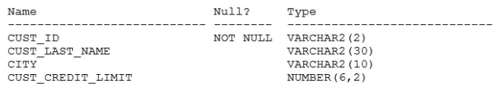  
You need to display last names and credit limits of all customers whose last name starts with A or B in lower or upper case, and whose credit limit is below 1000.  
Examine this partial query:  
  
Which **two** WHERE conditions give the required result?

1. 
2. 
3. 
4. 
5. 

**Correct Answer:** *E* >> AD

# Question #233

Examine the data in the CUST_NAME column of the CUSTOMERS table:  
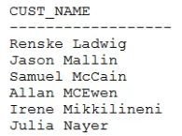  
You want to display the CUST_NAME values where the last name starts with Mc or MC.  
Which **two** WHERE clauses give the required result?

* A. WHERE SUBSTR (cust_name, INSTR (cust_name, "˜') +1) LIKE "˜Mc%'
* B. WHERE INITCAP (SUBSTR (cust_name, INSTR(cust_name, "˜')+1)) IN ("˜MC%', "˜Mc%)
* C. WHERE UPPER (SUBSTR (cust_name, INSTR(cust_name, "˜')+1)) LIKE UPPER ("˜MC%')
* D. WHERE SUBSTR (cust_name, INSTR (cust_name, "˜') +1) LIKE "˜Mc%' OR "˜MC%'
* E. WHERE INITCAP (SUBSTR (cust_name, INSTR(cust_name, "˜')+1)) LIKE "˜Mc%'

**Correct Answer:** *A* >> CE

# Question #234

Which three are true about the MERGE statement?

* A. It can combine rows from multiple tables conditionally to insert into a single table.
* B. It can merge rows only from tables.
* C. It can use subqueries to produce source rows.
* D. It can update, insert, or delete rows conditionally in multiple tables.
* E. It can update the same row of the target table multiple times.
* F. It can use views to produce source rows.

**Correct Answer:** *CDF*   
Reference:  
https://www.oracletutorial.com/oracle-basics/oracle-merge/

# Question #235

Which three actions can you perform only with system privileges?

* A. Query any table in a database.
* B. Log in to a database.
* C. Access flat files via a database, which are stored in an operating system directory.
* D. Truncate a table in another schema.
* E. Execute a procedure in another schema.
* F. Use the WITH GRANT OPTION clause.

**Correct Answer:** *ABF*   
<https://docs.oracle.com/cd/B19306_01/server.102/b14200/statements_9013.htm>

# Question #236

Which three are true about multitable INSERT statements?

* A. They can be performed on external tables using SQL* Loader.
* B. They can be performed on relational tables.
* C. They can be performed only by using a subquery.
* D. They can insert each computed row into more than one table.
* E. They can be performed on views.
* F. They can be performed on remote tables.

**Correct Answer:** *ABC*   
Reference:  
https://www.akadia.com/services/ora_multitable_insert.html

https://oracle-base.com/articles/9i/multitable-inserts

# Question #237

Examine the description of the SALES table:  
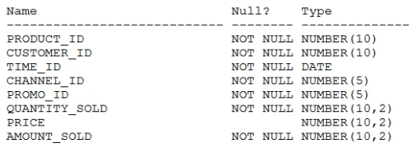  
The SALES table has 55,000 rows.  
Examine this statement:  
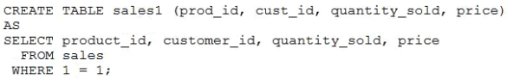  
Which two statements are true?

* A. SALES1 has NOT NULL constraints on any selected columns which had those constraints in the SALES table.
* B. SALES1 is created with 55,000 rows.
* C. SALES1 has PRIMARY KEY and UNIQUE constraints on any selected columns which had those constraints in the SALES table.
* D. SALES1 is created with no rows.
* E. SALES1 is created with 1 row.

**Correct Answer:** *AD* >> AB  
Reference:  
https://www.oracle.com/a/ocom/docs/dc/ww-ou-5297-database2019-studyguide-5.pdf

# Question #238

Which three statements are true about GLOBAL TEMPORARY TABLES?

* A. A GLOBAL TEMPORARY TABLE can have multiple indexes.
* B. A GLOBAL TEMPORARY TABLE cannot have a PUBLIC SYNONYM.
* C. A trigger can be created on a GLOBAL TEMPORARY TABLE.
* D. A GLOBAL TEMPORARY TABLE can be referenced in the defining query of a view.
* E. A GLOBAL TEMPORARY TABLE can have only one index.
* ~~F. Data Manipulation Language (DML) on GLOBAL TEMPORARY TABLES generates no REDO.~~

**Correct Answer:** *CDF* >> ACD  
Reference:  
https://books.google.com.pk/books?id=oP88fSdbQJIC&pg=PA11&lpg=PA11&dq=oracle+database+GLOBAL+TEMPORARY+TABLES+Data  
+Manipulation+Language+(DML)+on+GLOBAL+TEMPORARY+TABLES+generates+no  
+REDO&source=bl&ots=F7EL8Y0ST9&sig=ACfU3U1KuLlqyyJFxqAG1LRT4OxprsVZdg&hl=en&sa=X&ved=2ahUKEwi0xdPU94vlAhWp34UKHUYpBtAQ6AEwA  
HoECAkQAQ#v=onepage&q=oracle%20database%20GLOBAL%20TEMPORARY%20TABLES%20Data%20Manipulation%20Language%20(DML)%20on%  
20GLOBAL%20TEMPORARY%20TABLES%20generates%20no%20REDO&f=false

<https://oracle-base.com/articles/misc/temporary-tables>

# Question #239

Which two statements are true about the results of using the INTERSECT operator in compound queries?

* ~~A. INTERSECT ignores NULLs.~~
* B. Reversing the order of the intersected tables can sometimes affect the output.
* C. The number of columns in each SELECT in the compound query can be different.
* D. INTERSECT returns rows common to both sides of the compound query.
* E. Column names in each SELECT in the compound query can be different.

**Correct Answer:** *AE* >> DE

# Question #240

Examine the description of the CUSTOMERS table:  
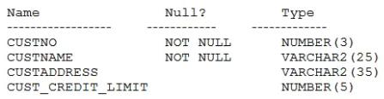 is the PRIMARY KEY.  
  
CUSTNO -  
You must determine if any customers' details have been entered more than once using a different CUSTNO, by listing all duplicate names.  
Which two methods can you use to get the required result?

* A. LEFT OUTER JOIN with self join
* B. self join
* C. RIGHT OUTER JOIN with self join
* D. FULL OUTER JOIN with self join
* E. subquery

Correct Answer: *BE*

# Question #241

Which CREATE TABLE statement is valid?  
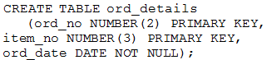  
A.  
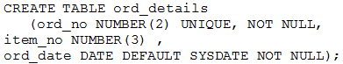  
B.  
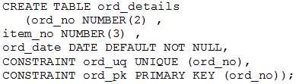  
C.  
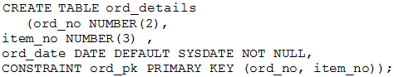  
D.

**Correct Answer:** *D* 

# Question #242

The SALES table has columns PROD_ID and QUANTITY_SOLD of data type NUMBER.  
Which two queries execute successfully?

* A. SELECT prod_id FROM sales WHERE quantity_sold > 55000 GROUP BY prod_id HAVING COUNT(*) >10;
* B. SELECT prod_id FROM sales WHERE quantity_sold > 55000 AND COUNT(*) > 10 GROUP BY prod_id HAVING COUNT(*) >10;
* C. SELECT COUNT (prod_id) FROM sales WHERE quantity_sold > 55000 GROUP BY prod_id;
* D. SELECT prod_id FROM sales WHERE quantity_sold > 55000 AND COUNT(*) > 10 GROUP BY COUNT(*) >10;
* E. SELECT COUNT(prod_id) FROM sales GROUP BY prod_id WHERE quantity_sold > 55000;

**Correct Answer:** *AC* 

# Question #243

Examine these statements executed in a single Oracle session:  
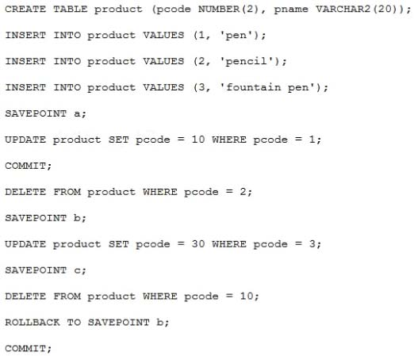  
Which three statements are true?

* ~~A. The code for pen is 1.~~
* B. There is no row containing pencil.
* C. The code for fountain pen is 3.
* D. The code for pen is 10.
* E. There is no row containing fountain pen.
* F. There is no row containing pen.

**Correct Answer:** *ABC* >> BCD

# Question #244

Which two are true about dropping columns from a table?

* A. A column drop is implicitly committed.
* B. A column that is referenced by another column in any other table cannot be dropped.
* C. A column can be removed only if it contains no data.
* D. Multiple columns can be dropped simultaneously using the ALTER TABLE command.
* E. A column must be set as unused before it is dropped from a table.
* ~~F. A primary key column cannot be dropped.~~

**Correct Answer:** *DF* >> AD  
Reference:  
https://oracle-base.com/articles/8i/dropping-columns

# Question #245

You issued this command:  
  
Which three statements are true?

* ~~A. Views referencing HR.EMPLOYEES are dropped.~~
* B. All constraints defined on HR.EMPLOYEES are dropped.
* C. Sequences used to populate columns in the HR.EMPLOYEES table are dropped.
* D. The HR.EMPLOYEES table may be moved to the recycle bin.
* E. All indexes defined on HR.EMPLOYEES are dropped.
* F. Synonyms for HR.EMPLOYEES are dropped.

**Correct Answer:** *ABE* >> ADE  
Reference:  
https://docs.oracle.com/cd/B28359_01/server.111/b28310/tables010.htm#ADMIN01505

<https://docs.oracle.com/html/E25494_01/tables010.htm>

# Question #246

The EMPLOYEES table contains columns EMP_ID of data type NUMBER and HIRE_DATE of data type DATE.  
You want to display the date of the first Monday after the completion of six month since hiring.  
The NLS_TERRITORY parameter is set to AMERICA in the session and, therefore, Sunday is the first day of the week.  
Which query can be used?

* A. SELECT emp_id, NEXT_DAY (MONTHS_BETWEEN (hire_date, SYSDATE), 6) FROM employees;
* B. SELECT emp_id, NEXT_DAY(ADD_MONTHS(hire_date, 6), "˜MONDAY') FROM employees;
* C. SELECT emp_id, ADD_MONTHS(hire_date, 6), NEXT_DAY("˜MONDAY') FROM employees;
* D. SELECT emp_id, NEXT_DAY(ADD_MONTHS(hire_date, 6), 1) FROM employees;

**Correct Answer:** *B*   
Reference:  
http://www.dba-oracle.com/t_add_months.htm

# Question #247

Which two statements are true about date/time functions in a session where NLS_DATE_FORMAT is set to DD-MON-YYYY HH24:MI:SS?

* A. CURRENT_TIMESTAMP returns the same date as CURRENT_DATE.
* B. CURRENT_TIMESTAMP returns the same date and time as SYSDATE with additional details of fractional seconds.
* C. SYSDATE and CURRENT_DATE return the current date and time set for the operating system of the database server.
* D. SYSDATE can be used in expressions only if the default date format is DD-MON-RR.
* ~~E. SYSDATE can be queried only from the DUAL table.~~
* F. CURRENT_DATE returns the current date and time as per the session time zone.

**Correct Answer:** *EF* >> AF

# Question #248

Which three statements are true about the Oracle join and ANSI join syntax?

* A. The Oracle join syntax supports natural joins.
* B. The Oracle join syntax performs less well than the SQL:1999 compliant ANSI join syntax.
* C. The Oracle join syntax supports creation of a Cartesian product of two tables.
* D. The SQL:1999 compliant ANSI join syntax supports natural joins.
* E. The Oracle join syntax performs better than the SQL:1999 compliant ANSI join syntax.
* F. The Oracle join syntax only supports right outer joins.
* G. The SQL:1999 compliant ANSI join syntax supports creation of a Cartesian product of two tables.

**Correct Answer:** *ADG*   
Reference:  
http://www.dba-oracle.com/oracle_tips_iso99_joins.htm

<https://oracle-base.com/articles/misc/sql-for-beginners-joins#:~:text=Using%20the%20ANSI%20join%20syntax,placed%20in%20the%20WHERE%20clause.&text=Using%20the%20non%2DANSI%20join,result%20of%20an%20outer%20join>.

# Question #249

View the Exhibit and examine the description of the tables.  
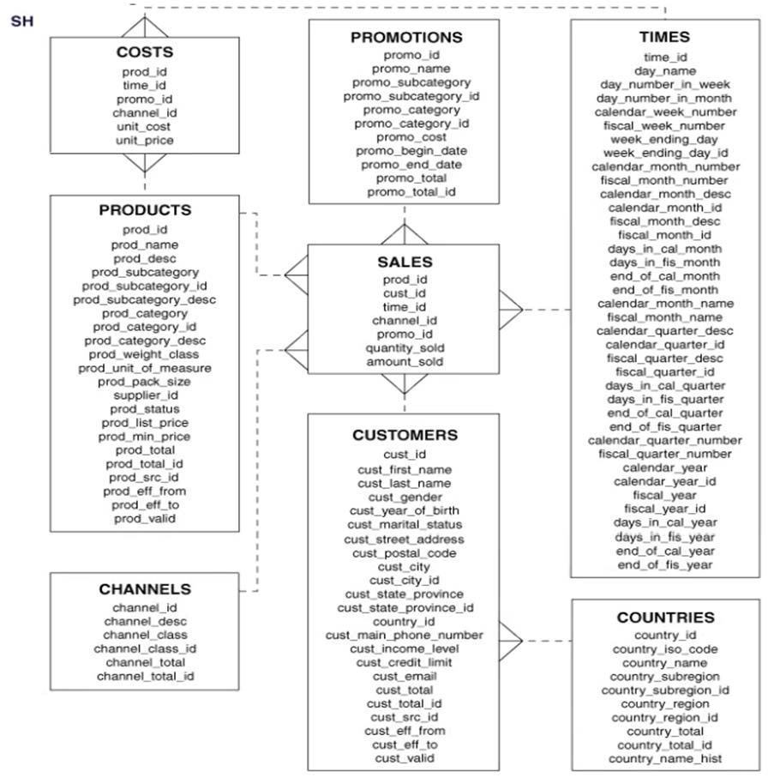  
You execute this SQL statement:  
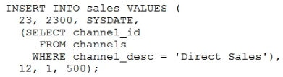  
Which three statements are true?

* A. The statement will execute successfully and a new row will be inserted into the SALES table.
* B. A product can have a different unit price at different times.
* C. The statement will fail because a subquery may not be contained in a VALUES clause.
* D. The statement will fail if a row already exists in the SALES table for product 23.
* E. A customer can exist in many countries.
* F. The SALES table has five foreign keys.

**Correct Answer:** *AEF* 

# Question #250

Examine the description of the PRODUCT_STATUS table:  
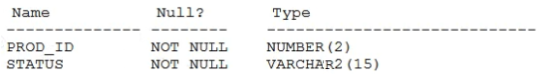  
The STATUS column contains the values "˜IN STOCK' or "˜OUT OF STOCK' for each row.  
Which two queries will execute successfully?

  
A.

  
B.

  
C.

  
D.

  
E.

  
F.

Correct Answer: *B~~E~~* >> BD

# Question #251

Examine the description of the CUSTOMERS table:  
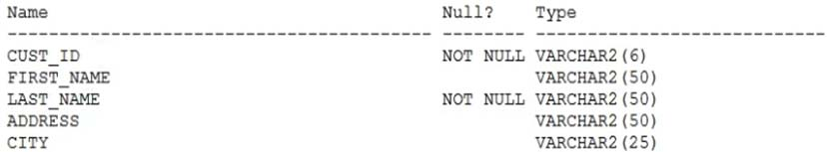  
You want to display details of all customers who reside in cities starting with the letter D followed by at least two characters.  
Which query can be used?

* A. SELECT * FROM customers WHERE city = "˜D_%';
* B. SELECT * FROM customers WHERE city LIKE "˜D_';
* C. SELECT * FROM customers WHERE city LIKE "˜D_%';
* D. SELECT * FROM customers WHERE city = "˜%D_';

**Correct Answer:** *C* 

# Question #252

Examine this SQL statement:  
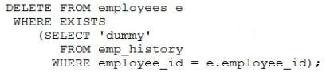  
Which two are true?

* A. The subquery is not a correlated subquery.
* ~~B. The subquery is executed before the DELETE statement is executed.~~
* C. The DELETE statement executes successfully even if the subquery selects multiple rows.
* D. The subquery is executed for every row in the EMPLOYEES table.
* E. All existing rows in the EMPLOYEES table are deleted.

**Correct Answer:** *BD* >> CD

# Question #253

What is true about non-equijoin statement performance?

* A. The BETWEEN condition always performs less well than using the >= and <= conditions.
* B. The join syntax used makes no difference to performance.
* C. Table aliases can improve performance.
* D. The BETWEEN condition always performs better than using the >= and <= conditions.
* E. The Oracle join syntax performs better than the SQL:1999 compliant ANSI join syntax.

**Correct Answer:** *C* ?; B đúng; ADE sai  
Reference:  
https://www.academia.edu/17342225/SQL_notes

# Question #254

Which three statements are true about multiple row subqueries?

* A. They can contain GROUP BY clauses.
* B. They can return multiple columns.
* ~~C. Two or more values are always returned from the subquery.~~
* D. They can contain HAVING clauses.
* E. They cannot contain a subquery.

**Correct Answer:** *ABC* >> ABD  
Reference:  
<https://www.w3resource.com/sql/subqueries/multiplee-row-column-subqueries.php>

# Question #255

Examine this description of the PRODUCTS table:  
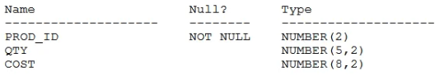  
You successfully execute this command:  
  
Which **two** statements execute without errors?  
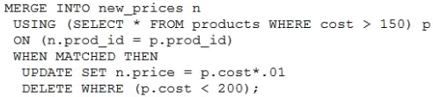  
A.  
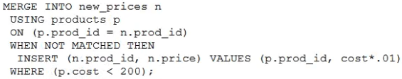  
B.  
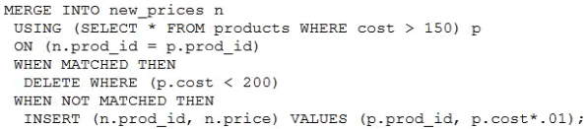  
C.  
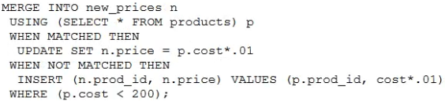  
D.

**Correct Answer:** A*B*   
<https://docs.oracle.com/cd/B28359_01/server.111/b28286/statements_9016.htm#SQLRF01606>

# Question #256

In which three situations does a new transaction always start?

* A. when issuing a TRUNCATE statement after a SELECT statement was issued in the same session
* B. when issuing a CREATE INDEX statement after a CREATE TABLE statement completed successfully in the same session
* C. when issuing a CREATE TABLE statement after a SELECT statement was issued in the same session
* D. when issuing the first Data Manipulation Language (DML) statement after a COMMIT or ROLLBACK statement was issued in the same session
* E. when issuing a DML statement after a DML statement failed in the same session
* F. when issuing a SELECT FOR UPDATE statement after a CREATE TABLE AS SELECT statement was issued in the same session

**Correct Answer:** *DEF*   
Reference:  
https://docs.oracle.com/cd/B19306_01/server.102/b14220/transact.htm

<http://dba.fyicenter.com/faq/oracle/Ways-to-Start-New-Transaction.html>

<https://stackoverflow.com/questions/1468116/does-oracle-roll-back-the-transaction-on-an-error>

# Question #257

View the Exhibit and examine the structure of the PRODUCT table.  
  
Which two tasks would require subqueries? (Choose two.)

* A. display all products whose PROD_MIN_PRICE is more than the average PROD_LIST_PRICE of all products, and whose status is orderable
* B. display the total number of products supplied by supplier 102 and have product status as "˜OBSOLETE'
* C. display the number of products whose PROD_LIST_PRICE is more than the average PROD_LIST_PRICE.
* D. display suppliers whose PROD_LIST_PRICE is less than 1000
* E. display the minimum PROD_LIST_PRICE for each product status

**Correct Answer:** *AC* 

# Question #258

Which two statements are true regarding the COUNT function? (Choose two.)

* A. A SELECT statement using the COUNT function with a DISTINCT keyword cannot have a WHERE clause.
* B. COUNT(DISTINCT inv_amt) returns the number of rows excluding rows containing duplicates and NULLs in the INV_AMT column.
* C. COUNT(inv_amt) returns the number of rows in a table including rows with NULL in the INV_AMT column.
* D. COUNT(*) returns the number of rows including duplicate rows and rows containing NULL value in any column.
* E. It can only be used for NUMBER data types.

**Correct Answer:** *BD* 

# Question #259

Examine this statement:  
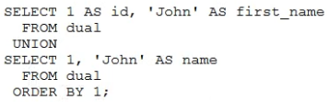  
What is returned upon execution?

* A. 0 rows
* B. an error
* C. 1 row
* D. 2 rows

**Correct Answer:** *D* 

# Question #260

Examine the description of the PRODUCT_INFORMATION table:  
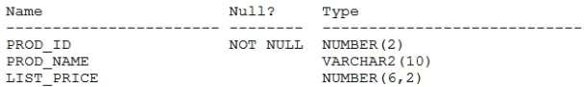  
Which query retrieves the number of products with a null list price?

* A. SELECT COUNT (DISTINCT list_price) FROM product_information WHERE list_price IS NULL;
* B. SELECT COUNT (list_price) FROM product_information WHERE list_price IS NULL;
* C. SELECT COUNT (list_price) FROM product_information WHERE list_price = NULL;
* D. SELECT COUNT(NVL(list_price, 0)) FROM product_information WHERE list_price IS NULL;

**Correct Answer:** *D*   
Reference:  
https://www.oracletutorial.com/oracle-aggregate-functions/oracle-avg/

# Question #261

Which statement is true about aggregate functions?

* A. The AVG function implicitly converts NULLS to zero.
* B. Aggregate functions can be nested to any number of levels.
* C. The MAX and MIN functions can be used on columns with character data types.
* D. Aggregate functions can be used in any clause of a SELECT statement.

**Correct Answer:** *B*   
Reference:  
https://docs.oracle.com/database/121/SQLRF/functions003.htm

# Question #262

Which three statements are true about time zones, date data types, and timestamp data types in an Oracle database?

* A. The DBTIMEZONE function can return an offset from Universal Coordinated Time (UTC).
* B. A TIMESTAMP data type column contains information about year, month, and day.
* C. The CURRENT_TIMESTAMP function returns data without time zone information.
* D. A TIMESTAMP WITH LOCAL TIMEZONE data type column is stored in the database using the time zone of the session that inserted the row.
* E. The SESSIONTIMEZONE function can return an offset from Universal Coordinated Time (UTC).

**Correct Answer:** *ACE*   
Reference:  
https://docs.oracle.com/database/121/NLSPG/ch4datetime.htm

# Question #263

✑ MANAGER is an existing role with no privileges or roles.  
✑ EMP is an existing role containing the CREATE TABLE privilege.  
✑ EMPLOYEES is an existing table in the HR schema.  
Which two commands execute successfully?

* A. GRANT CREATE SEQUENCE TO manager, emp;
* B. GRANT CREATE ANY SESSION, CREATE ANY TABLE TO manager;
* ~~C. GRANT SELECT, INSERT ON hr.employees TO manager WITH GRANT OPTION;~~
* D. GRANT CREATE TABLE, emp TP manager;
* E. GRANT CREATE TABLE, SELECT ON hr.employees TO manager;

**Correct Answer:** AD

*AC* >> AD

# Question #264

Which statement is true about the INTERSECT operator used in compound queries?

* A. INTERSECT is of lower precedence than UNION or UNION ALL.
* B. Multiple INTERSECT operators are not possible in the same SQL statement.
* C. It ignores NULLs.
* D. It processes NULLs in the selected columns.

Correct Answer: *D* 

# Question #265

Which statement is true regarding the default behavior of the ORDER BY clause?

* A. In a character sort, the values are case-sensitive.
* B. NULLs are not included in the sort operation.
* C. Only columns that are specified in the SELECT list can be used in the ORDER BY clause.
* D. Numeric values are displayed in descending order if they have decimal positions.
* E. Column aliases can be used in the ORDER BY clause.

**Correct Answer:** *A*   
The ORDER BY clause performs case sensitive sorting with character values.

# Question #266

You execute this query:  
  
What is the result?

* A. It returns the date for the first Monday of the next month.
* B. It returns the date for the last Monday of the current month.
* C. It executes successfully but does not return any result.
* D. It generates an error.

**Correct Answer:** *A* 

# Question #267

Which two are true about granting privileges on objects?

* A. An object privilege can be granted to other users only by the owner of that object.
* B. An object privilege can be granted to a role only by the owner of that object.
* C. A table owner must grant the REFERENCES privilege to allow other users to create FOREIGN KEY constraints using that table.
* D. The owner of an object acquires all object privileges on that object by default.
* E. The WITH GRANT OPTION clause can be used only by DBA users.

**Correct Answer:** *CD*   
Reference:  
https://docs.oracle.com/cd/B19306_01/network.102/b14266/authoriz.htm#i1008214

# Question #268

Which statement is true about TRUNCATE and DELETE?

* A. You can never TRUNCATE a table if foreign key constraints will be violated.
* B. For large tables TRUNCATE is faster than DELETE.
* C. For tables with multiple indexes and triggers DELETE is faster than TRUNCATE.
* D. You can never DELETE rows from a table if foreign key constraints will be violated.

**Correct Answer:** *B*   
Reference:  
https://www.sqlservercentral.com/articles/difference-between-truncate-and-delete

# Question #269

In the PROMOTIONS table, the PROMO_BEGIN_DATE column is of data type DATE and the default date format is DD-MON-RR.  
Which two statements are true about expressions using PROMO_BEGIN_DATE contained a query?

* A. PROMO_BEGIN_DATE "" 5 will return a date.
* B. PROMO_BEGIN_DATE "" SYSDATE will return a number.
* C. TO_NUMBER(PROMO_BEGIN_DATE) "" 5 will return a number.
* ~~D. TO_DATE(PROMO_BEGIN_DATE * 5) will return a date.~~
* E. PROMO_BEGIN_DATE "" SYSDATE will return an error.

**Correct Answer:** AB

*BD* >> AB

# Question #270

Which two statements are true about Oracle synonyms?

* A. A synonym can have a synonym.
* ~~B. All private synonym names must be unique in the database.~~
* C. Any user can create a PUBLIC synonym.
* ~~D. A synonym can be created on an object in a package.~~
* E. A synonym has an object number.

**Correct Answer:** AE

*BD* >> AE  
Reference:  
https://docs.oracle.com/cd/B19306_01/server.102/b14200/statements_7001.htm

# Question #271

Examine the description of the SALES1 table:  
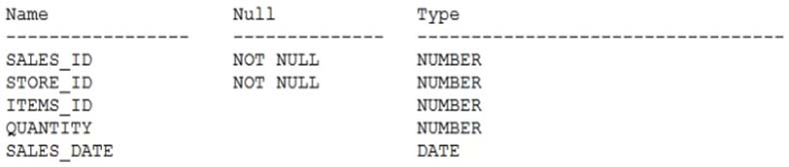 is a table with the same description as SALES1.  
  
SALES2 -  
Some sales data is duplicated in both tables.  
You want to display the rows from the SALES1 table which are not present in the SALES2 table.  
Which set operator generates the required output?

* A. SUBTRACT
* B. INTERSECT
* C. UNION ALL
* D. UNION
* E. MINUS

**Correct Answer:** *E* 

# Question #272

Examine this query:  
SELECT 2 FROM dual d1 CROSS JOIN dual d2 CROSS JOIN dual d3;  
What is returned upon execution?

* A. 8 rows
* B. 1 row
* C. 6 rows
* D. 3 rows
* E. 0 rows
* F. an error

**Correct Answer:** *B* 

# Question #273

The PRODUCT_INFORMATION table has a UNIT_PRICE column of data type NUMBER (8, 2).  
Evaluate this SQL statement:  
SELECT TO_CHAR(unit_price, "˜$9,999') FROM product_information;  
Which two statements are true about the output?

* A. A row whose UNIT_PRICE column contains the value 1023.99 will be displayed as $1,024.
* B. A row whose UNIT_PRICE column contains the value 10235.99 will be displayed as $1,0236.
* C. A row whose UNIT_PRICE column contains the value 10235.99 will be displayed as #######.
* D. A row whose UNIT_PRICE column contains the value 10235.99 will be displayed as $1,023.
* E. A row whose UNIT_PRICE column contains the value 1023.99 will be displayed as $1,023.

**Correct Answer:** *CE* 

# Question #274

Examine the description of the BOOKS_TRANSACTIONS table:  
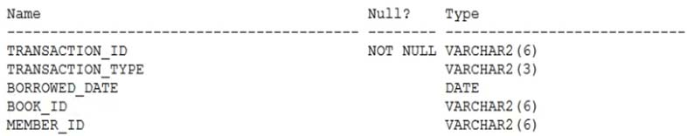  
Examine this partial SQL statement:  
SELECT * FROM books_transactions  
Which two WHERE conditions give the same result?

* A. WHERE borrowed_date = SYSDATE AND (transaction_type = "˜RM' OR member_id IN ("˜A101', "˜A102'));
* B. WHERE (borrowed_date = SYSDATE AND transaction_type = "˜RM') OR member_id IN ("˜A101', "˜A102');
* ~~C. WHERE borrowed_date = SYSDATE AND (transaction_type = "˜RM' AND (member_id = A101' OR member_id = "˜A102'));~~
* D. WHERE borrowed_date = SYSDATE AND transaction_type = "˜RM' OR member_id IN ("˜A101', "˜A102');
* E. WHERE borrowed_date = SYSDATE AND (transaction_type = "˜RM' AND member_id = "˜A101' OR member_id = "˜A102');

**Correct Answer:** BD

*BC* >> BD

# Question #275

Which two statements are true about a self join?

* A. It can be a left outer join.
* B. It must be a full outer jolin.
* C. It can be an inner join.
* D. It must be an equijoin.
* ~~E. The join key column must have an index.~~

**Correct Answer:** AC

*CE* >> AC  
Reference:  
https://www.oracletutorial.com/oracle-basics/oracle-self-join/

# Question #276

You create a table by using this command:  
CREATE TABLE rate_list (rate NUMBER(6,2));  
Which two are true about executing statements?

* A. INSERT INTO rate_list VALUES (-10) produces an error.
* B. INSERT INTO rate_list VALUES (87654.556) inserts the value as 87654.6.
* C. INSERT INTO rate_list VALUES (0.551) inserts the value as .55.
* ~~D. INSERT INTO rate_list VALUES (-99.99) inserts the value as 99.99.~~
* E. INSERT INTO rate_list VALUES (0.999) produces an error.
* F. INSERT INTO rate_list VALUES (-.9) inserts the value as -.9.

**Correct Answer:** CF

*CD* >> CF

# Question #277

Examine these SQL statements which execute successfully:  
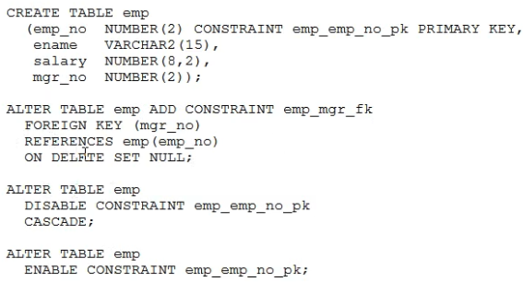  
Which two statements are true after execution?

* A. The foreign key constraint will be disabled.
* ~~B. The primary key constraint will be enabled and DEFERRED.~~
* C. The foreign key constraint will be enabled and DEFERRED.
* ~~D. The foreign key constraint will be enabled and IMMEDIATE.~~
* E. The primary key constraint will be enabled and IMMEDIATE.

**Correct Answer:** AE

*BD* >> AE

# Question #278

Which two statements are true about conditional INSERT ALL?

* A. Each WHEN condition is tested for each row returned by the subquery.
* B. The total number of rows inserted is always equal to the number of rows returned by the subquery.
* C. A single WHEN condition can be used for multiple INTO clauses.
* ~~D. It cannot have an ELSE clause.~~
* E. Each row returned by the subquery can be inserted into only a single target table.

**Correct Answer:** AC

*CD* >> AC

# Question #279

Examine the description of the EMPLOYEES table:  
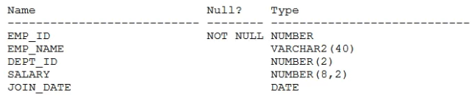  
Which query is valid?

* A. SELECT dept_id, MAX(AVG(salary)) FROM employees GROUP BY dept_id;
* B. SELECT dept_id, AVG(MAX(salary)) FROM employees GROUP BY dept_id;
* C. SELECT dept_id, join_date, SUM(salary) FROM employees GROUP BY dept_id, join_date;
* ~~D. SELECT dept_id, join_date, SUM(salary) FROM employees GROUP BY dept_id;~~

**Correct Answer:** C

*D* >> C

# Question #280

Which three statements are true about performing Data Manipulation Language (DML) operations on a view in an Oracle Database?

* A. Views cannot be used to add or modify rows in an underlying table if the defining query of the view contains the DISTINCT keyword.
* ~~B. Views cannot be used to query rows from an underlying table if the table has a PRIMARY KEY and the PRIMARY KEY columns are not referenced in the defining query of the view.~~
* C. Views cannot be used to add rows to an underlying table if the table has columns with NOT NULL constraints lacking default values which are not referenced in the defining query of the view.
* D. The WITH CHECK clause has no effect when deleting rows from the underlying table through the view.
* E. Insert statements can always be done on a table through a view.
* F. Views cannot be used to add or modify rows in an underlying table if the defining query of the view contains aggregating functions.

Correct Answer: ACF

*BCF* >> ACF

# Question #281

Which two statements are true about the ORDER BY clause when used with a SQL statement containing a SET operator such as UNION?

* A. Each SELECT statement in the compound query must have its own ORDER BY clause.
* ~~B. Each SELECT statement in the compound query can have its own ORDER BY clause.~~
* C. Column positions must be used in the ORDER BY clause.
* D. The first column in the first SELECT of the compound query with the UNION operator is used by default to sort output in the absence of an ORDER BY clause.
* E. Only column names from the first SELECT statement in the compound query are recognized.

**Correct Answer:** DE

*BE* >> DE

# Question #282

Which three statements are true about Data Manipulation Language (DML)?

* A. UPDATE statements can have different subqueries to specify the values for each updated column.
* B. INSERT statements can insert NULLS explicitly into a column.
* C. DELETE statements can remove multiple rows based on multiple conditions.
* D. DML statements require a primary key be defined on a table.
* ~~E. INSERT INTO"¦SELECT"¦FROM statements automatically commit.~~

**Correct Answer:** ABC

*ACE* >> ABC

# Question #283

Examine the description of the BOOKS table:  
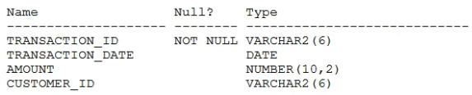  
The table has 100 rows.  
Examine this sequence of statements issued in a new session:  
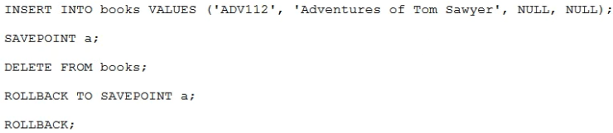  
Which two statements are true?

* A. The first ROLLBACK command restores the 101 rows that were deleted, leaving the inserted row still to be committed.
* B. The second ROLLBACK command replays the delete.
* ~~C. The first ROLLBACK command restores the 101 rows that were deleted and commits the inserted row.~~
* D. The second ROLLBACK command undoes the insert.
* E. The second ROLLBACK command does nothing.

**Correct Answer:** AD

*CD* >> AD

# Question #284

Which three are true about privileges and roles?

* A. A role is owned by the user who created it.
* B. A role can contain a combination of several privileges and roles.
* C. System privileges always set privileges for an entire database.
* D. A user has all object privileges for every object in their schema by default.
* E. All roles are owned by the SYS schema.
* F. PUBLIC can be revoked from a user.
* G. PUBLIC acts as a default role granted to every user in a database.

**Correct Answer:** *BDG*   
Reference:  
https://docs.oracle.com/cd/B19306_01/network.102/b14266/authoriz.htm#i1010570

<https://docs.oracle.com/cd/B28359_01/network.111/b28531/authorization.htm#DBSEG97972>

# Question #285

Examine this query:  
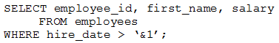  
Which two methods should you use to prevent prompting for a hire date value when this query is executed?

* A. Replace "˜&1' with "˜&&1' in the query.
* B. Use the DEFINE command before executing the query.
* C. Use the UNDEFINE command before executing the query.
* ~~D. Execute the SET VERIFY ON command before executing the query.~~
* E. Store the query in a script and pass the substitution value to the script when executing it.
* F. Execute the SET VERIFY OFF command before executing the query.

**Correct Answer:** BE

*DE* >> BE

# Question #286

Which two statements are true about a full outer join?

* ~~A. It includes rows that are returned by an inner join.~~
* B. It returns only unmatched rows from both tables being joined.
* C. It includes rows that are returned by a Cartesian product.
* D. It returns matched and unmatched rows from both tables being joined.
* E. The Oracle join operator (+) must be used on both sides of the join condition in the WHERE clause.

**Correct Answer:** CD

*AD* >> CD  
Reference:  
https://www.w3resource.com/oracle/joins/oracle-full-outer-join.php

# Question #287

Which three statements are true about defining relations between tables in a relational database?

* ~~A. Primary key columns allow null values.~~
* B. Every primary or unique key value must refer to a matching foreign key value.
* C. Foreign key columns allow null values.
* ~~D. Every foreign key value must refer to a matching primary or unique key value.~~
* E. Unique key columns allow null values.

**Correct Answer:** CE

*AD* >> CE

# Question #288

You execute this command:  
  
Which two are true?

* A. It drops any triggers defined on the table.
* B. It always retains the space used by the removed rows.
* C. A ROLLBACK statement can be used to retrieve the deleted data.
* D. It retains the integrity constraints defined on the table.
* E. It retains the indexes defined on the table.
* F. A FLASHBACK TABLE statement can be used to retrieve the deleted data.

**Correct Answer:** *DE*   
Reference:  
https://docs.oracle.com/html/E25494_01/general003.htm

# Question #289

Which two are true about a SQL statement using SET operators such as UNION?

* A. The number, but not names, of columns must be identical for all SELECT statements in the query.
* B. The data type of each column returned by the second query must be implicitly convertible to the data type of the corresponding column returned by the first query.
* C. The data type group of each column returned by the second query must match the data type group of the corresponding column returned by the first query.
* D. The names and number of columns must be identical for all SELECT statements in the query.
* ~~E. The data type of each column returned by the second query must exactly match the data type of the corresponding column returned by the first query.~~

**Correct Answer:** AC

*CE* >> AC

# Question #290

Which three statements are true about Structured Query Language (SQL)?

* A. It best supports relational databases.
* B. It is used to define encapsulation and polymorphism for a relational table.
* C. It is the only language that can be used for both relational and object-oriented databases.
* D. It guarantees atomicity, consistency, isolation, and durability (ACID) features.
* E. It provides independence for logical data structures being manipulated from the underlying physical data storage
* ~~F. It requires that data be contained in hierarchical data storage.~~

**Correct Answer:** ADE

*DEF* >> ADE  
Reference:  
https://docs.microsoft.com/en-us/sql/relational-databases/hierarchical-data-sql-server?view=sql-server-2017

<https://docs.oracle.com/database/121/CNCPT/intro.htm#CNCPT88785>

# Question #291

Evaluate these commands which execute successfully:  
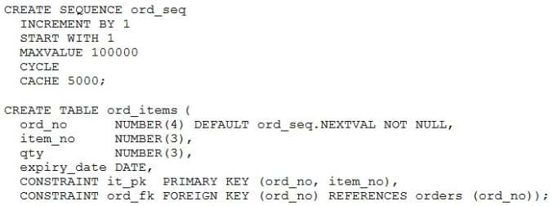  
Which two statements are true about the ORD_ITEMS table and the ORD_SEQ sequence?

* A. Sequence ORD_SEQ cycles back to 1 after every 5000 numbers and can cycle 20 times.
* B. Any user inserting rows into table ORD_ITEMS must have been granted access to sequence ORD_SEQ.
* C. Column ORD_NO gets the next number from sequence ORD_SEQ whenever a row is inserted into ORD_ITEMS and no explicit value is given for ORD_NO.
* D. If sequence ORD_SEQ is dropped then the default value for column ORD_NO will be NULL for rows inserted into ORD_ITEMS.
* ~~E. Sequence ORD_SEQ is guaranteed not to generate duplicate numbers.~~

**Correct Answer:** BC

*BE* >> BC

<https://oracle-base.com/articles/12c/default-values-for-table-columns-enhancements-12cr1#:~:text=Databases%20(Pre%2012c)-,DEFAULT%20Values%20Using%20Sequences,Identity%20columns%20for%20this%20purpose>.

# Question #292

Which two statements are true about INTERVAL data types?

* A. The YEAR field in an INTERVAL YEAR TO MONTH column must be a positive value.
* B. INTERVAL DAY TO SECOND columns support fractions of seconds.
* C. INTERVAL YEAR TO MONTH columns only support monthly intervals within a single year.
* D. INTERVAL YEAR TO MONTH columns support yearly intervals.
* E. INTERVAL YEAR TO MONTH columns only support monthly intervals within a range of years.
* F. The value in an INTERVAL DAY TO SECOND column can be copied into an INTERVAL YEAR TO MONTH column.

**Correct Answer:** *BE*   
Reference:  
https://www.oracletutorial.com/oracle-basics/oracle-interval/

# Question #293

Which two statements are true about the DUAL table?

* A. It can display multiple rows but only a single column.
* B. It can be accessed by any user who has the SELECT privilege in any schema.
* C. It can display multiple rows and columns.
* D. It consists of a single row and single column of VARCHAR2 data type.
* E. It can be used to display only constants or pseudo columns.
* F. It can be accessed only by the SYS user.

**Correct Answer:** *BD* 

# Question #294

The CUSTOMERS table has a CUST_CREDIT_LIMIT column of data type NUMBER.  
Which two queries execute successfully?

* A. SELECT NVL (cust_credit_limit * .15, "˜Not Available') FROM customers;
* B. SELECT TO_CHAR(NVL(cust_credit_limit * .15, "˜Not Available')) FROM customers;
* C. SELECT NVL(TO_CHAR(cust_credit_limit * .15), "˜Not Available') FROM customers;
* D. SELECT NVL2(cust_credit_limit, TO_CHAR(cust_credit_limit * .15), "˜Not Available') FROM customers;
* ~~E. SELECT NVL2 (cust_credit_limit * .15, "˜Not Available') FROM customers;~~

**Correct Answer:** CD

*CE* >> CD

# Question #295

Which two are true about the WITH GRANT OPTION clause?

* A. The grantee must have the GRANT ANY OBJECT PRIVILEGE system privilege to use this option.
* B. It can be used when granting privileges to roles.
* C. It cannot be used to pass on privileges to PUBLIC by the grantee.
* ~~D. It can be used for system and object privileges.~~
* E. It can be used to pass on privileges to other users by the grantee.
* F. The grantee can grant the object privilege to any user in the database, with or without including this option.

**Correct Answer:** EF

*DE* >> EF  
Reference:  
https://docs.oracle.com/cd/B19306_01/server.102/b14200/statements_9013.htm

# Question #296

Examine the description of the EMPLOYEES table:  
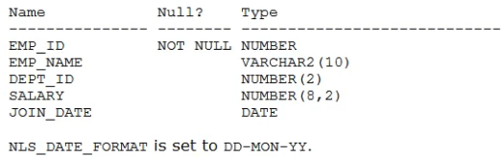  
Which query requires explicit data type conversion?

* A. SELECT join_date FROM employees WHERE join_date > '10-02-2018';
* B. SELECT salary + "˜120.50' FROM employees;
* C. SELECT SUBSTR(join_date, 1, 2) "" 10 FROM employees;
* D. SELECT join_date + "˜20' FROM employees;
* E. SELECT join_date || "˜ "˜ || salary FROM employees;

**Correct Answer:** *A* 

# Question #297

Examine this partial command:  
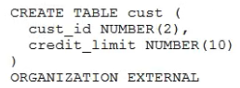  
Which two clauses are required for this command to execute successfully?

* A. the LOCATION clause
* B. the access driver TYPE clause
* C. the REJECT LIMIT clause
* D. the DEFAULT DIRECTORY clause
* E. the ACCESS PARAMETERS clause

**Correct Answer:** *AB* 

# Question #298

Which three statements are true about GLOBAL TEMPORARY TABLES?

* ~~A. GLOBAL TEMPORARY TABLE rows inserted by a session are available to any other session whose user has been granted select on the table.~~
* ~~B. GLOBAL TEMPORARY TABLE space allocation occurs at session start.~~
* ~~C. A DELETE command on a GLOBAL TEMPORARY TABLE cannot be rolled back.~~
* D. A GLOBAL TEMPORARY TABLE's definition is available to multiple sessions.
* E. Any GLOBAL TEMPORARY TABLE rows existing at session termination will be deleted.
* F. A TRUNCATE command issued in a session causes all rows in a GLOBAL TEMPORARY TABLE for the issuing session to be deleted.

**Correct Answer:** DEF

*ABC* >> DEF

# Question #299

Examine the description of the TRANSACTIONS table:  
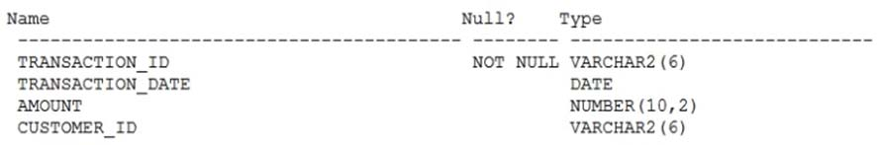  
Which two SQL statements execute successfully?

* A. SELECT customer_id AS "CUSTOMER-ID", transaction_date AS DATE, amount + 100 "DUES" FROM transactions;
* B. SELECT customer_id AS CUSTOMER-ID, transaction_date AS TRANS_DATE, amount + 100 "DUES AMOUNT" FROM transactions;
* C. SELECT customer_id CUSTID, transaction_date TRANS_DATE, amount +100 DUES FROM transactions;
* D. SELECT customer_id AS "CUSTOMER-ID", transaction_date AS "DATE", amount + 100 DUES FROM transactions;
* E. SELECT customer_id AS "˜CUSTOMER-ID', transaction_date AS DATE, amount + 100 "˜DUES' FROM transactions;

**Correct Answer:** *CD* 

# Question #300

Which three statements are true about indexes and their administration in an Oracle database?

* A. An index can be created as part of a CREATE TABLE statement.
* B. A DROP INDEX statement always prevents updates to the table during the drop operation.
* C. A UNIQUE and non-unique index can be created on the same table column.
* D. A descending index is a type of function-based index.
* E. If a query filters on an indexed column then it will always be used during execution of the query.
* ~~F. An INVISIBLE index is not maintained when Data Manipulation Language (DML) is performed on its underlying table.~~

Correct Answer: ACD

*ADF* >> ACD

# Question #301

Examine this description of the PRODUCTS table:  
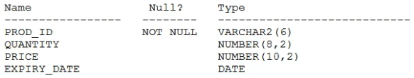  
Rows exist in this table with data in all the columns. You put the PRODUCTS table in read-only mode.  
Which three commands execute successfully on PRODUCTS?

* A. DROP TABLE products;
* B. ALTER TABLE products DROP COLUMN expiry_date;
* C. ALTER TABLE products SET UNUSED (expiry_date);
* D. ALTER TABLE products DROP UNUSED COLUMNS;
* E. CREATE INDEX price_idx ON products (price);
* ~~F. TRUNCATE TABLE products;~~

**Correct Answer:** ADE

*AEF* >> ADE

# Question #302

Which two statements are true about transactions in the Oracle Database server?

* A. If a session has an uncommitted transaction, then a DDL statement issues a COMMIT before starting a new transaction.
* B. An uncommitted transaction commits automatically if the user exists SQL*Plus.
* ~~C. Data Manipulation Language (DML) statements always start a new transaction.~~
* D. A user can always see uncommitted updates made by the same user in a different session.
* E. A Data Definition Language (DDL) statement does a COMMIT automatically only for the data dictionary updates caused by the DDL.
* F. A session can always see uncommitted updates made by itself.

**Correct Answer:** AF

*CF* >> AF

# Question #303

You want to write a query that prompts for two column names and the WHERE condition each time it is executed in a session but only prompts for the table name the first time it is executed.  
The variables used in your query are never undefined in your session?  
Which query can be used?  
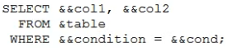  
A.  
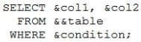  
B.  
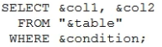  
C.  
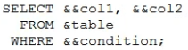  
D.  
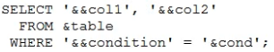  
E.

**Correct Answer:** B

*D* >> B

# Question #304

Evaluate the following statement.  
  
INSERT ALL -  
WHEN order_total < 10000 THEN  
  
INTO small_orders -  
WHEN order_total > 10000 AND order_total < 20000 THEN  
  
INTO medium_orders -  
WHEN order_total > 200000 AND order_total < 20000 THEN  
  
INTO large_orders -  
SELECT order_id, order_total, customer_id  
FROM orders;  
Which statement is true regarding the evaluation of rows returned by the subquery in the INSERT statement?

* A. They are evaluated by all the three WHEN clauses regardless of the results of the evaluation of any other WHEN clause.
* B. They are evaluated by the first WHEN clause. If the condition is true, then the row would be evaluated by the subsequent WHEN clauses.
* C. They are evaluated by the first WHEN clause. If the condition is false, then the row would be evaluated by the subsequent WHEN clauses.
* D. The insert statement would give an error because the ELSE clause is not present for support in case none of WHEN clauses are true.

**Correct Answer:** *A*   
References:  
http://psoug.org/definition/WHEN.htm

# Question #305

Examine the structure of the MEMBERS table:  
Name Null? Type  
---------------- ----------------- ---------------------------  
MEMBER_ID NOT NULL VARCHAR2 (6)  
FIRST_NAME VARCHAR2 (50)  
LAST_NAME NOT NULL VARCHAR2 (50)  
ADDRESS VARCHAR2 (50)  
CITY VARCHAR2 (25)  
STATE VARCHAR2 (3)  
You want to display details of all members who reside in states starting with the letter A followed by exactly one character.  
Which SQL statement must you execute?

* A. SELECT * FROM MEMBERS WHERE state LIKE '%A_';
* B. SELECT * FROM MEMBERS WHERE state LIKE 'A_';
* C. SELECT * FROM MEMBERS WHERE state LIKE 'A_%';
* D. SELECT * FROM MEMBERS WHERE state LIKE 'A%';

**Correct Answer:** *B* 

# Question #306

View the exhibit and examine the structures of the EMPLOYEES and DEPARTMENTS tables.  
  
EMPLOYEES -  
Name Null? Type  
----------------- ----- -------------  
EMPLOYEE_ID NOT NULL NUMBER(6)  
FIRST_NAME VARCHAR2(20)  
LAST_NAME NOT NULL VARCHAR2(25)  
HIRE_DATE NOT NULL DATE  
JOB_ID NOT NULL VARCHAR2(10)  
SALARY NUMBER(10,2)  
COMMISSION NUMBER(6,2)  
MANAGER_ID NUMBER(6)  
DEPARTMENT_ID NUMBER(4)  
  
DEPARTMENTS -  
Name Null? Type  
----------------- ----- -------------  
DEPARTMENT_ID NOT NULL NUMBER(4)  
DEPARTMENT_NAME NOT NULL VARCHAR2(30)  
MANAGER_ID NUMBER(6)  
LOCATION_ID NUMBER(4)  
You want to update EMPLOYEES table as follows:  
✑ Update only those employees who work in Boston or Seattle (locations 2900 and 2700).  
✑ Set department_id for these employees to the department_id corresponding to London (location_id 2100).  
✑ Set the employees' salary in location_id 2100 to 1.1 times the average salary of their department.  
✑ Set the employees' commission in location_id 2100 to 1.5 times the average commission of their department.  
You issue the following command:  
  
SQL> UPDATE employees -  
SET department_id =  
(SELECT department_id  
  
FROM departments -  
WHERE location_id = 2100),  
(salary, commission) =  
(SELECT 1.1*AVG(salary), 1.5*AVG(commission)  
  
FROM employees, departments -  
WHERE departments.location_id IN(2900, 2700, 2100))  
  
WHERE department_id IN -  
(SELECT department_id  
  
FROM departments -  
  
WHERE location_id = 2900 -  
OR location_id = 2700;  
What is outcome?

* A. It generates an error because multiple columns (SALARY, COMMISSION) cannot be specified together in an UPDATE statement.
* B. It generates an error because a subquery cannot have a join condition in a UPDATE statement.
* C. It executes successfully and gives the correct result.
* D. It executes successfully but does not give the correct result.

**Correct Answer:** *D* 

# Question #307

Evaluate the following two queries:  
SQL> SELECT cust_last_name, cust_city  
  
FROM customers -  
WHERE cust_credit_limit IN (1000, 2000, 3000);  
SQL> SELECT cust_last_name, cust_city  
  
FROM customers -  
WHERE cust_credit_limit = 1000 or cust_credit_limit = 2000 or cust_credit_limit = 3000  
Which statement is true regarding the above two queries?

* A. Performance would improve in query 2 only if there are null values in the CUST_CREDIT_LIMIT column.
* B. There would be no change in performance.
* C. Performance would degrade in query 2.
* D. Performance would improve in query 2.

**Correct Answer:** *B*   
References:  
http://oraclexpert.com/restricting-and-sorting-data/

# Question #308

View the Exhibit and examine the details of PRODUCT_INFORMATION table.  
  
PRODUCT_NAME -  
  
CATEGORY_ID -  
  
SUPPLIER_ID -  
  
Inkjet C/8/HQ -  
102094  
  
Inkjet C/4 -  
102090  
  
LaserPro 600/6/BW -  
102087  
  
LaserPro 1200/8/BW -  
102099  
  
Inkjet B/6 -  
102096  
  
Industrial 700/ID -  
102086  
  
Industrial 600/DQ -  
102088  
  
Compact 400/LQ -  
102087  
  
Compact 400/DQ -  
102088  
  
HD 12GB /R -  
102090  
  
HD 10GB /I -  
102071  
  
HD 12GB @7200 /SE -  
102057  
  
HD 18.2GB @10000 /E -  
102078  
  
HD 18.2GB @10000 /I -  
102050  
  
HD 18GB /SE -  
102083  
  
HD 6GB /I -  
102072  
  
HD 8.2GB@5400 -  
102093  
You have the requirement to display PRODUCT_NAME from the table where the CATEGORY_ID column has values 12 or 13, and the SUPPLIER_ID column has the value 102088. You executed the following SQL statement:  
  
SELECT product_name -  
  
FROM product_information -  
WHERE (category_id = 12 AND category_id = 13) AND supplier_id = 102088;  
Which statement is true regarding the execution of the query?

* A. It would not execute because the same column has been used in both sides of the AND logical operator to form the condition.
* B. It would not execute because the entire WHERE clause condition is not enclosed within the parentheses.
* C. It would execute and the output would display the desired result.
* D. It would execute but the output would return no rows.

**Correct Answer:** *D* 

# Question #309

View the exhibit and examine the structure of the STORES table.  
  
STORES table -  
Name Null? Type  
----------------- ----- -------------  
STORE_ID NUMBER  
NAME VARCHAR2(100)  
ADDRESS VARCHAR2(200)  
CITY VARCHAR2(100)  
COUNTRY VARCHAR2(100)  
START_DATE DATE  
END_DATE DATE  
PROPERTY_PRICE NUMBER  
You want to display the NAME of the store along with the ADDRESS, START_DATE, PROPERTY_PRICE, and the projected property price, which is 115% of property price.  
The stores displayed must have START_DATE in the range of 36 months starting from 01-Jan-2000 and above.  
Which SQL statement would get the desired output?

* A. SELECT name, concat (address| | ','| |city| |', ', country) AS full_address, start_date, property_price, property_price*115/100 FROM stores WHERE MONTHS_BETWEEN (start_date, '01-JAN-2000') <=36;
* B. SELECT name, concat (address| | ','| |city| |', ', country) AS full_address, start_date, property_price, property_price*115/100 FROM stores WHERE TO_NUMBER(start_date-TO_DATE('01-JAN-2000','DD-MON-RRRR')) <=36;
* C. SELECT name, address||','||city||','||country AS full_address, start_date, property_price, property_price*115/100 FROM stores WHERE MONTHS_BETWEEN (start_date, TO_DATE('01-JAN-2000','DD-MON-RRRR')) <=36;
* ~~D. SELECT name, concat (address||','| |city| |', ', country) AS full_address, start_date, property_price, property_price*115/100 FROM stores~~

**Correct Answer:** C

*D* >> C

# Question #310

Examine the command:  
SQL> ALTER TABLE books_transactions  
ADD CONSTRAINT fk_book_id FOREIGN KEY (book_id)  
REFERENCES books (book_id) ON DELETE CASCADE;  
What does ON DELETE CASCADE imply?

* A. When the BOOKS table is dropped, the BOOK_TRANSACTIONS table is dropped.
* B. When the BOOKS table is dropped, all the rows in the BOOK_TRANSACTIONS table are deleted but the table structure is retained.
* C. When a row in the BOOKS table is deleted, the rows in the BOOK_TRANSACTIONS table whose BOOK_ID matches that of the deleted row in the BOOKS table are also deleted.
* D. When a value in the BOOKS.BOOK_ID column is deleted, the corresponding value is updated in the BOOKS_TRANSACTIONS.BOOK_ID column.

Correct Answer: *C*

# Question #311

Examine the structure of the EMPLOYEES table.  
Name Null? Type  
----------------- ----- ------ ------  
EMPLOYEE_ID NOT NULL NUMBER(6)  
FIRST_NAME VARCHAR2(20)  
LAST_NAME NOT NULL VARCHAR2(25)  
EMAIL NOT NULL VARCHAR2(25)  
PHONE NUMBER VARCHAR2(20)  
HIRE_DATE NOT NULL DATE  
JOB_ID NOT NULL VARCHAR2(10)  
SALARY NUMBER(8,2)  
COMMISSION_PCT NUMBER(2,2)  
MANAGER_ID NUMBER(6)  
DEPARTMENT_ID NUMBER(4)  
There is a parent/child relationship between EMPLOYEE_ID and MANAGER_ID.  
You want to display the last names and manager IDs of employees who work for the same manager as the employee whose EMPLOYEE_ID is 123.  
Which query provides the correct output?

* A. SELECT e.last_name, m.manager_id FROM employees e RIGHT OUTER JOIN employees m on (e.manager_id = m.employee_id) AND e.employee_id = 123;
* ~~B. SELECT e.last_name, m.manager_id FROM employees e RIGHT OUTER JOIN employees m on (e.employee_id = m.manager_id) WHERE e.employee_id = 123;~~
* C. SELECT e.last_name, e.manager_id FROM employees e RIGHT OUTER JOIN employees m on (e.employee_id = m.employee_id) WHERE e.employee_id = 123;
* D. SELECT m.last_name, e.manager_id FROM employees e LEFT OUTER JOIN employees m on (e.manager_id = m.manager_id) WHERE e.employee_id = 123;

**Correct Answer:** D

*B* >> D

# Question #312

Sales data of a company is stored in two tables, SALES1 and SALES2, with some data being duplicated across the tables. You want to display the results from the table, which are not present in the SALES2 table.  
  
SALES1 -  
  
SALES1 table -  
Name Null Type  
------------------ ------------- ----------------  
SALES_ID NUMBER  
STORE_ID NUMBER  
ITEMS_ID NUMBER  
QUANTITY NUMBER  
SALES_DATE DATE  
  
SALES2 table -  
Name Null Type  
---------------- ------------- -----------------  
SALES_ID NUMBER  
STORE_ID NUMBER  
ITEMS_ID NUMBER  
QUANTITY NUMBER  
SALES_DATE DATE  
Which set operator generates the required output?

* A. INTERSECT
* B. UNION
* C. PLUS
* D. MINUS
* E. SUBTRACT

**Correct Answer:** *D*   
References:  
https://docs.oracle.com/cd/B19306_01/server.102/b14200/queries004.htm

# Question #313

Examine the structure of the MEMBERS table.  
Name Null? Type  
---------------- ----------------- ---------------------------  
MEMBER_ID NOT NULL VARCHAR2 (6)  
FIRST_NAME VARCHAR2 (50)  
LAST_NAME NOT NULL VARCHAR2 (50)  
ADDRESS VARCHAR2 (50)  
CITY VARCHAR2 (25)  
STATE NOT NULL VARCHAR2 (3)  
Which query can be used to display the last names and city names only for members from the states MO and MI?

* A. SELECT last_name, city FROM members WHERE state ='MO' AND state ='MI';
* B. SELECT last_name, city FROM members WHERE state LIKE 'M%';
* C. SELECT last_name, city FROM members WHERE state IN ('MO', 'MI');
* D. SELECT DISTINCT last_name, city FROM members WHERE state ='MO' OR state ='MI';

**Correct Answer:** *C* 

# Question #314

Examine the structure of the BOOKS_TRANSACTIONS table:  
Name Null? Type  
---------------- ----------------- ---------------------------  
TRANSACTION_ID NOT NULL VARCHAR2 (6)  
BORROWED_DATE VARCHAR2 (50)  
DUE_DATE DATE  
BOOK_ID DATE  
MEMBER_ID VARCHAR2 (6)  
You want to display the member IDs, due date, and late fee as $2 for all transactions.  
Which SQL statement must you execute?

* A. SELECT member_id AS MEMBER_ID, due_date AS DUE_DATE, $2 AS LATE_FEE FROM BOOKS_TRANSACTIONS;
* B. SELECT member_id 'MEMBER ID', due_date 'DUE DATE', '$2 AS LATE FEE' FROM BOOKS_TRANSACTIONS;
* C. SELECT member_id AS "MEMBER ID", due_date AS "DUE DATE", '$2' AS "LATE FEE" FROM BOOKS_TRANSACTIONS;
* D. SELECT member_id AS "MEMBER ID", due_date AS "DUE DATE", $2 AS "LATE FEE" FROM BOOKS_TRANSACTIONS;

**Correct Answer:** *C* 

# Question #315

View the exhibit and examine the data in ORDERS_MASTER and MONTHLY_ORDERS tables.  
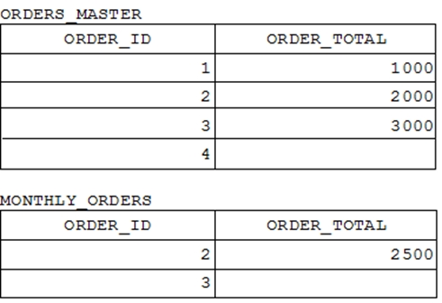  
Evaluate the following MERGE statement:  
  
MERGE_INTO orders_master o -  
  
USING monthly_orders m -  
ON (o.order_id = m.order_id)  
  
WHEN MATCHED THEN -  
UPDATE SET o.order_total = m.order_total  
DELETE WHERE (m.order_total IS NULL)  
  
WHEN NOT MATCHED THEN -  
INSERT VALUES (m.order_id, m.order_total)  
What would be the outcome of the above statement?

* A. The ORDERS_MASTER table would contain the ORDER_IDs 1, 2, 3 and 4.
* ~~B. The ORDERS_MASTER table would contain the ORDER_IDs 1, 2 and 4.~~
* C. The ORDERS_MASTER table would contain the ORDER_IDs 1, 2 and 3.
* D. The ORDERS_MASTER table would contain the ORDER_IDs 1 and 2.

**Correct Answer:** C

*B* >> C  
References:  
https://docs.oracle.com/cd/B28359_01/server.111/b28286/statements_9016.htm

# Question #316

Evaluate the following SQL statement:  
SELECT product_name || 'it's not available for order'  
  
FROM product_information -  
WHERE product_status = 'obsolete';  
You received the following error while executing the above query:  
  
ERROR -  
ORA-01756: quoted string not properly terminated  
What would you do to execute the query successfully?

* A. Use Quote (q) operator and delimiter to allow the use of single quotation mark in the literal character string.
* B. Enclose the literal character string in the SELECT clause within the double quotation marks.
* C. Do not enclose the character literal string in the SELECT clause within the single quotation marks.
* D. Use escape character to negate the single quotation mark inside the literal character string in the SELECT clause.

**Correct Answer:** *A*   
References:  
http://docs.oracle.com/cd/B19306_01/server.102/b14200/sql_elements003.htm

# Question #317

View the exhibit and examine the ORDERS table.  
  
ORDERS -  
  
Name -  
Null?  
  
Type -  
  
ORDER ID -  
  
NOT NULL -  
NUMBER(4)  
  
ORDATE DATE -  
  
DATE -  
  
CUSTOMER ID -  
NUMBER(3)  
  
ORDER TOTAL -  
NUMBER(7,2)  
The ORDERS table contains data and all orders have been assigned a customer ID. Which statement would add a NOT NULL constraint to the CUSTOMER_ID column?

* A. ALTER TABLE orders MODIFY CONSTRAINT orders_cust_id_nn NOT NULL (customer_id);
* B. ALTER TABLE orders ADD CONSTRAINT orders_cust_id_nn NOT NULL (customer_id);
* C. ALTER TABLE orders MODIFY customer_id CONSTRAINT orders_cust_nn NOT NULL (customer_id);
* D. ALTER TABLE orders

**Correct Answer:** *C* 

# Question #318

Examine the structure of the INVOICE table.  
Name Null? Type  
------------------ ------------------- -------------  
INV_NO NOT NULL NUMBER(3)  
INV_DATE DATE  
INV_AMT NUMBER(10,2)  
Which two SQL statements would execute successfully?

* A. SELECT inv_no, NVL2(inv_date, 'Pending', 'Incomplete') FROM invoice;
* B. SELECT inv_no, NVL2(inv_amt, inv_date, 'Not Available') FROM invoice;
* C. SELECT inv_no, NVL2(inv_date, sysdate-inv_date, sysdate) FROM invoice;
* D. SELECT inv_no, NVL2(inv_amt, inv_amt*.25, 'Not Available')

**Correct Answer:** *AC* 

# Question #319

The user SCOTT who is the owner of ORDERS and ORDER_ITEMS tables issues the following GRANT command:  
  
GRANT ALL -  
  
ON orders, order_items -  
TO PUBLIC;  
What correction needs to be done to the above statement?

* A. PUBLIC should be replaced with specific usernames.
* B. ALL should be replaced with a list of specific privileges.
* C. WITH GRANT OPTION should be added to the statement.
* D. Separate GRANT statements are required for ORDERS and ORDER_ITEMS tables.

**Correct Answer:** *D*   
References:  
http://docs.oracle.com/javadb/10.8.3.0/ref/rrefsqljgrant.html

# Question #320

You want to display the date for the first Monday of the next month and issue the following command:  
SQL>SELECT TO_CHAR(NEXT_DAY(LAST_DAY(SYSDATE), 'MON'),  
'dd "is the first Monday for" fmmonth rrrr')  
FROM DUAL;  
What is the outcome?

* A. In generates an error because rrrr should be replaced by rr in the format string.
* B. It executes successfully but does not return the correct result.
* C. It executes successfully and returns the correct result.
* D. In generates an error because TO_CHAR should be replaced with TO_DATE.
* E. In generates an error because fm and double quotation marks should not be used in the format string.

Correct Answer: *C*

# Question #321

Examine the commands used to create DEPARTMENT_DETAILS and COURSE_DETAILS:  
SQL>CREATE TABLE DEPARTMENT_DETAILS  
(DEPARTMENT_ID NUMBER PRIMARY KEY,  
DEPARTMENT_NAME VARCHAR2(50),  
HOD VARCHAR2(50));  
  
SQL>CREATE TABLE COURSE_DETAILS -  
(COURSE_ID NUMBER PRIMARY KEY,  
COURSE_NAME VARCHAR2(50),  
DEPARTMENT_ID VARCHAR2(50));  
You want to generate a list of all department IDs along with any course IDs that may have been assigned to them.  
Which SQL statement must you use?

* A. SELECT d.department_id, c.course_id FROM department_details d RIGHT OUTER JOIN course_details c ON (d.department_id=c. department_id);
* B. SELECT d.department_id, c.course_id FROM department_details d LEFT OUTER JOIN course_details c ON (d.department_id=c. department_id);
* C. SELECT d.department_id, c.course_id FROM course_details c LEFT OUTER JOIN department_details d ON (c.department_id=d. department_id);
* D. SELECT d.department_id, c.course_id FROM department_details d RIGHT OUTER JOIN course_details c ON

**Correct Answer:** *B* 

# Question #322

View the exhibit for the structure of the STUDENT and FACULTY tables.  
  
STUDENT -  
Name Null? Type  
------------------ ------------------- -------------  
STUDENT_ID NOT NULL NUMBER(2)  
STUDENT_NAME VARCHAR2(20)  
FACULTY_ID VARCHAR2(2)  
LOCATION_ID NUMBER(2)  
  
FACULTY -  
Name Null? Type  
------------------ ------------------- -------------  
FACULTY_ID NOT NULL NUMBER(2)  
FACULTY_NAME VARCHAR2(20)  
LOCATION_ID NUMBER(2)  
You need to display the faculty name followed by the number of students handled by the faculty at the base location.  
Examine the following two SQL statements:  
  
Statement 1 -  
SQL>SELECT faculty_name, COUNT(student_id)  
  
FROM student JOIN faculty -  
USING (faculty_id, location_id)  
GROUP BY faculty_name;  
  
Statement 2 -  
SQL>SELECT faculty_name, COUNT(student_id)  
FROM student NATURAL JOIN faculty  
GROUP BY faculty_name;  
Which statement is true regarding the outcome?

* A. Only statement 2 executes successfully and gives the required result.
* ~~B. Only statement 1 executes successfully and gives the required result.~~
* C. Both statements 1 and 2 execute successfully and give different results.
* D. Both statements 1 and 2 execute successfully and give the same required result.

**Correct Answer:** D

*B* >> D

# Question #323

View the exhibit and examine the structure of ORDERS and CUSTOMERS tables.  
  
ORDERS -  
  
Name -  
Null?  
  
Type -  
  
ORDER_ID -  
  
NOT NULL -  
NUMBER(4)  
  
ORDER_DATE -  
  
NOT NULL -  
  
DATE -  
  
ORDER_MODE -  
VARCHAR2(8)  
  
CUSTOMER_ID -  
  
NOT NULL -  
NUMBER(6)  
  
ORDER_TOTAL -  
NUMBER(8, 2)  
  
CUSTOMERS -  
  
Name -  
Null?  
  
Type -  
  
CUSTOMER_ID -  
  
NOT NULL -  
NUMBER(6)  
  
CUST_FIRST_NAME -  
  
NOT NULL -  
VARCHAR2(20)  
  
CUST_LAST_NAME -  
  
NOT NULL -  
VARCHAR2(20)  
  
CREDIT_LIMIT -  
NUMBER(9,2)  
  
CUST_ADDRESS -  
VARCHAR2(40)  
Which INSERT statement should be used to add a row into the ORDERS table for the customer whose CUST_LAST_NAME is Roberts and CREDIT_LIMIT is 600?  
Assume there exists only one row with CUST_LAST_NAME as Roberts and CREDIT_LIMIT as 600.

* A. INSERT INTO (SELECT o.order_id, o.order_date, o.order_mode, c.customer_id, o.order_total FROM orders o, customers c WHERE o.customer_id = c.customer_id AND c.cust_last_name='Roberts' AND c.credit_limit=600) VALUES (1,'10-mar-2007', 'direct', (SELECT customer_id FROM customers WHERE cust_last_name='Roberts' AND credit_limit=600), 1000);
* B. INSERT INTO orders (order_id, order_date, order_mode, (SELECT customer id FROM customers WHERE cust_last_name='Roberts' AND credit_limit=600), order_total); VALUES (1,'10-mar-2007', 'direct', &customer_id, 1000);
* C. INSERT INTO orders VALUES (1,'10-mar-2007', 'direct', (SELECT customer_id FROM customers WHERE cust_last_name='Roberts' AND credit_limit=600), 1000);
* D. INSERT INTO orders (order_id, order_date, order_mode, (SELECT customer_id FROM customers WHERE cust_last_name='Roberts' AND credit_limit=600), order_total);

**Correct Answer:** *C* 

# Question #324

The following are the steps for a correlated subquery, listed in random order:  
1. The WHERE clause of the outer query is evaluated.  
2. The candidate row is fetched from the table specified in the outer query.  
3. The procedure is repeated for the subsequent rows of the table, till all the rows are processed.  
4. Rows are returned by the inner query, after being evaluated with the value from the candidate row in the outer query.  
Identify the option that contains the steps in the correct sequence in which the Oracle server evaluates a correlated subquery.

* A. 2, 1, 4, 3
* B. 4, 1, 2, 3
* C. 4, 2, 1, 3
* D. 2, 4, 1, 3

**Correct Answer:** *D*   
References:  
http://rajanimohanty.blogspot.co.uk/2014/01/correlated-subquery.html

# Question #325

Evaluate the following SELECT statement and view the exhibit to examine its output:  
SELECT constraint_name, constraint_type, search_condition, r_constraint_name, delete_rule, status,  
  
FROM user_constraints -  
WHERE table_name = 'ORDERS';  
  
CONSTRAINT_NAME -  
  
CON SEARCH_CONDITI -  
R_CONSTRAINT_NAME DELETE_RULE STATUS  
  
ON -  
  
ORDER_DATE_NN -  
"ORDER_DATE" IS  
  
ENABLED -  
  
NOT NULL -  
ORDER_CUSTOMER_ID_  
  
C -  
"CUSTOMER_ID" IS  
  
ENABLED -  
  
NN -  
  
NOT NULL -  
  
ORDER_MODE_LOV -  
  
C -  
order _mode in  
  
ENABLED -  
('direct',  
'online')  
  
ORDER TOTAL MIN -  
  
C -  
order total >= 0  
  
ENABLED -  
  
ORDER PK -  
  
P -  
  
ENABLED -  
  
ORDERS CUSTOMER ID R -  
  
CUSTOMERS ID -  
  
SET NULL -  
  
ENABLED -  
  
ORDERS SALES REP -  
  
R -  
  
EMP EMP ID -  
  
SET NULL -  
  
ENABLED -  
Which two statements are true about the output? (Choose two.)

* A. The R_CONSTRAINT_NAME column gives the alternative name for the constraint.
* B. In the second column, 'c' indicates a check constraint.
* C. The STATUS column indicates whether the table is currently in use.
* D. The column DELETE_RULE decides the state of the related rows in the child table when the corresponding row is deleted from the parent table.

**Correct Answer:** *BD* 

# Question #326

Which two statements are true about sequences created in a single instance Oracle database? (Choose two.)

* A. When the MAXVALUE limit for a sequence is reached, it can be increased by using the ALTER SEQUENCE statement.
* B. DELETE <sequencename> would remove a sequence from the database.
* C. The numbers generated by an explicitly defined sequence can only be used to insert data in one table.
* D. CURRVAL is used to refer to the most recent sequence number that has been generated for a particular sequence.
* E. When a database instance shuts down abnormally, sequence numbers that have been cached but not used are available again when the instance is restarted.

**Correct Answer:** *AD*   
References:  
http://docs.oracle.com/cd/E11882_01/server.112/e41084/statements_2012.htm#SQLRF00817 https://docs.oracle.com/cd/A84870_01/doc/server.816/a76989/ch26.htm

# Question #327

Which two statements are true regarding the UNION and UNION ALL operators? (Choose two.)

* A. The output is sorted by the UNION ALL operator
* B. The names of columns selected in each SELECT statement must be identical
* C. The number of columns selected in each SELECT statement must be identical
* D. Duplicates are eliminated automatically by the UNION ALL operator
* E. NULLS are not ignored during duplicate checking

**Correct Answer:** *CE* 

# Question #328

Which three actions can you perform on an existing table containing data? (Choose three.)

* A. Add a new NOT NULL column with a DEFAULT value
* B. Change the default value of a column
* C. Change a DATE column containing data to a NUMBER data type
* ~~D. Add a new column as the table's first column~~
* E. Define a default value that is automatically inserted into a column containing nulls
* F. Increase the width of a numeric column

**Correct Answer:** ABF

*BD* >> ABF  
Reference:  
https://docs.oracle.com/javadb/10.8.3.0/ref/rrefsqlj24513.html

# Question #329

Which two statements are true about single-row functions? (Choose two.)

* A. CEIL: can be used for positive and negative numbers
* B. FLOOR: returns the smallest integer greater than or equal to a specified number
* C. TRUNC: can be used with NUMBER and DATE values
* D. CONCAT: can be used to combine any number of values
* ~~E. MOD: returns the quotient of a division operation~~

**Correct Answer:** AC

*CE* >> AC  
Reference:  
https://www.folkstalk.com/2012/01/oracle-single-row-functions-examples.html

# Question #330

Which three statements are true about sequences in a single instance Oracle database? (Choose three.)

* A. A sequence can issue duplicate values
* B. A sequence's unallocated cached value are lost if the instance shuts down
* C. Sequences can always have gaps
* D. Two or more tables cannot have keys generated from the same sequence
* ~~E. A sequence can only be dropped by a DBA~~
* ~~F. A sequence number that was allocated can be rolled back if a transaction fails~~

**Correct Answer:** ABC

*BEF* >> ABC  
Reference:  
https://docs.oracle.com/cd/B19306_01/server.102/b14200/statements_6015.htm

# Question #331

Which two statements are true about the SET VERIFY ON command? (Choose two.)

* A. It can be used in SQL Developer and SQL*Plus
* B. It displays values for variables used only in the WHERE clause of a query
* ~~C. It can be used only in SQL*Plus~~
* D. It displays values for variables prefixed with &&
* E. It displays values for variables created by the DEFINE command

**Correct Answer:** AD

*CE* >> AD  
Reference:  
https://blogs.oracle.com/opal/sqlplus-101-substitution-variables#4_1_8

# Question #332

Which two statements are true about the rules of precedence for operators? (Choose two.)

* A. The concatenation operator | | is always evaluated before addition and subtraction in an expression
* B. Multiple parentheses can be used to override the default precedence of operators in an expression
* C. Arithmetic operators with equal precedence area evaluated from left to right within an expression
* D. NULLS influence the precedence of operators in an expression
* ~~E. The + binary operator has the highest precedence in an expression in a SQL statement~~

**Correct Answer:** BC

*BE* >> BC  
Reference:  
https://docs.oracle.com/cd/B19306_01/server.102/b14200/operators001.htm

<https://docs.oracle.com/cd/E49933_01/server.770/es_eql/src/ceql_expr_precedence_rules.html>

# Question #333

Which four statements are true regarding primary and foreign key constraints and the effect they can have on table data? (Choose four.)

* A. It is possible for child rows that have a foreign key to remain in the child table at the time the parent row is deleted
* B. Only the primary key can be defined at the column and table level
* ~~C. The foreign key columns and parent table primary key columns must have the same names~~
* D. A table can have only one primary key and one foreign key
* E. A table can have only one primary key but multiple foreign keys
* F. Primary key and foreign key constraints can be defined at both the column and table level
* G. It is possible for child rows that have a foreign key to be deleted automatically from the child table at the time the parent row is deleted

**Correct Answer:** AEFG

*CEFG* >> AEFG

# Question #334

Which three are true about system and object privileges? (Choose three.)

* ~~A. WITH GRANT OPTION can be used when granting an object privilege to both users and roles~~
* B. Adding a primary key constraint to an existing table in another schema requires a system privilege
* C. Adding a foreign key constraint pointing to a table in another schema requires the REFERENCES object privilege
* D. Revoking a system privilege that was granted with WITH ADMIN OPTION has a cascading effect
* E. Revoking an object privilege that was granted with the WITH GRANT OPTION clause has a cascading effect.
* F. WITH GRANT OPTION cannot be used when granting an object privilege to PUBLIC

**Correct Answer:** BCE

*ACE* >> BCE  
Reference -  
https://docs.oracle.com/cd/B28359_01/network.111/b28531/authorization.htm#DBSEG004

# Question #335

Which two statements are true about selecting related rows from two tables based on an Entity Relationship Diagram (ERD)? (Choose two.)

* A. Implementing a relationship between two tables might require joining additional tables
* B. Relating data from a table with data from the same table is implemented with a self join
* C. Rows from unrelated tables cannot be joined
* D. Every relationship between the two tables must be implemented in a join condition
* ~~E. An inner join relates rows within the same table~~

**Correct Answer:** AB

*AE* >> AB

# Question #336

Which two statements are true about substitution variables? (Choose two.)

* A. A substitution variable can be used with any clause in a SELECT statement
* ~~B. A substitution variable used to prompt for a column name must be enclosed in a single quotation marks~~
* ~~C. A substitution variable prefixed with & always prompts only once for a value in a session~~
* D. A substitution variable can be used only in a SELECT statement
* E. A substitution variable used to prompt for a column name must be enclosed in double quotation marks
* F. A substitution variable prefixed with && prompts only once for a value in a session unless it is set to undefined in the session

**Correct Answer:** AF

*BC* >> AF  
Reference:  
https://blogs.oracle.com/opal/sqlplus-101-substitution-variables

# Question #337

Which three statements are true about inner and outer joins? (Choose three.)

* A. A full outer join must use Oracle syntax
* B. An inner join returns matched rows
* ~~C. A left or right outer join returns only unmatched rows~~
* D. A full outer join returns matched and unmatched rows
* E. Outer joins can only be used between two per query
* F. Outer joins can be used when there are multiple join conditions on two tables

**Correct Answer:** BDF

*BCD* >> BDF  
Reference:  
https://www.studytonight.com/dbms/joining-in-sql.php

# Question #338

Which three statements are true about the DESCRIBE command? (Choose three.)

* A. It can be used to display the structure of an existing view
* ~~B. It can be used only from SQL*Plus~~
* C. It displays the PRIMARY KEY constraint for any column or columns that have that constraint
* D. It can be used from SQL Developer
* E. It displays all constraints that are defined for each column
* F. It displays the NOT NULL constraint for any columns that have that constraint

**Correct Answer:** ADF

*ABF* >> ADF

# Question #339

The CUSTOMERS table has a CUST_LAST_NAME column of data type VARCHAR2.  
The table has two rows whose CUST_LAST_NAME values are Anderson and Ausson.  
Which query produces output for CUST_LAST_NAME containing Oder for the first row and Aus for the second?

* A. SELECT REPLACE (TRIM(TRAILING "˜son' FROM cust_last_name), "˜An', "˜O') FROM customers;
* B. SELECT INITCAP (REPLACE(TRIM("˜son' FROM cust_last_name), "˜An', "˜O')) FROM customers;
* C. SELECT REPLACE (SUBSTR(cust_last_name, -3), "˜An', "˜O') FROM customers;
* D. SELECT REPLACE (REPLACE(cust_last_name, "˜son', "˜'), "˜An', "˜O') FROM customers;

**Correct Answer:** *D* 

# Question #340

Which three statements are true about performing Data Manipulation Language (DML) operations on a view with no INSTEAD OF triggers defined? (Choose three.)

* ~~A. Insert statements can always be done on a table through a view.~~
* B. Views cannot be used to add rows to an underlying table if the table has columns with NOT NULL constraints lacking default values which are not referenced in the defining query of the view.
* ~~C. Views cannot be used to query rows from an underlying table if the table has a PRIMARY KEY and the PRIMARY KEY columns are not referenced in the defining query of the view.~~
* ~~D. Delete statements can always be done on a table through a view.~~
* E. The WITH CHECK clause has no effect when deleting rows from the underlying table through the view.
* F. Views cannot be used to add or modify rows in an underlying table if the defining query of the view contains the DISTINCT keyword.

Correct Answer: BEF

*ACD* >> BEF

# Question #341

An Oracle database server session has an uncommitted transaction in progress which updated 5000 rows in a table.  
In which three situations does the transactions complete thereby committing the updates? (Choose three.)

* A. when a DBA issues a successful SHUTDOWN TRANSACTIONAL statement and the user then issues a COMMIT
* B. when a CREATE INDEX statement is executed successfully in the same session
* C. when a COMMIT statement is issued by the same user from another session in the same database instance
* D. when the session logs out successfully
* ~~E. when a DBA issues a successful SHUTDOWN IMMEDIATE statement and the user then issues a COMMIT~~
* F. when a CREATE TABLE AS SELECT statement is executed unsuccessfully in the same session

**Correct Answer:** ABF

*BDE* >> ABDF (D không chắc lắm)

# Question #342

The INVOICE table has a QTY_SOLD column of data type NUMBER and an INVOICE_DATE column of data type DATE.  
NLS_DATE_FORMAT is set to DD-MON-RR.  
Which two are true about data type conversions involving these columns in query expressions? (Choose two.)

* A. CONCAT(qty_sold, invoice_date) : requires explicit conversion
* B. invoice_date > '01-02-2019' : uses implicit conversion
* ~~C. invoice_date = '15-march-2019' : uses implicit conversion~~
* D. qty_sold BETWEEN "˜101' AND "˜110' : uses implicit conversion
* E. qty_sold = "˜0554982' : requires explicit conversion

**Correct Answer:** AD

*CD* >> AD

# Question #343

The ORDERS table has a primary key constraint on the ORDER_ID column.  
The ORDER_ITEMS table has a foreign key constraint on the ORDER_ID column, referencing the primary key of the ORDERS table.  
The constraint is defined with ON DELETE CASCADE.  
There are rows in the ORDERS table with an ORDER_TOTAL of less than 1000.  
Which three DELETE statements execute successfully?

* ~~A. DELETE order_id FROM orders WHERE order_total < 1000;~~
* B. DELETE FROM orders WHERE order_total < 1000;
* C. DELETE orders WHERE order_total < 1000;
* D. DELETE * FROM orders WHERE order_total < 1000;
* E. DELETE FROM orders;

**Correct Answer:** BCE

*AC* >> BCE

# Question #344

Examine this query:  
SELECT TRUNC(ROUND(156.00, -2), -1) FROM DUAL;  
What is the result?

* A. 16
* B. 200
* C. 100
* D. 160
* ~~E. 150~~

**Correct Answer:** B

*E* >> B  
Reference -  
https://docs.oracle.com/cd/B19306_01/server.102/b14200/functions200.htm

# Question #345

Which three statements are true regarding indexes? (Choose three.)

* ~~A. A SELECT statement can access one or more indices without accessing any tables~~
* B. An update to a table can result in no updates to any of the table's indexes
* C. A table belonging to one user can have an index that belongs to a different user
* D. A UNIQUE index can be altered to be non-unique
* E. An update to a table can result in updates to any or all of the table's indexes
* F. When a table is dropped and is moved to the RECYCLE BIN, all indexes built on that table are permanently dropped

**Correct Answer:** BEF

*ABF* >> BEF

# Question #346

Which three are true about the CREATE TABLE command? (Choose three.)

* A. It can include the CREATE..INDEX statement for creating an index to enforce the primary key constraint
* B. It implicitly executes a commit
* ~~C. A user must have the CREATE ANY TABLE privilege to create tables~~
* D. It implicitly rolls back any pending transactions
* E. The owner of the table should have space quota available on the tablespace where the table is defined
* ~~F. The owner of the table must have the UNLIMITED TABLESPACE system privilege~~

**Correct Answer:** ABE

*BCF* >> ABE  
Reference:  
https://docs.oracle.com/html/E25494_01/tables003.htm

# Question #347

st  
You need to calculate the number of days from 1  
January 2019 until today.  
Dates are stored in the default format of DD-MON-RR.  
Which two queries give the required output?

* ~~A. SELECT TO_CHAR(SYSDATE, "˜DD-MON-YYYY') "" '01-JAN-2019' FROM DUAL;~~
* B. SELECT SYSDATE "" TO_DATE('01-JANUARY-2019') FROM DUAL;
* C. SELECT ROUND(SYSDATE "" '01-JAN-2019') FROM DUAL;
* D. SELECT ROUND(SYSDATE "" TO_DATE("˜01/JANUARY/2019')) FROM DUAL;
* E. SELECT TO_DATE(SYSDATE, "˜DD/MONTH/YYYY') "" "˜01/JANUARY/2019' FROM DUAL;

**Correct Answer:** BD

*A* >> BD

# Question #348

Which three actions can you perform by using the ORACLE_DATAPUMP access driver? (Choose three.)

* A. Read data from an external table and load it into a table in the database
* B. Create a directory object for an external table
* C. Execute DML statements on an external table
* D. Query data from an external table
* E. Read data from a table in the database and insert it into an external table
* F. Create a directory object for a flat file

**Correct Answer:** ADE

*BDE* >> ADE  
<https://docs.oracle.com/en/database/oracle/oracle-database/12.2/sutil/oracle-external-tables-concepts.html#GUID-ACF1D3AA-1D61-4682-AEC5-42C944756E12>

# Question #349

Which three statements are true about single-row functions? (Choose three.)

* A. They can be nested to any level
* B. The data type returned can be different from the data type of the argument
* C. They can accept only one argument
* D. The argument can be a column name, variable, literal or an expression
* E. They can be used only in the WHERE clause of a SELECT statement
* F. They return a single result row per table

**Correct Answer:** ABD

*BD* >> ABD  
Reference:  
https://www.folkstalk.com/2012/01/oracle-single-row-functions-examples.html

# Question #350

Which two statements are true regarding a SAVEPOINT? (Choose two.)

* A. A SAVEPOINT does not issue a COMMIT
* B. Only one SAVEPOINT may be issued in a transaction
* C. Rolling back to a SAVEPOINT can undo a TRUNCATE statement
* D. Rolling back to a SAVEPOINT can undo a CREATE INDEX statement
* E. Rolling back to a SAVEPOINT can undo a DELETE statement

Correct Answer: *AE*

# Question #351

Which three privileges can be restricted to a subset of columns in a table? (Choose three.)

* A. ALTER
* ~~B. DELETE~~
* C. UPDATE
* ~~D. SELECT~~
* E. INDEX
* F. REFERENCES
* G. INSERT

**Correct Answer:** CFG

*BCD* >> CFG

# Question #352

You execute this command:  
ALTER TABLE employees SET UNUSED (department_id)  
Which two are true? (Choose two.)

* A. No updates can be made to the data in the DEPARTMENT_ID column.
* B. A new column with the name DEPARTMENT_ID can be added to the EMPLOYEES table.
* C. A query can be display data from the DEPARTMENT_ID column.
* ~~D. The DEPARTMENT_ID column is set to null for all rows in the table.~~
* E. The DEPARTMENT_ID column can be recovered from the recycle bin.
* F. The storage space occupied by the DEPARTMENT_ID column is released only after a COMMIT is issued.

**Correct Answer:** AC

*BD* >> AC  
If a new column is added to a table, the column is initially NULL  
Reference:  
https://docs.oracle.com/cd/B28359_01/server.111/b28310/tables006.htm#ADMIN11005

# Question #353

You have been tasked to create a table for a banking application.  
One of the columns must meet three requirements:  
1) Be stored in a format supporting date arithmetic without using conversion functions  
2) Store a load period of up to 10 years  
3) Be used for calculating interest for the number of days the loan remains unpaid  
Which data type should you use?

* A. TIMESTAMP WITH LOCAL TIMEZONE
* B. TIMESTAMP WITH TIMEZONE
* C. INTERVAL DAY TO SECOND
* D. TIMESTAMP
* E. INTERVAL YEAR TO MONTH

**Correct Answer:** *C* 

# Question #354

The ORDERS table has a column ORDER_DATE of data type DATE.  
The default display format for a date is DD-MON-RR.  
Which two WHERE conditions demonstrate the correct usage of conversion functions? (Choose two.)

* A. WHERE TO_CHAR(order_date, 'MON DD YYYY') = 'JAN 20 2019'
* B. WHERE order_date > TO_DATE('JUL 10 2018', 'MON DD YYYY')
* C. WHERE order_date > TO_CHAR(ADD_MONTHS(SYSDATE,6), 'MON DD YYYY')
* D. WHERE order_date > TO_DATE(ADD_MONTHS(SYSDATE,6), 'MON DD YYYY')
* E. WHERE order_date IN (TO_DATE('OCT 21 2018', 'Mon DD YYYY'), TO_CHAR('Nov 21 2018', 'Mon DD YYYY'))

**Correct Answer:** *AB*   
Reference:  
https://ss64.com/ora/syntax-to_date.html

# Question #355

Which two are true about savepoints? (Choose two.)

* A. After issuing a savepoints, you can roll back to the savepoint name within the current transaction.
* B. A ROLLBACK TO SAVEPOINT command issued before the start of a transaction results in an error.
* C. They make uncommitted updates visible to other sessions owned by the same user.
* D. After issuing a savepoint, you cannot roll back the complete transaction.
* ~~E. You can commit updates done between two savepoints without committing other updates in the current transaction.~~
* F. They make uncommitted updates visible to sessions owned by other users.

**Correct Answer:** AB

*AE* >> AB (B không chắc lắm)  
Reference:  
https://www.vertica.com/docs/9.2.x/HTML/Content/Authoring/SQLReferenceManual/Statements/SAVEPOINT.htm

# Question #356

The SYSDATE function displays the current Oracle Server date as:  
21-MAY-19  
You wish to display the date as:  
  
MONDAY, 21 MAY, 2019 -  
Which statement will do this?

* A. SELECT TO_DATE(SYSDATE, "˜FMDAY, DD MONTH, YYYY') FROM DUAL;
* B. SELECT TO_CHAR(SYSDATE, "˜FMDD, DAY MONTH, YYYY') FROM DUAL;
* C. SELECT TO_CHAR(SYSDATE, "˜FMDAY, DDTH MONTH, YYYY') FROM DUAL;
* D. SELECT TO_CHAR(SYSDATE, "˜FMDAY, DD MONTH, YYYY') FROM DUAL;

**Correct Answer:** *D*   
SELECT ID, TO_CHAR(Start_Date,'fmDay Month fmDD, YYYY') AS "Start Date" FROM Employee;  
Reference:  
http://www.java2s.com/Code/Oracle/Data-Type/TOCHARDatefmDayMonthfmDDYYYYEmbeddedspacescanberemovedbyplacingthefmprefix.htm

# Question #357

Which two are SQL features? (Choose two.)

* A. processing sets of data
* B. providing update capabilities for data in external files
* C. providing graphical capabilities
* D. providing variable definition capabilities
* E. providing database transaction control

**Correct Answer:** *AE*   
Reference:  
https://docs.oracle.com/database/121/TGSQL/tgsql_sqlproc.htm#TGSQL175 https://www.tutorialspoint.com/sql/sql-transactions.htm

# Question #358

Which two are true about scalar subquery expressions? (Choose two.)

* A. They can return at most one row.
* B. You can use them as a default value for a column.
* C. You cannot correlate them with a table in the parent statement.
* D. You must enclose them in parentheses.
* E. They can return two columns.

**Correct Answer:** *AD* 

# Question #359

You have the privileges to create any type of synonym.  
Which statement will create a synonym called EMP for the HCM.EMPLOYEE_RECORDS table that is accessible to all users?

* A. CREATE PUBLIC SYNONIM emp FOR hcm.employee_records;
* B. CREATE GLOBAL SYNONIM emp FOR hcm.employee_records;
* C. CREATE SYNONIM emp FOR hcm.employee_records;
* D. CREATE SYNONIM PUBLIC.emp FOR hcm.employee_records;
* E. CREATE SYNONIM SYS.emp FOR hcm.employee_records;

**Correct Answer:** *A*   
CREATE PUBLIC SYNONYM emp_table -  
Reference:  
https://docs.oracle.com/database/121/SQLRF/statements_7001.htm#SQLRF01401

# Question #360

A session's NLS_DATE_FORMAT is set to DD Mon YYYY.  
Which two queries return the value 1 Jan 2019?

* A. SELECT TO_DATE("˜2019-01-01') FROM DUAL;
* B. SELECT DATE "˜2019-01-01' FROM DUAL;
* C. SELECT "˜2019-01-01' FROM DUAL;
* D. SELECT TO_CHAR("˜2019-01-01') FROM DUAL;
* E. SELECT TO_DATE("˜2019-01-01', "˜YYYY-MM-DD') FROM DUAL;

**Correct Answer:** *BE*   
select date'2015-01-10' d from dual union  
SELECT to_date( '01-01-2007' , 'DD-MM-YYYY') Tarih FROM dual;  
Reference:  
https://livesql.oracle.com/apex/livesql/file/content_BFKOA5UQHDV1MV7HRUDDUEPM4.html https://www.baskent.edu.tr/~tkaracay/etudio/ders/dbase/sql/pdfSQL/DateConversions.pdf

# Question #361

No-user-defined locks are used in your database.  
Which three are true about Transaction Control Language (TCL)?

* A. COMMIT erases all the transaction's savepoints and releases its locks.
* B. ROLLBACK TO SAVEPOINT undoes the transaction's changes made since the named savepoint and then ends the transaction.
* C. COMMIT ends the transaction and makes all its changes permanent.
* D. ROLLBACK without the TO SAVEPOINT clause undoes all the transaction's changes but does not erase its savepoints.
* E. ROLLBACK without the TO SAVEPOINT clause undoes all the transaction's changes but does not release its locks.
* F. ROLLBACK without the TO SAVEPOINT clause undoes all the transaction's changes, releases its locks and erases its savepoints.

**Correct Answer:** *ACF*   
Reference:  
https://docs.oracle.com/cd/A58617_01/server.804/a58233/trans.htm https://docs.oracle.com/cd/B19306_01/server.102/b14200/statements_9021.htm

# Question #362

Which three are key components of an Entity Relationship Model? (Choose three.)

* A. an activity
* B. a table
* C. a relationship
* D. an attribute
* E. a unique identifier
* F. an entity

**Correct Answer:** *CDF*   
The three main components of the ER Model are entities, attributes and relationships.  
Reference:  
https://www.dlsweb.rmit.edu.au/Toolbox/knowmang/content/data_concepts/e_r_model.htm

# Question #363

Which two are true about external tables that use the ORACLE_DATAPUMP access driver? (Choose two.)

* A. When creating an external table, data can be selected from another external table or from a table whose rows are stored in database blocks.
* B. Creating an external table creates a dump file that can be used only by an external table in the same database.
* C. When creating an external table, data can be selected only from a table whose rows are stored in database blocks.
* D. Creating an external table creates a directory object.
* E. Creating an external table creates a dump file that can be used by an external table in the same or a different database.

**Correct Answer:** *AD*   
The external tables feature is a complement to existing SQL*Loader functionality. It enables you to access data in external sources as if it were in a table in the database.  
You must create the directory object before you create the external table.  
Reference:  
https://docs.oracle.com/cd/B19306_01/server.102/b14215/et_concepts.htm https://docs.oracle.com/cd/E11882_01/server.112/e22490/et_concepts.htm#SUTIL011

# Question #364

Which three statements are true about external tables? (Choose three.)

* A. DML statements can modify them.
* B. They can be temporary tables.
* C. They can be used in queries containing joins.
* D. They can be indexed.
* E. They can be used in queries containing sorts.
* F. Their metadata is stored in the database.

**Correct Answer:** *CEF*   
Reference:  
https://oracle-base.com/articles/9i/external-tables-9i  
https://docs.oracle.com/html/E25494_01/tables013.htm

# Question #365

Which three are true about privileges? (Choose three.)

* A. Only users with the DBA role can create roles.
* B. A combination of object and system privileges can be granted to a role.
* C. All schema objects have associated object privileges.
* D. Object privileges granted on a table automatically apply to all synonyms for that table.
* ~~E. Only users with the GRANT ANY PRIVILEGE privilege can grant and revoke system privileges from other users.~~
* F. Schema owners can grant any object privilege on any object in their schema to any other user or role.

**Correct Answer:** BDF

*DEF* >> BDF (B đúng; E không hoàn toàn đúng)  
Object privileges granted for a table, view, sequence, procedure, function, or package apply whether referencing the base object by name or by using a synonym.  
A user with the GRANT ANY OBJECT PRIVILEGE can grant or revoke any specified object privilege to another user  
A user can grant any object privilege on any schema object he or she owns to any other user or role.  
Reference:  
https://docs.oracle.com/cd/B19306_01/network.102/b14266/authoriz.htm#DBSEG5000 https://docs.oracle.com/cd/B19306_01/network.102/b14266/authoriz.htm#DBSEG5000 https://docs.oracle.com/cd/B19306_01/network.102/b14266/authoriz.htm#DBSEG5000

# Question #366

Which three statements about roles are true? (Choose three.)

* A. Roles are assigned to roles using the ALTER ROLE statement.
* B. A single role can be assigned to multiple users.
* C. A single user can be assigned multiple roles.
* D. Privileges are assigned to a role using the ALTER ROLE statement.
* E. A role is named group of related privileges that can only be assigned to a user.
* F. Privileges are assigned to a role using the GRANT statement.
* G. Roles are assigned to users using the ALTER USER statement.

**Correct Answer:** *BCF*   
Use the GRANT statement to assign access privileges and roles.  
Reference:  
http://archive.dnnsoftware.com/docs/85/administrators/security/roles/assign-multiple-users-to-role.html https://www.dnnsoftware.com/docs/administrators/user-accounts/assign-user-to-multiple-roles.html https://www.ibm.com/support/knowledgecenter/en/SSGU8G_11.70.0/com.ibm.sqls.doc/ids_sqs_0828.htm

# Question #367

Which two statements are true about an Oracle database? (Choose two.)

* A. A table can have multiple foreign keys.
* B. A column definition can specify multiple data types.
* Incease
* C. A VARCHAR2 column without data has a NULL value.
* ~~D. A NUMBER column without data has a zero value.~~
* E. A table can have multiple primary keys.

**Correct Answer:** AC

*AD* >> AC

# Question #368

Table HR.EMPLOYEES contains a row where the EMPLOYEE_ID is 109.  
User ALICE has no privileges to access HR.EMPLOYEES.  
User ALICE starts a session.  
User HR starts a session and successfully executes these statements:  
GRANT DELETE ON employees TO alice;  
UPDATE employees SET salary = 24000 WHERE employee_id = 109;  
In her existing session ALICE then executes:  
DELETE FROM hr.employees WHERE employee_id = 109;  
What is the result?

* A. The DELETE command will wait for HR'S transaction to end then delete the row.
* ~~B. The DELETE command will immediately delete the row.~~
* C. The DELETE command will immediately return an error.
* D. The DELETE command will wait for HR'S transaction to end then return an error.

**Correct Answer:**

*B* > A

# Question #369

Which two statements are true about the data dictionary? (Choose two.)

* A. Views with the prefix ALL_, DBA_ and USER_ are not all available for every type of metadata.
* B. Views with the prefix ALL_ display metadata for objects to which the current user has access.
* ~~C. Views with the prefix DBA_ display only metadata for objects in the SYS schema.~~
* D. The data dictionary does not store metadata in tables.
* E. The data dictionary is accessible when the database is closed.

**Correct Answer:** AB

*BC* >> AB  
ALL_ - include objects all objects (from all schemas) accessible to the current user.  
Reference:  
https://dataedo.com/blog/useful-oracle-data-dictionary-queries-every-dba-should-have https://docs.oracle.com/cd/E11882_01/server.112/e40540/datadict.htm

# Question #370

Which two will execute successfully? (Choose two.)

* ~~A. SELECT COALESCE('DATE', SYSDATE) FROM (SELECT NULL AS "DATE" FROM DUAL);~~
* B. SELECT COALESCE('DATE', SYSDATE) FROM DUAL;
* C. SELECT NVL('DATE', SYSDATE) FROM DUAL;
* ~~D. SELECT COALESCE(0, SYSDATE) FROM DUAL;~~
* E. SELECT NVL('DATE', 200) FROM (SELECT NULL AS "DATE" FROM DUAL);

Correct Answer: CE

*AD* >> CE

# Question #371

Which two statements are true about dropping views? (Choose two.)

* A. Data selected by a view's defining query is deleted from its underlying tables when the view is dropped.
* B. Read only views cannot be dropped.
* ~~C. The creator of a view to be dropped must have the DROP ANY VIEW privilege.~~
* D. CASCADE CONSTRAINTS must be specified when referential integrity constraints on other objects refer to primary or unique keys in the view to be dropped.
* E. Views referencing a dropped view become invalid.

**Correct Answer:** DE

*CD* >> DE  
The view must be in your own schema or you must have the DROP ANY VIEW system privilege.  
Specify CASCADE CONSTRAINTS to drop all referential integrity constraints that refer to primary and unique keys in the view to be dropped.  
Reference:  
https://docs.oracle.com/cd/B12037_01/server.101/b10759/statements_9009.htm

# Question #372

You need to allow user ANDREW to:  
1. Modify the TITLE and ADDRESS columns of your CUSTOMERS table.  
2. GRANT that permission to other users.  
Which statement will do this?

* A. GRANT UPDATE (title, address) ON customers TO andrew WITH GRANT OPTION;
* B. GRANT UPDATE (title, address) ON customers TO andrew WITH ADMIN OPTION;
* C. GRANT UPDATE ON customers.title, customers.address TO andrew WITH ADMIN OPTION;
* D. GRANT UPDATE (title, address) ON customers TO andrew;
* E. GRANT UPDATE ON customers.title, customers.address TO andrew WITH GRANT OPTION;
* F. GRANT UPDATE ON customers.title, customers.address TO andrew;

**Correct Answer:** *A* 

# Question #373

Which two are true about using constraints? (Choose two.)

* A. A table can have only one PRIMARY KEY but may have multiple FOREIGN KEY constraints.
* B. A table can have multiple PRIMARY KEY and multiple FOREIGN KEY constraints.
* C. PRIMARY KEY and FOREIGN KEY constraints can be specified at the column and at the table level.
* ~~D. NOT NULL can be specified at the column and at the table level.~~
* E. A FOREIGN KEY column in a child table and the referenced PRIMARY KEY column in the parent table must have the same names.
* F. A table can have only one PRIMARY KEY and one FOREIGN KEY constraint.

**Correct Answer:** AC

*AD* >> AC  
FOREIGN KEY constraint can only point to one table and each table can only have one PRIMARY KEY constraint.  
Or you can have multiple FOREIGN KEY constraints on the same column(s) referencing one PRIMARY KEY.  
The identified columns must be defined as NOT NULL.  
Reference:  
https://stackoverflow.com/questions/42268886/how-to-have-a-foreign-key-pointing-to-two-primary-keys https://docs.oracle.com/javadb/10.8.3.0/ref/rrefsqlj13590.html

# Question #374

Which three statements are true about multiple row subqueries? (Choose three.)

* ~~A. Two or more values are always returned from the subquery.~~
* B. They can contain GROUP BY clauses.
* C. They cannot contain a subquery.
* D. They can return multiple columns.
* E. They can contain HAVING clauses.

**Correct Answer:** BDE

*ADE* >> BDE  
Reference:  
https://www.w3resource.com/sql/subqueries/multiplee-row-column-subqueries.php https://docs.oracle.com/javadb/10.8.3.0/ref/rrefsqlj14854.html